Section 1:--Introduction and helm fundamentals

**Section 2:- helm in action**

**Section 3: Advanced Command**

Section 4- Create Charts

Section 5 Templates Deep

Section 6 Advanced Chart

Section 7 : Repositories

Section 8 : Chart Security

**Section 9 : Usecase**

**Section 10 :- starters**

**Section 11: Plugins**

**Section 12 : More helm**

Section 1:--Introduction and helm fundamentals

<https://helm.sh/docs/>

**Issues we face in k8s without using helm**

If we look deployment of m/s in k8s all these files are static.Most of the element are same.

It hard to maintain revision history.

**Helm :-**

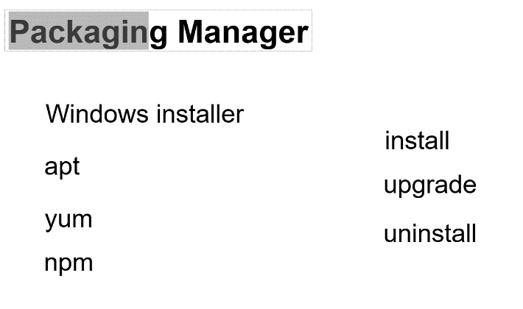

Apt,yum :-- linux

Npm :-- node js

Helm is packaging manager for the work of k8s.

Helm work with charts, charts are like packages.

These chart will have all the templates file and configuration file required to create k8s resources.

Helm maintain revision for,we can undeploy it.

**After Helm**

**Advantages of using helm:-**

**1-**Helm simplifies k8s **deployment process** by abstracting out all the complexity

2-Helm will pull mongo db chart from centralized chart repository with single command it will do installation

On k8s

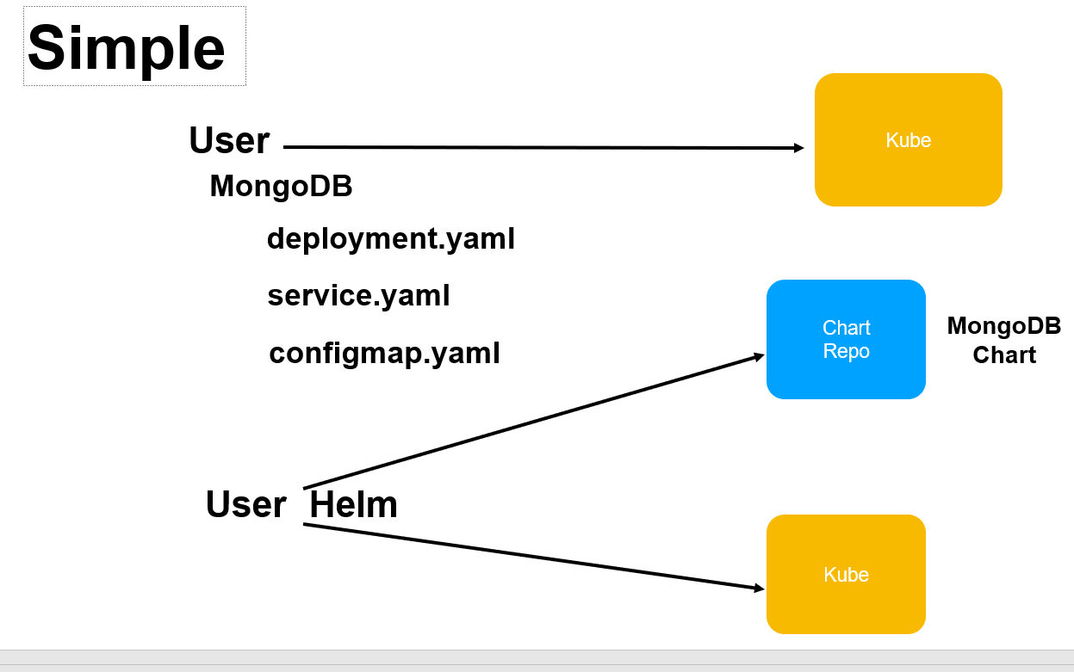

1. Helm will maintain **revision history** as we do installation and upgrades and it will store all in particular location. As we will do upgrade it will create another revision history for us.

Helm maintain revision history and at any time we can revert it

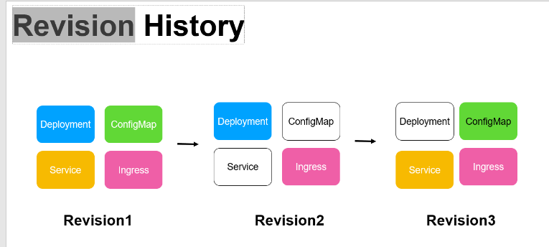

1. **Dynamic configuration**

When we create a chart all these files generated as templates.

Helm uses **values.yaml** using which we can pass parameter to these files.

The combination of values.yaml and template will be use by helm to generate final yaml that will send to k8s

All boilerplate code will be gone. It add dynamic to the template.

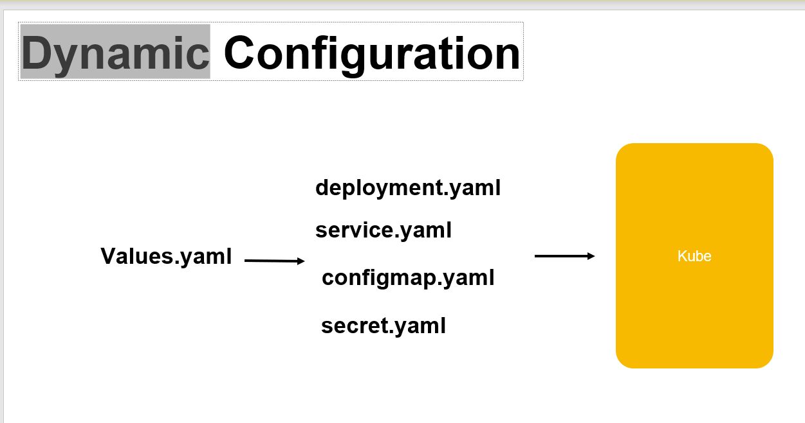

**5 consistency**

**6:- Intelligent deployment**

When we deploy in k8s we need to maintain order

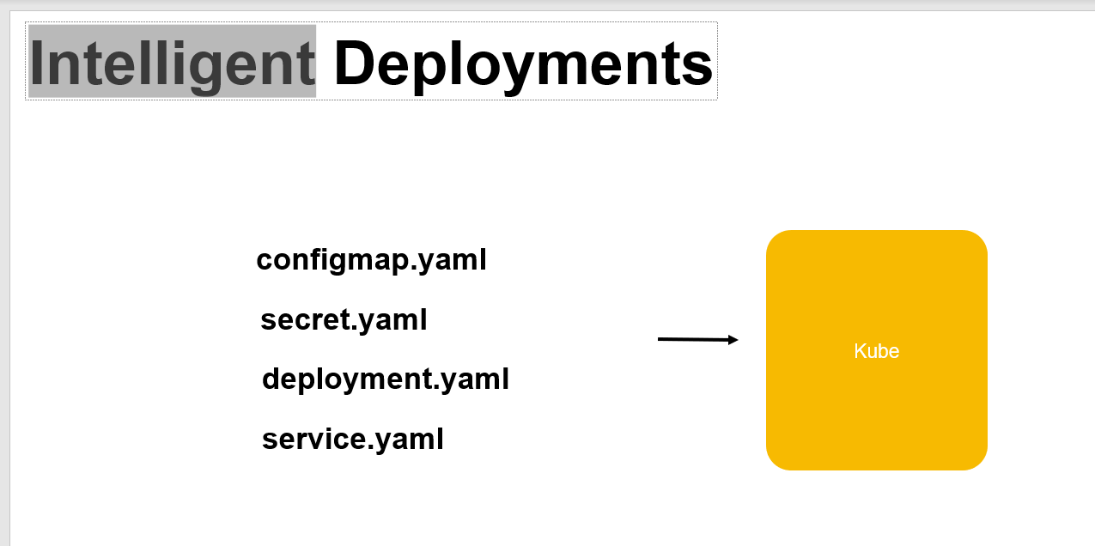

**Example :-**

configMap and secret should be created before services and we need to provide these info to k8s.

But helm knows order it will automatically do for us.

Helm also give **life cycle hooks .** If there is any work which is directly not related to k8s.

But it has to be done during installation or upgradation helm allow us to write hook that can be hooked

Into lifecycle like upgrade,installation like writing data to d/b

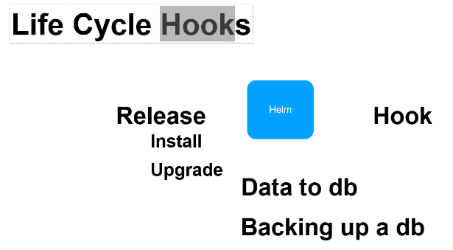

**Security :**

Helm ensure that the chart are downloaded from central repo are secure.

Helm verify the chart.

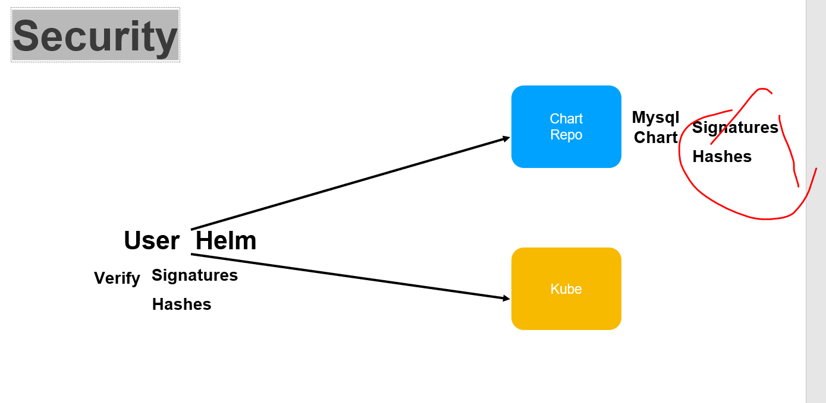

**Chart and Repos**

Helm uses the **concept of chart which are like packages** to install a particular application **to the k8s cluster**.

And these packages and chart are stored in chart repository.

Later on we will learn how to create our own chart repository.

<https://bitnami.com/stack/helm> :--

is very popular one for host chart

We can read this chart and it will give instruction how to install on k8s cluster

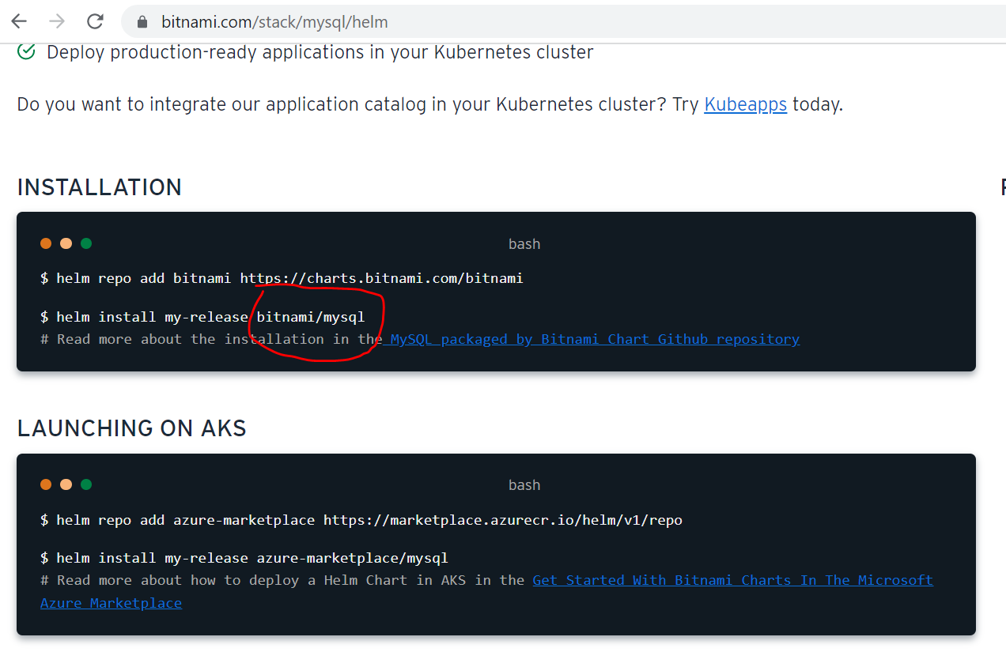

Here is the package details of chart, will learn how to create our own chart and package it.

Repositories are where chart are stored

and we work will helm , when we will do helm install

it will pull those chart from Repository and we will be configure on machine and will be use for k8s installation

**Source of chart**

<https://github.com/bitnami/charts>

Every chart has folder directory . Under template will find various dynamic k8s file is there.

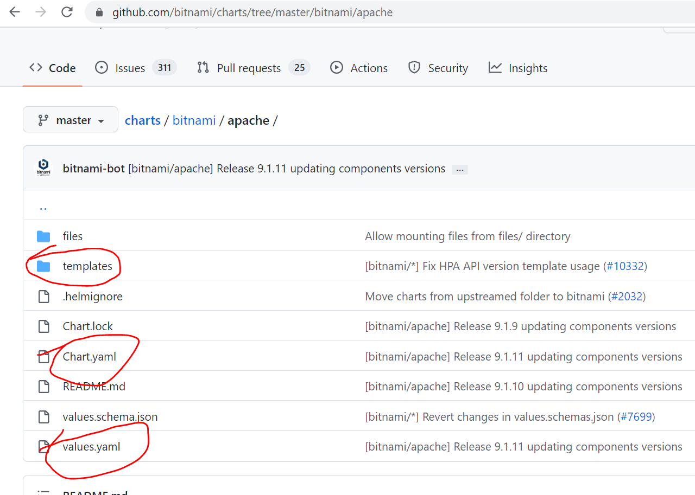

As of now will use chart(apache) which is already available in bitnami using command

Then we will create our own chart

**Section 2:- helm in action**

**Objective :**

How to install helm on machine

Helm is return google go programming language which is compiled language.

Install helm :

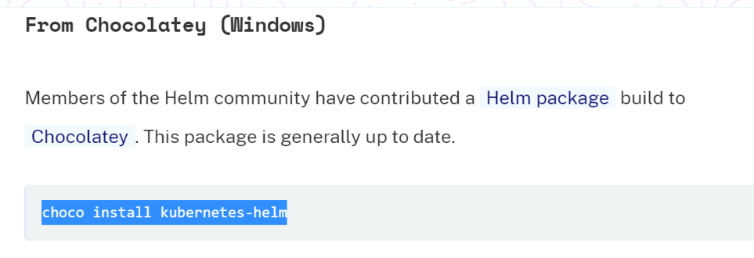

Query :

How does helm know about k8s cluster

Helm uses the same config file which kubectl uses.

**Work with chart repositories**

**Objective:**

**How to work with chart repository.**

1. **Helm repo list**

Starting with 3.0 helm don’t come with any predefined repositor

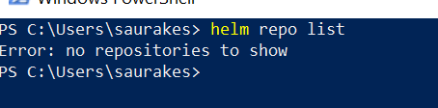

1. **To add repo**

helm repo add bitnami <https://charts.bitnami.com/bitnami>

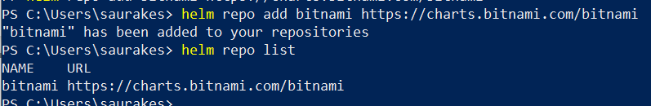

**Now helm can work with repository.**

1. **To remove repo :**

helm repo remove bitnami

4-**Search the repository:**

Helm search repo apache

Helm search repo mysql

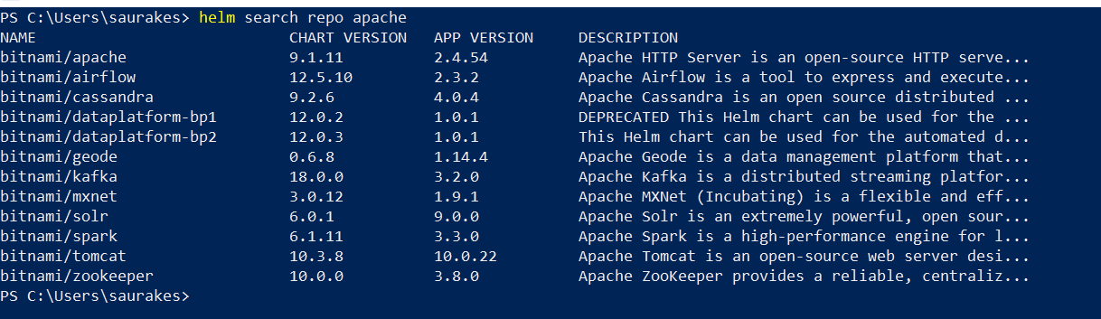

We have chart version and app version , apache is present in many other chart also

By default it will show latest version of the chart

**The magic of helm**

**When minikube is up we are able to run kubectl command**

How does helm know about k8s cluster

**Helm uses the same config file which kubectl uses.**

**So after running helm install command for chart minikube will get images and it will launch a container for mysql**

**Objective :**

Install a package to k8s cluster using helm install command and the helm package.

The installation is nothing but instance of chart we are using in this case we are going to install mysql pkf from bitnami chart.

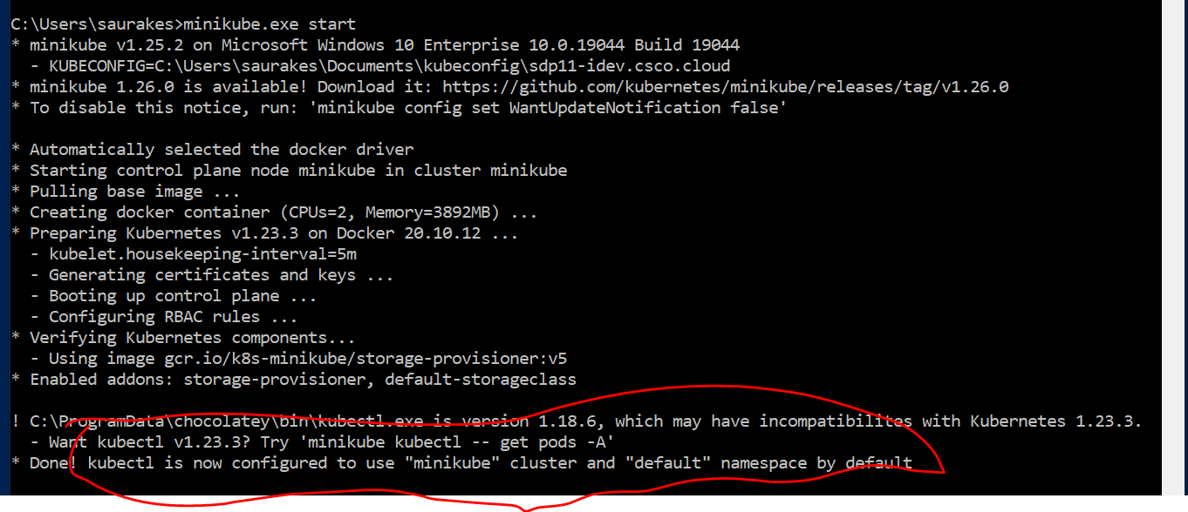

Launch three terminal

Terminal 1:

Kubectl get pods

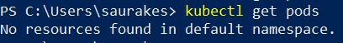

Terminal 2:

Minikube.exe ssh

This will take to minikube cluster node not local machine

These are default images that come ith minikube.

Once we finish package installation will see my sql image as well

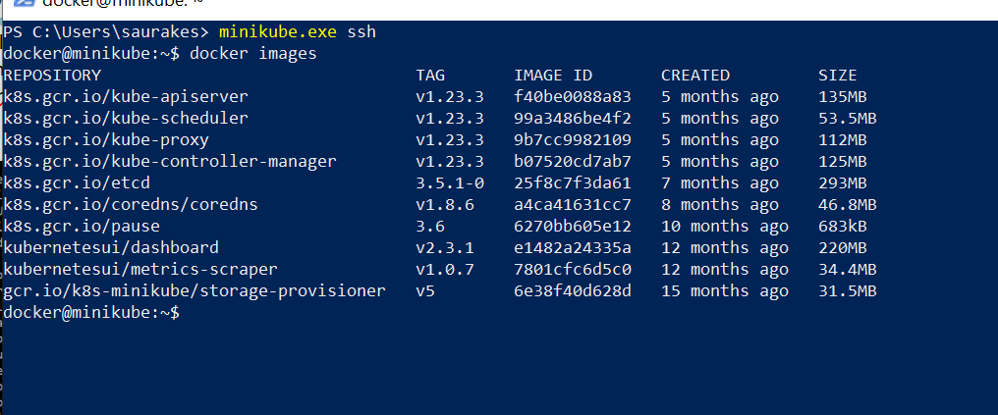

**Now run command in terminal 1:**

**Helm install mydb bitnami/mysql**

**Note :** mydb should be unique name and it is the instance of mysql (particular chart)

After running this command we will get lot of info

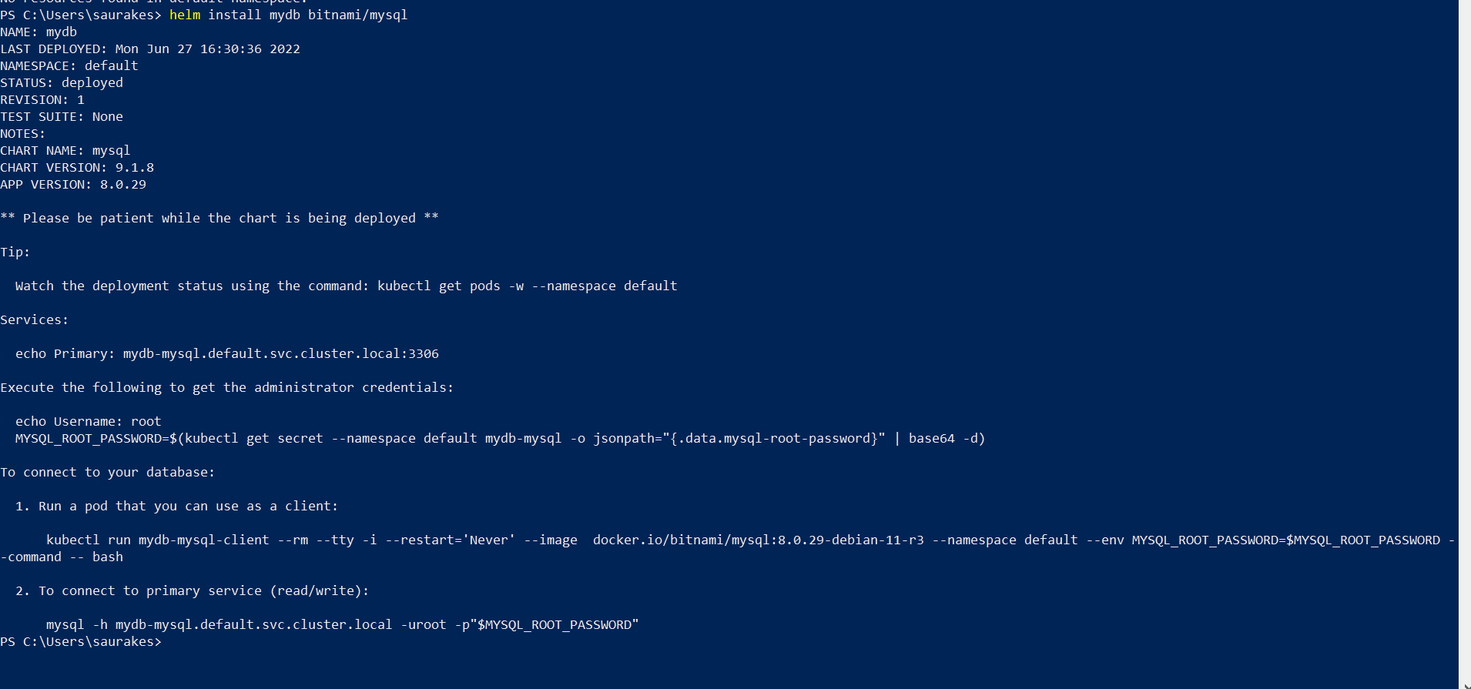

Pod will create

Service will create

We will get default pw

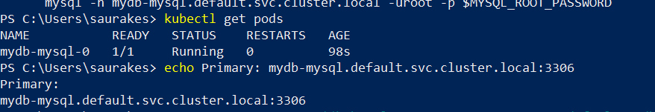



To connect to your d/b it will give command here which will launch another mysql pod

Using the mysql image and version it is launching another pod which we are going to use as a client

Now we are inside new pod

**To connect to your database:**

1. Run a pod that you can use as a client:

kubectl run mydb-mysql-client --rm --tty -i --restart='Never' --image docker.io/bitnami/mysql:8.0.29-debian-11-r3 --namespace default --env MYSQL_ROOT_PASSWORD=$MYSQL_ROOT_PASSWORD --command -- bash

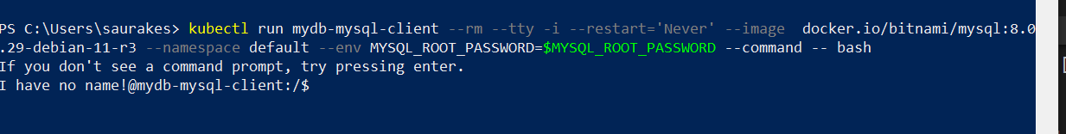

A pod is launch we are inside the pod

**Run in first terminal** : kubectl get pods , now we will get two pods

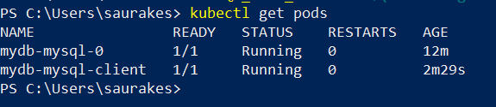

**First pod** was launch by installation

**Second pod** was launch by kubectl command so that we can use this as a client to connect with mysql server

2**. To connect to primary service (read/write):**

mysql -h mydb-mysql.default.svc.cluster.local -uroot -p"$MYSQL_ROOT_PASSWORD"

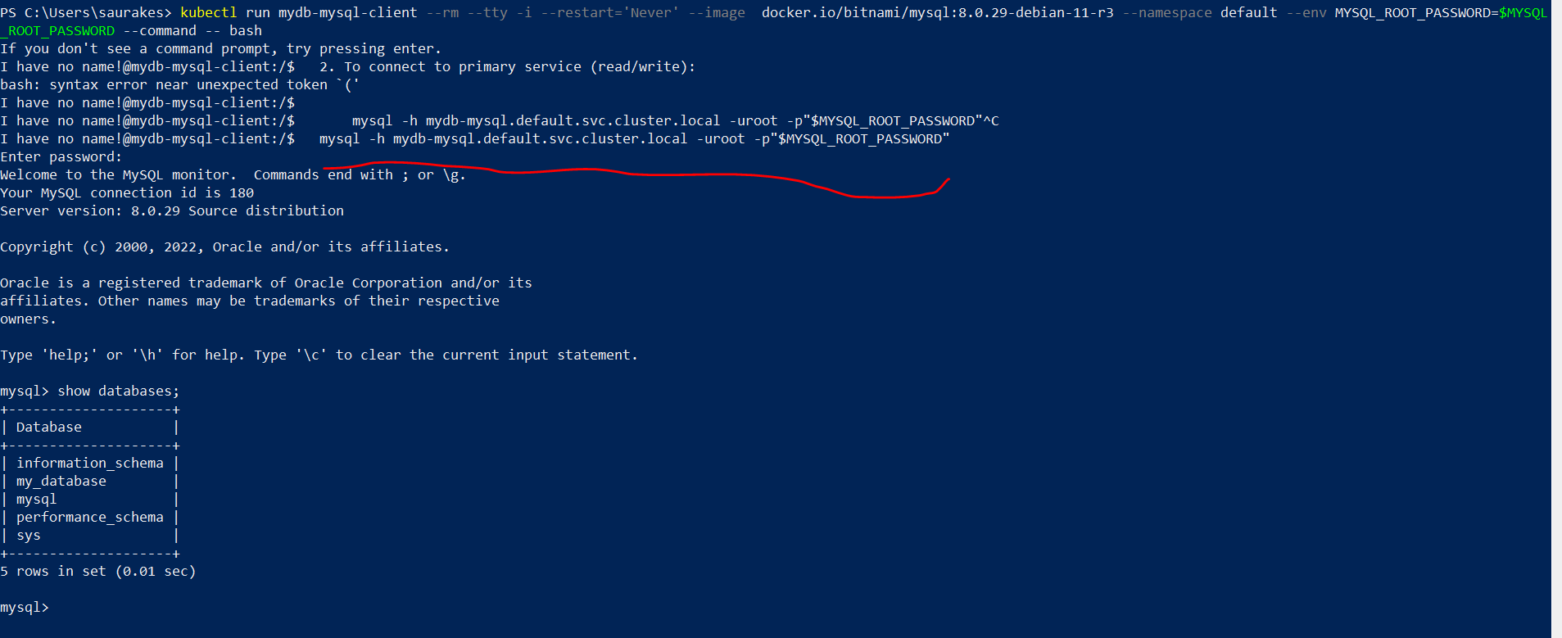

Sucessfully installed my-sql package by using helm install.

We are able to launch another pos which we are using as client connect to the mysql pod is launch through helm install

Then we are able to access mysql client

During the intallation process it will pull mysql images then it uses the images to launch a container and pod

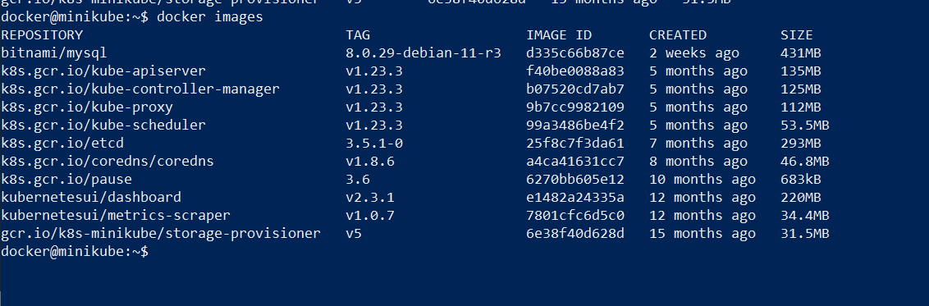

At any time we want to get all info we can run

**Helm status mydb**

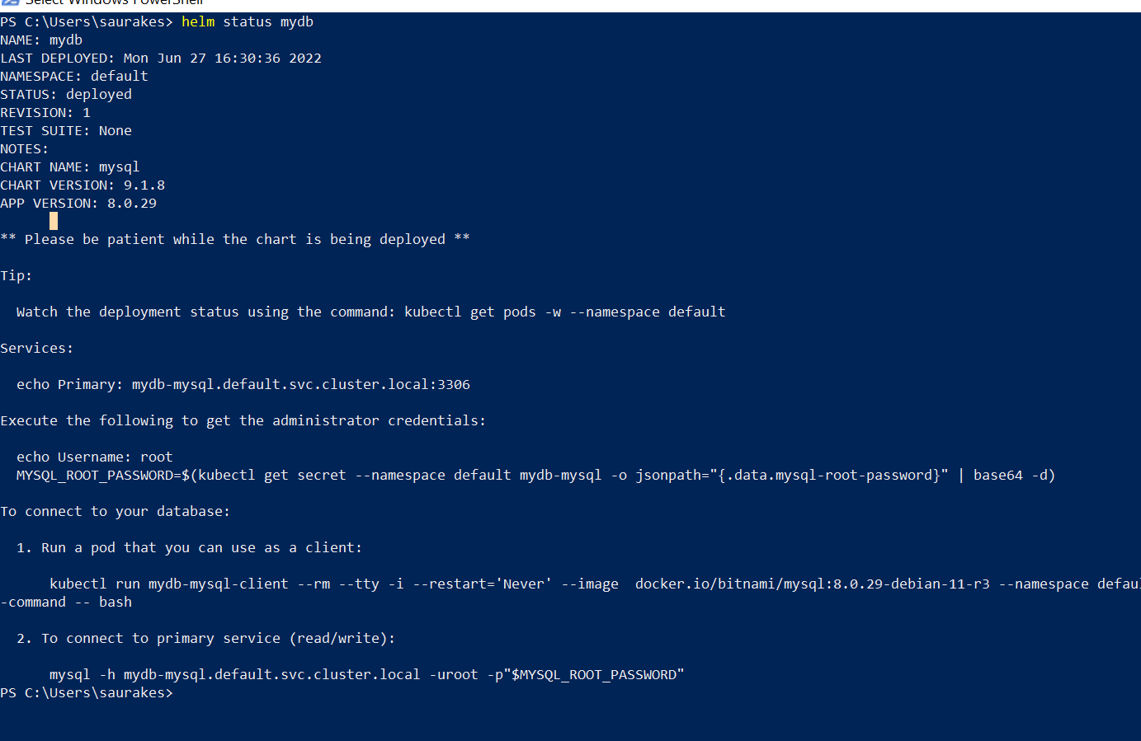

**Using same installation name**

**In previous lecture** we gave installation name and chart name we want to use

We will get an error if executing same name

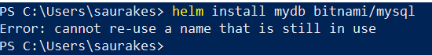

Either delete installation or use a different namespace

**Kubectl create ns teamtwo**

**helm install --namespace teamtwo mydb bitnami/mysql**

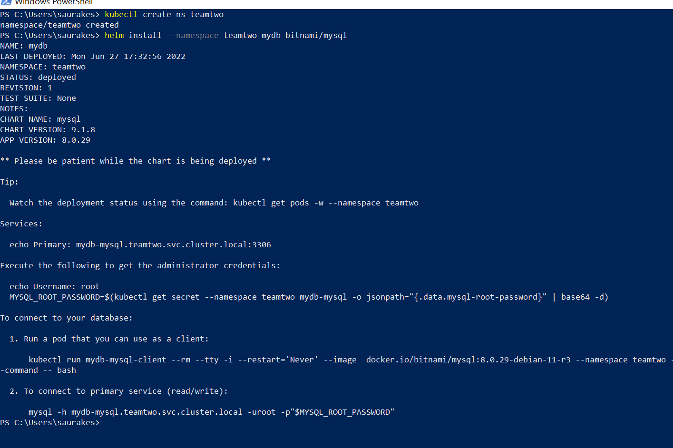

Now another deployment or installation happen for us but this deployment happen in different ns

Earlier namespace was default now namespace is teamtwo

**Note** : installation name should be unique for namespace

**List and uninstall**

**Objective:**

How to list all the packages that are installed on k8s cluster and also how to uninstall package or deployment

**Helm list** :--- will see about the installation we have done

Helm list -n (or --namespace) teamtwo

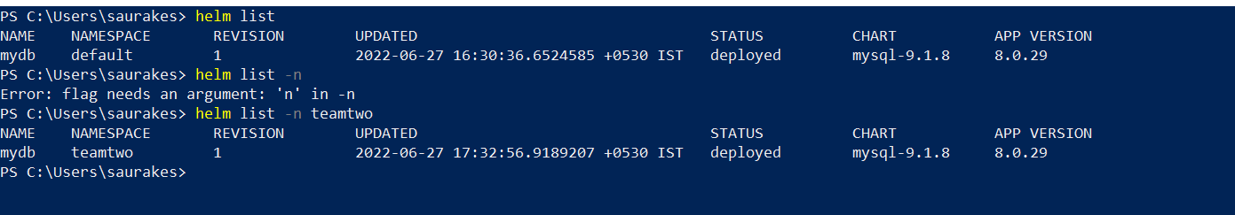

**Delete or uninstall pkg from cluster**

**Helm uninstall mydb (** this will go default namespace**)**

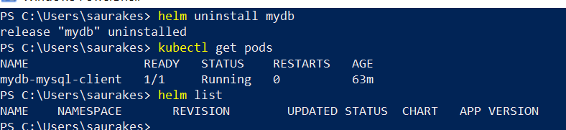

Now only client pod have

**Delete from particular namespace**

helm uninstall mydb --namespace teamtwo

helm list -n teamtwo

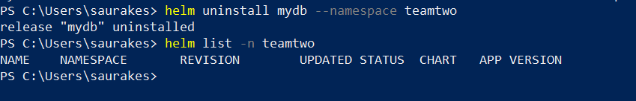

**Providing custom values**

**Objective :**

When we install my sql we get default password .

Here we will learn how to pass custom configuration wn we install pkg using helm chart

We are going to set our own password instead of using default password

Step :-

Kill minikube , we are going to start with new cluster

**Minikube.exe delete**

**Minikube.exe start (** minikube is up and running we have k8s cluster**)**

**To pass a custom configuration (**recommended way to use values.yaml**)**

When mysql server pod is up and running **test1234 will be the pw will use this to connect from client pod.**

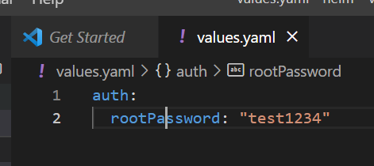

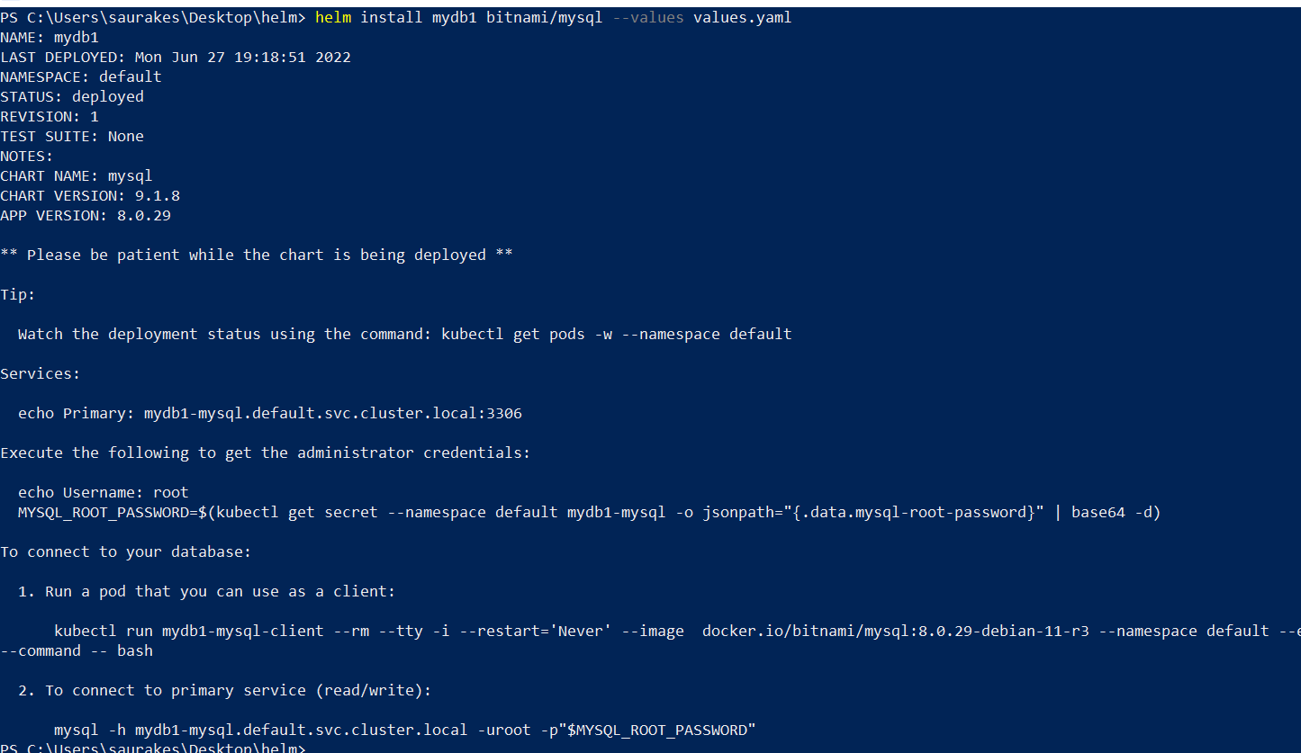

This time we will get our own password

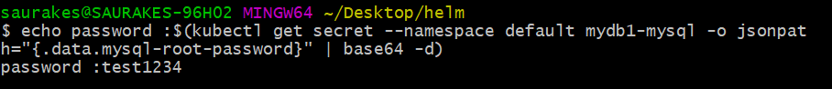

We are connecting to mysql

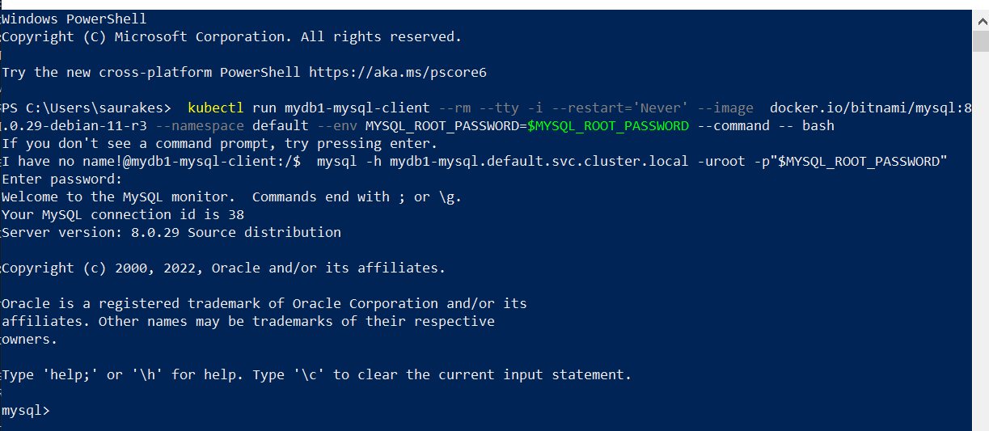

Another approach



**Helm upgrade**

**Objective :**

How to upgrade existing installation or release

Helm repo update

This command will fetch latest chart by going into repository

**helm upgrade mydb1 bitnami/mysql --values values.yaml**

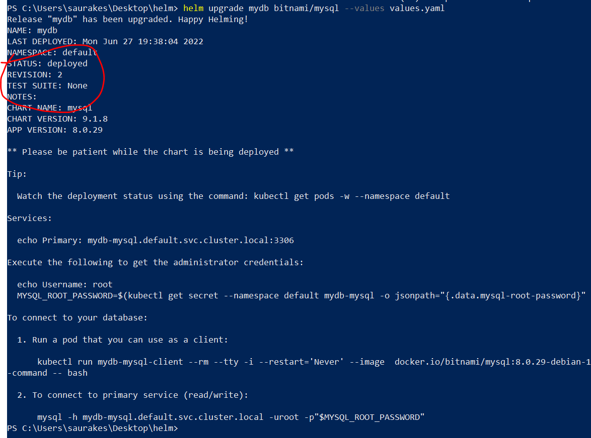

Helm will send those changes to the k8s that is required

Helm will generate k8s templates compare them to the old templates and only the changes are required will be push to the k8s

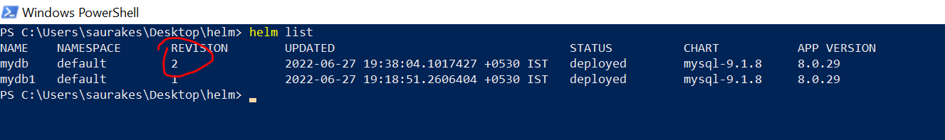

**More about upgrade**

**helm upgrade mydb1 bitnami/mysql**

If we will use like this it will pass default configuration

**Release Record**

**Objective :**

How helm maintain the release record as secret in k8s cluster

For each install and upgrade secret created. This is nothing but release record

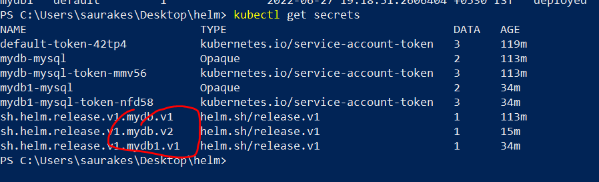

When we will do uninstall not only installation will be gone but all version will be deleted

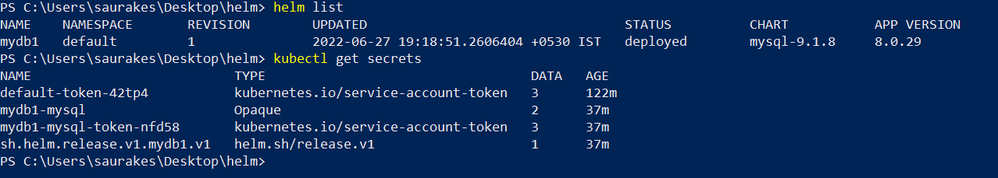

If we want to retain this info (secret) we can use rollback which we will learn later on

Section 3 Advanced Command

**Helm release workflow**

**Objective :**

Process will go through behind the scene when we execute helm install

Load the entire chart if chart has any dependency it will load that also

It parse the default values.yaml

Generate the template using that values and substituting the value in the template

Parse those yaml into k8s object , validate those object against k8s schema to ensure that

They are ok to create pod,deployment,services

Then it will generate yaml which is complaign to k8s and send to k8s

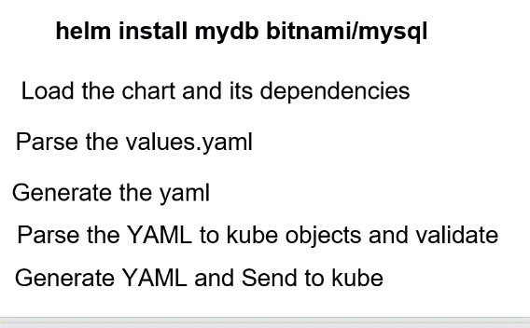

**Helm --dry-run :**

**Objective**

How to run dry run for helm installation and upgrades

helm install mydb bitnami/mysql --values values.yaml --dry-run

--dry-run :---

it will load the chart ,

substitute the value we provide through value.yaml into that chart

Render the k8s yaml but it will not submit into k8s cluster

It is a great way of **debugging** what will really happen when we install it or install the chart

**helm install mydb bitnami/mysql --values values.yaml --dry-run**

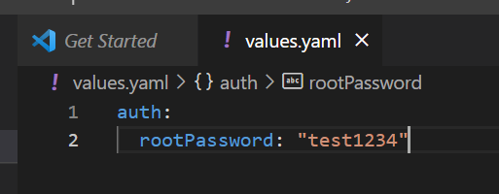

**Note :** the install never happen when we do dry run

**Here we have three section in this o/p**

**First section :**

Release info

**Second section :**

Where entire k8s template are dumped. There are dashes b/w each template

**Kind: statefulset** : this is where pod is created for us

**Section third : release notes** (like connect to d/b)

Dry run is very powerful to debug

==========================================================================

NAME: mydb

LAST DEPLOYED: Mon Jun 27 22:27:47 2022

NAMESPACE: default

STATUS: pending-install

REVISION: 1

TEST SUITE: None

HOOKS:

MANIFEST:

---

# Source: mysql/templates/serviceaccount.yaml

apiVersion: v1

kind: ServiceAccount

metadata:

name: mydb-mysql

namespace: "default"

labels:

app.kubernetes.io/name: mysql

helm.sh/chart: mysql-9.1.8

app.kubernetes.io/instance: mydb

app.kubernetes.io/managed-by: Helm

annotations:

automountServiceAccountToken: true

secrets:

- name: mydb-mysql

---

# Source: mysql/templates/secrets.yaml

apiVersion: v1

kind: Secret

metadata:

name: mydb-mysql

namespace: "default"

labels:

app.kubernetes.io/name: mysql

helm.sh/chart: mysql-9.1.8

app.kubernetes.io/instance: mydb

app.kubernetes.io/managed-by: Helm

type: Opaque

data:

mysql-root-password: "dGVzdDEyMzQ="

mysql-password: "YWpRMEdJdlhSMw=="

---

# Source: mysql/templates/primary/configmap.yaml

apiVersion: v1

kind: ConfigMap

metadata:

name: mydb-mysql

namespace: "default"

labels:

app.kubernetes.io/name: mysql

helm.sh/chart: mysql-9.1.8

app.kubernetes.io/instance: mydb

app.kubernetes.io/managed-by: Helm

app.kubernetes.io/component: primary

data:

my.cnf: |-

[mysqld]

default_authentication_plugin=mysql_native_password

skip-name-resolve

explicit_defaults_for_timestamp

basedir=/opt/bitnami/mysql

plugin_dir=/opt/bitnami/mysql/lib/plugin

port=3306

socket=/opt/bitnami/mysql/tmp/mysql.sock

datadir=/bitnami/mysql/data

tmpdir=/opt/bitnami/mysql/tmp

max_allowed_packet=16M

bind-address=0.0.0.0

pid-file=/opt/bitnami/mysql/tmp/mysqld.pid

log-error=/opt/bitnami/mysql/logs/mysqld.log

character-set-server=UTF8

collation-server=utf8_general_ci

slow_query_log=0

slow_query_log_file=/opt/bitnami/mysql/logs/mysqld.log

long_query_time=10.0

[client]

port=3306

socket=/opt/bitnami/mysql/tmp/mysql.sock

default-character-set=UTF8

plugin_dir=/opt/bitnami/mysql/lib/plugin

[manager]

port=3306

socket=/opt/bitnami/mysql/tmp/mysql.sock

pid-file=/opt/bitnami/mysql/tmp/mysqld.pid

---

# Source: mysql/templates/primary/svc-headless.yaml

apiVersion: v1

kind: Service

metadata:

name: mydb-mysql-headless

namespace: "default"

labels:

app.kubernetes.io/name: mysql

helm.sh/chart: mysql-9.1.8

app.kubernetes.io/instance: mydb

app.kubernetes.io/managed-by: Helm

app.kubernetes.io/component: primary

annotations:

spec:

type: ClusterIP

clusterIP: None

publishNotReadyAddresses: true

ports:

- name: mysql

port: 3306

targetPort: mysql

selector:

app.kubernetes.io/name: mysql

app.kubernetes.io/instance: mydb

app.kubernetes.io/component: primary

---

# Source: mysql/templates/primary/svc.yaml

apiVersion: v1

kind: Service

metadata:

name: mydb-mysql

namespace: "default"

labels:

app.kubernetes.io/name: mysql

helm.sh/chart: mysql-9.1.8

app.kubernetes.io/instance: mydb

app.kubernetes.io/managed-by: Helm

app.kubernetes.io/component: primary

annotations:

spec:

type: ClusterIP

sessionAffinity: None

ports:

- name: mysql

port: 3306

protocol: TCP

targetPort: mysql

nodePort: null

selector:

app.kubernetes.io/name: mysql

app.kubernetes.io/instance: mydb

app.kubernetes.io/component: primary

---

# Source: mysql/templates/primary/statefulset.yaml

apiVersion: apps/v1

kind: StatefulSet

metadata:

name: mydb-mysql

namespace: "default"

labels:

app.kubernetes.io/name: mysql

helm.sh/chart: mysql-9.1.8

app.kubernetes.io/instance: mydb

app.kubernetes.io/managed-by: Helm

app.kubernetes.io/component: primary

spec:

replicas: 1

podManagementPolicy: ""

selector:

matchLabels:

app.kubernetes.io/name: mysql

app.kubernetes.io/instance: mydb

app.kubernetes.io/component: primary

serviceName: mydb-mysql

updateStrategy:

type: RollingUpdate

template:

metadata:

annotations:

checksum/configuration: fd0c4a7518763d7217f48db568ea88de86d17ee3887cd2983335e75b1f78836e

labels:

app.kubernetes.io/name: mysql

helm.sh/chart: mysql-9.1.8

app.kubernetes.io/instance: mydb

app.kubernetes.io/managed-by: Helm

app.kubernetes.io/component: primary

spec:

serviceAccountName: mydb-mysql

affinity:

podAffinity:

podAntiAffinity:

preferredDuringSchedulingIgnoredDuringExecution:

- podAffinityTerm:

labelSelector:

matchLabels:

app.kubernetes.io/name: mysql

app.kubernetes.io/instance: mydb

namespaces:

- "default"

topologyKey: kubernetes.io/hostname

weight: 1

nodeAffinity:

securityContext:

fsGroup: 1001

initContainers:

containers:

- name: mysql

image: docker.io/bitnami/mysql:8.0.29-debian-11-r3

imagePullPolicy: "IfNotPresent"

securityContext:

runAsNonRoot: true

runAsUser: 1001

env:

- name: BITNAMI_DEBUG

value: "false"

- name: MYSQL_ROOT_PASSWORD

valueFrom:

secretKeyRef:

name: mydb-mysql

key: mysql-root-password

- name: MYSQL_DATABASE

value: "my_database"

envFrom:

ports:

- name: mysql

containerPort: 3306

livenessProbe:

failureThreshold: 3

initialDelaySeconds: 5

periodSeconds: 10

successThreshold: 1

timeoutSeconds: 1

exec:

command:

- /bin/bash

- -ec

- |

password_aux="${MYSQL_ROOT_PASSWORD:-}"

if [[ -f "${MYSQL_ROOT_PASSWORD_FILE:-}" ]]; then

password_aux=$(cat "$MYSQL_ROOT_PASSWORD_FILE")

fi

mysqladmin status -uroot -p"${password_aux}"

readinessProbe:

failureThreshold: 3

initialDelaySeconds: 5

periodSeconds: 10

successThreshold: 1

timeoutSeconds: 1

exec:

command:

- /bin/bash

- -ec

- |

password_aux="${MYSQL_ROOT_PASSWORD:-}"

if [[ -f "${MYSQL_ROOT_PASSWORD_FILE:-}" ]]; then

password_aux=$(cat "$MYSQL_ROOT_PASSWORD_FILE")

fi

mysqladmin status -uroot -p"${password_aux}"

startupProbe:

failureThreshold: 10

initialDelaySeconds: 15

periodSeconds: 10

successThreshold: 1

timeoutSeconds: 1

exec:

command:

- /bin/bash

- -ec

- |

password_aux="${MYSQL_ROOT_PASSWORD:-}"

if [[ -f "${MYSQL_ROOT_PASSWORD_FILE:-}" ]]; then

password_aux=$(cat "$MYSQL_ROOT_PASSWORD_FILE")

fi

mysqladmin status -uroot -p"${password_aux}"

resources:

limits: {}

requests: {}

volumeMounts:

- name: data

mountPath: /bitnami/mysql

- name: config

mountPath: /opt/bitnami/mysql/conf/my.cnf

subPath: my.cnf

volumes:

- name: config

configMap:

name: mydb-mysql

volumeClaimTemplates:

- metadata:

name: data

labels:

app.kubernetes.io/name: mysql

app.kubernetes.io/instance: mydb

app.kubernetes.io/component: primary

annotations:

spec:

accessModes:

- "ReadWriteOnce"

resources:

requests:

storage: "8Gi"

NOTES:

CHART NAME: mysql

CHART VERSION: 9.1.8

APP VERSION: 8.0.29

** Please be patient while the chart is being deployed **

Tip:

Watch the deployment status using the command: kubectl get pods -w --namespace default

Services:

echo Primary: mydb-mysql.default.svc.cluster.local:3306

Execute the following to get the administrator credentials:

echo Username: root

MYSQL_ROOT_PASSWORD=$(kubectl get secret --namespace default mydb-mysql -o jsonpath="{.data.mysql-root-password}" | base64 -d)

To connect to your database:

1. Run a pod that you can use as a client:

kubectl run mydb-mysql-client --rm --tty -i --restart='Never' --image docker.io/bitnami/mysql:8.0.29-debian-11-r3 --namespace default --env MYSQL_ROOT_PASSWORD=$MYSQL_ROOT_PASSWORD --command -- bash

2. To connect to primary service (read/write):

mysql -h mydb-mysql.default.svc.cluster.local -uroot -p"$MYSQL_ROOT_PASSWORD"

===========================================================

**Helm templates**

**Objective : why we need it**

* Dry run involve some non yaml into the templates
* Dry run can be use for both installation and upgradation
* Upgrade output of dry run will be completely different from install.
* Dry run validate template against api-server in k8s cluster. Local configuration should be there to work

To avoid all these helm given us helm template command

**Helm template mydb bitnami/mysql --values value.yaml**

Helm template also will go four phases just like dry run but it differs in several ways

* It doesn’t have release info. It just have template info.
* Helm template command never communicate with k8s api server. It doesn’t validate the template.
* So it doesn't need active k8s cluster
* It always act just like new installation

**More about release record (version store in secret)**

**helm install mydb bitnami/mysql --values values.yaml**

**Kubectl get secret**

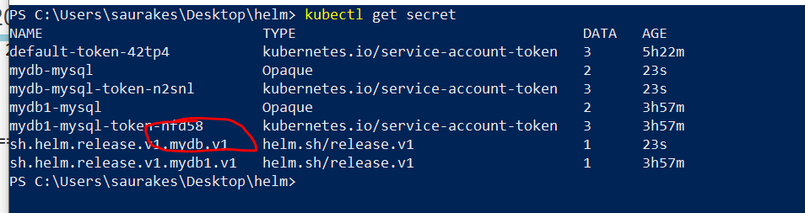

**This guy have all info. About template**

**Note :**

whenever we will do helm install , secret will create which will be having all info about template(yaml file)

**kubectl get secret sh.helm.release.v1.mydb.v1 -o yaml**

It will give all info about template in encoded form(base 64)

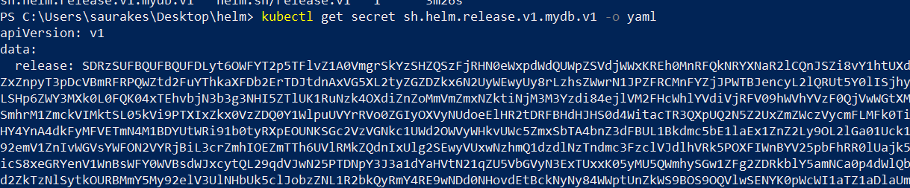

**Note : template info being available in secret.**

**Helm get**

**Helm ls :--** give very less info

So we can use **helm get notes mydb** which we will get usually after installation

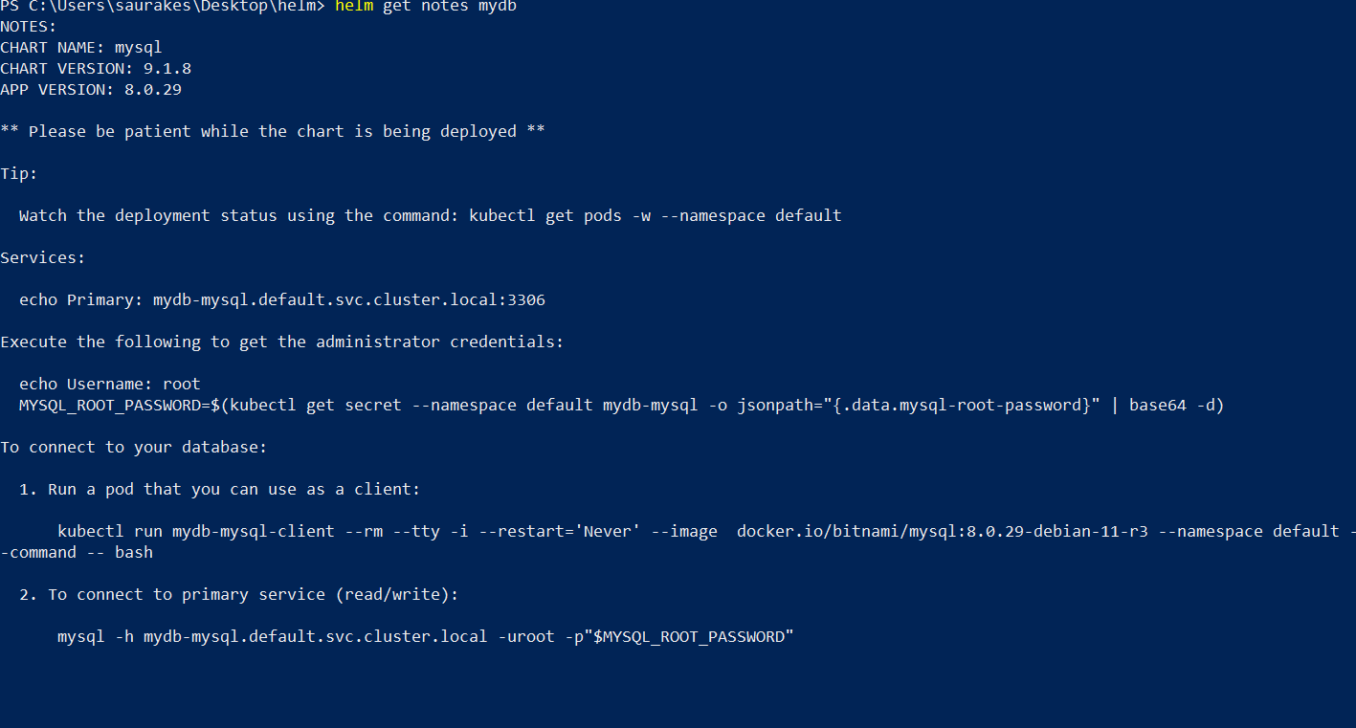

**1-Helm get values mydb**

This will show all the custom value we have use

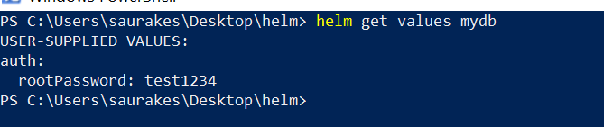

It will only show the value we customized not the default values

If we want **default values** we can use

1. **Helm get values mydb --all**

This will give so many values

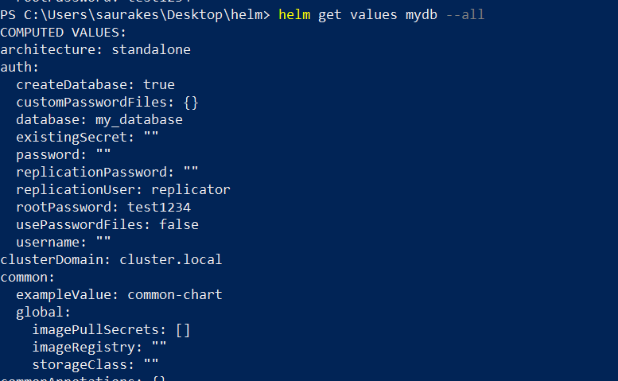

1. **Want to check value of particular version**

**helm get values mydb --revision 1**

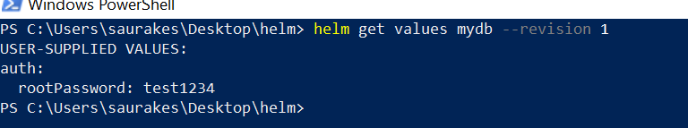

All these value is coming from k8s secret where release record is maintain(version)

**Helm get manifest mydb**

**Helm history**

**Helm history :** will show history of installation and upgrades

Let install apache to k8s cluster

**Helm install mywebserver bitnami/apache**

**helm upgrade mywebserver bitnami/apache --set image.pullPolicy=test -----** passing invalid values



**Helm history mywebserver** :--- will also show error even when upgrade or version failed

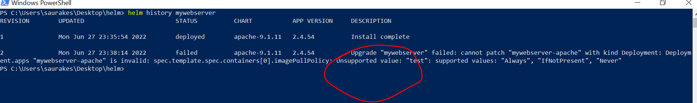

**Helm rollback**

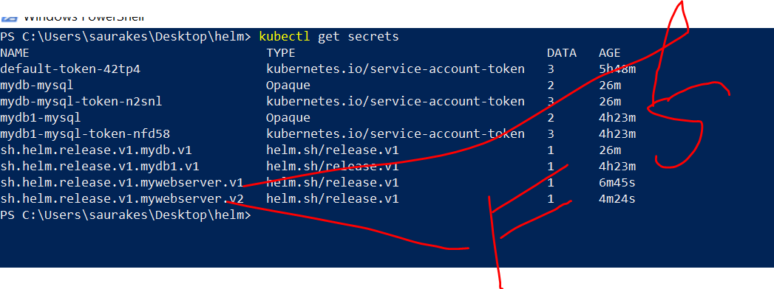

**First one is for success -install**

**Second one is for fail :- upgrade**

**Objective :**

How to rollback to certain version

It shows version 2 is got failed now we want version 1

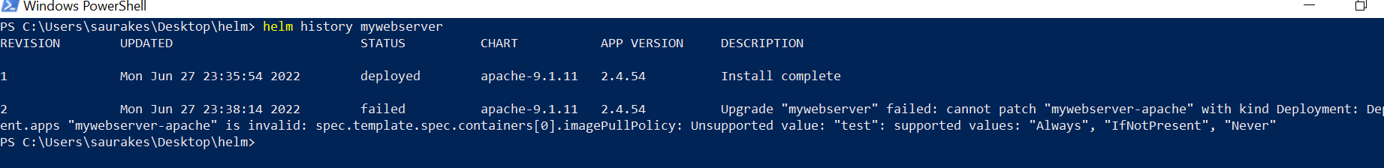

**Rollback it :**

**Helm rollback mywebserver 1**

After rollback will see a new version

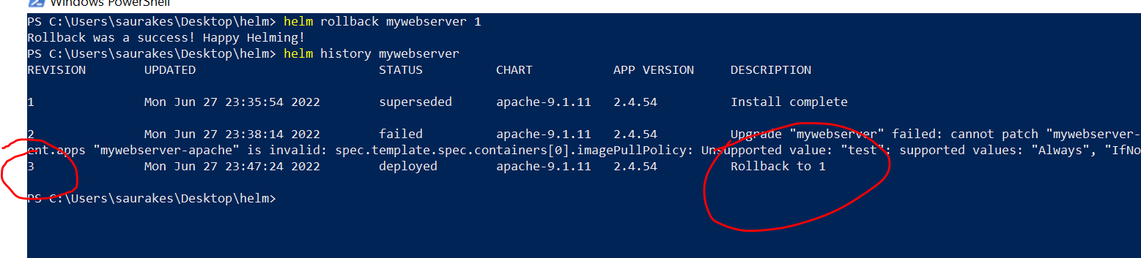

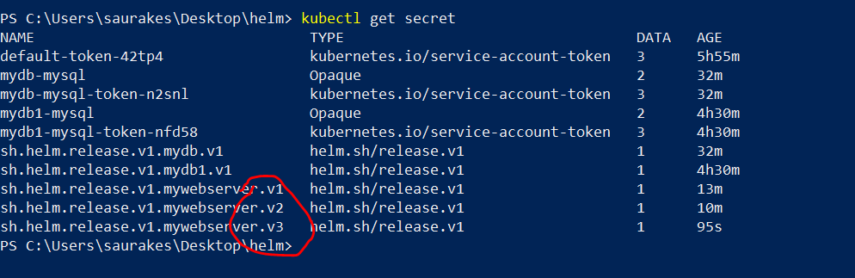

**V1-** success install

**V2 :-** upgrade error

**V3:--** rollback to version 1

Note :

If we want to rollback even after uninstall we need to use:---  **--keep-history**

this will uninstall it but in helm historyVersion will be maintain and using this we can rollback to particular version if we are using

--keep-history

**Helm uninstall mywebserver --keep-history**

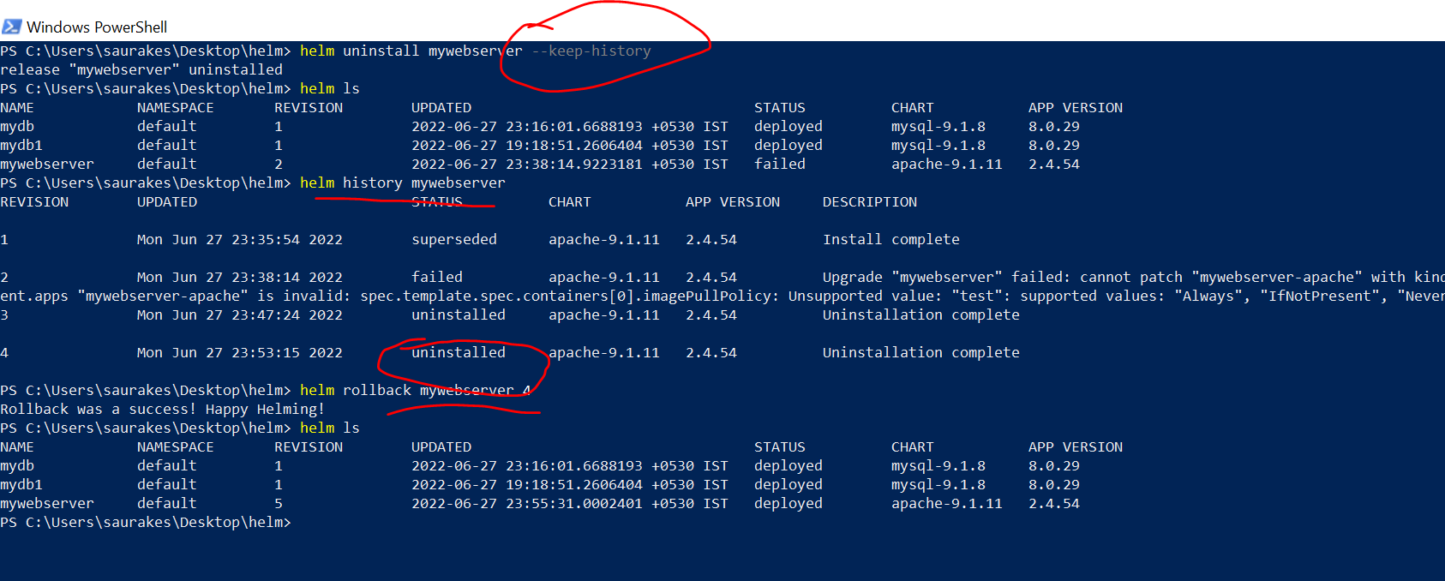

If we want to retain the history by uninstalling the application itself we need to us**e --keep-history**

**Otherwise history will be gone**

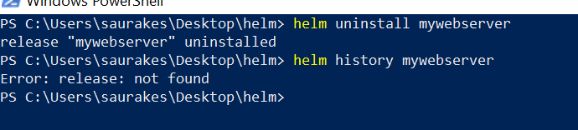

All the secret of webserver will be gone

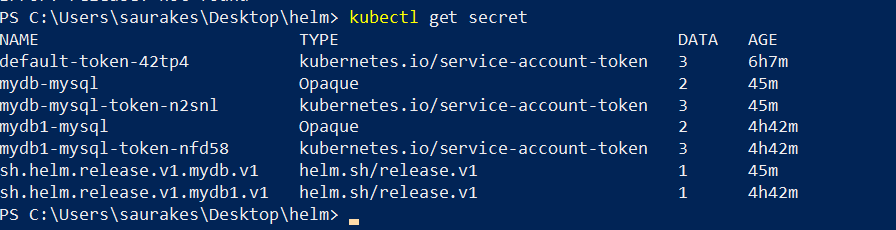

**Create namespace**

**Instead of creating first namespace then using in installation**

**Kubectl create ns teamtwo**

**helm install mydb bitnami/mysql --namespace teamtwo**

**Helm install mywebserver bitnami/apache --namespace mynamespace --create-namespace**

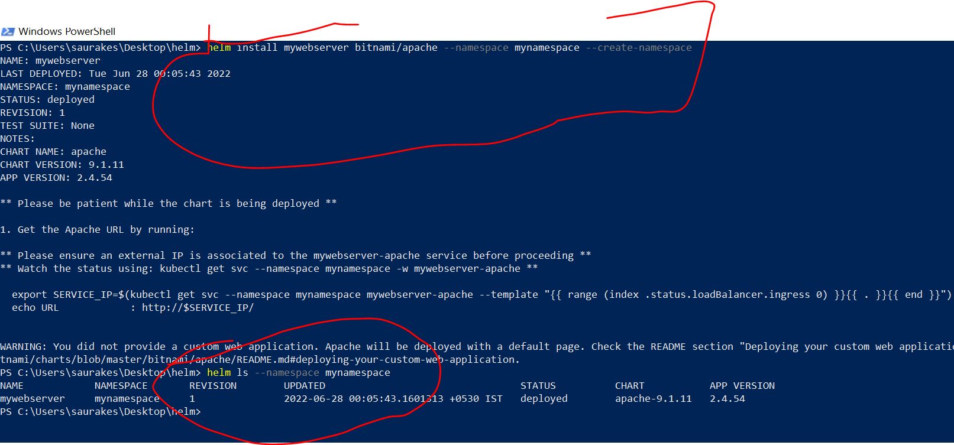

**Install or upgrades**

**Helm upgrade --install mywebserver bitnami/apache**

**Helm ls :-**

If installation is there it will upgrade otherwise it will install it

First time run the command

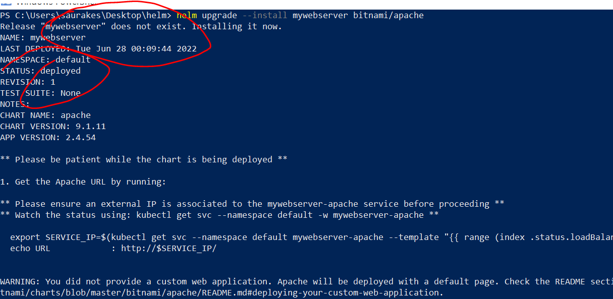

**Second time run the same command**

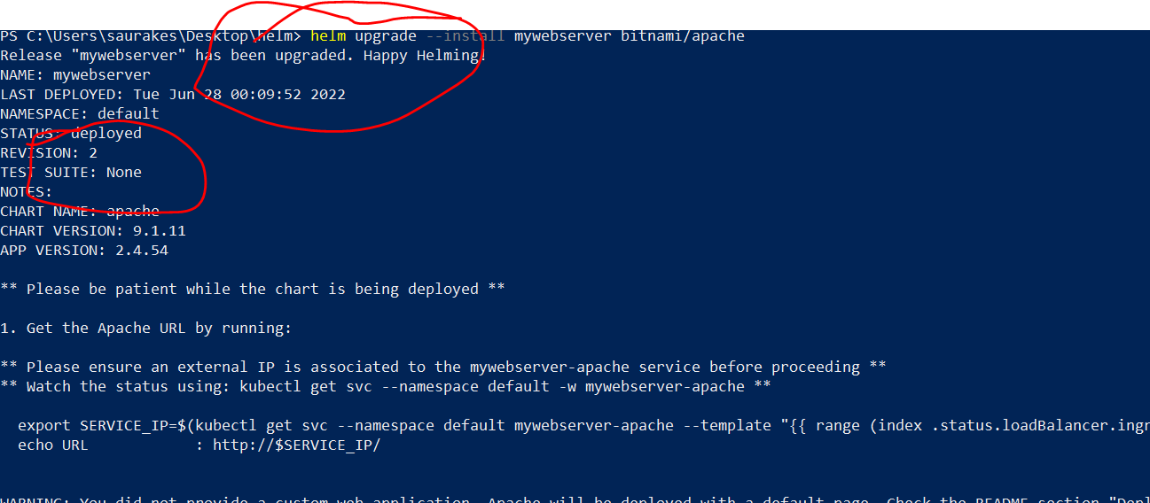

**Generate release names**

Instead of giving name to helm . It will generate name for us

**Helm install bitnami/apache --generate-name**

It will give name by using chart name/ random number

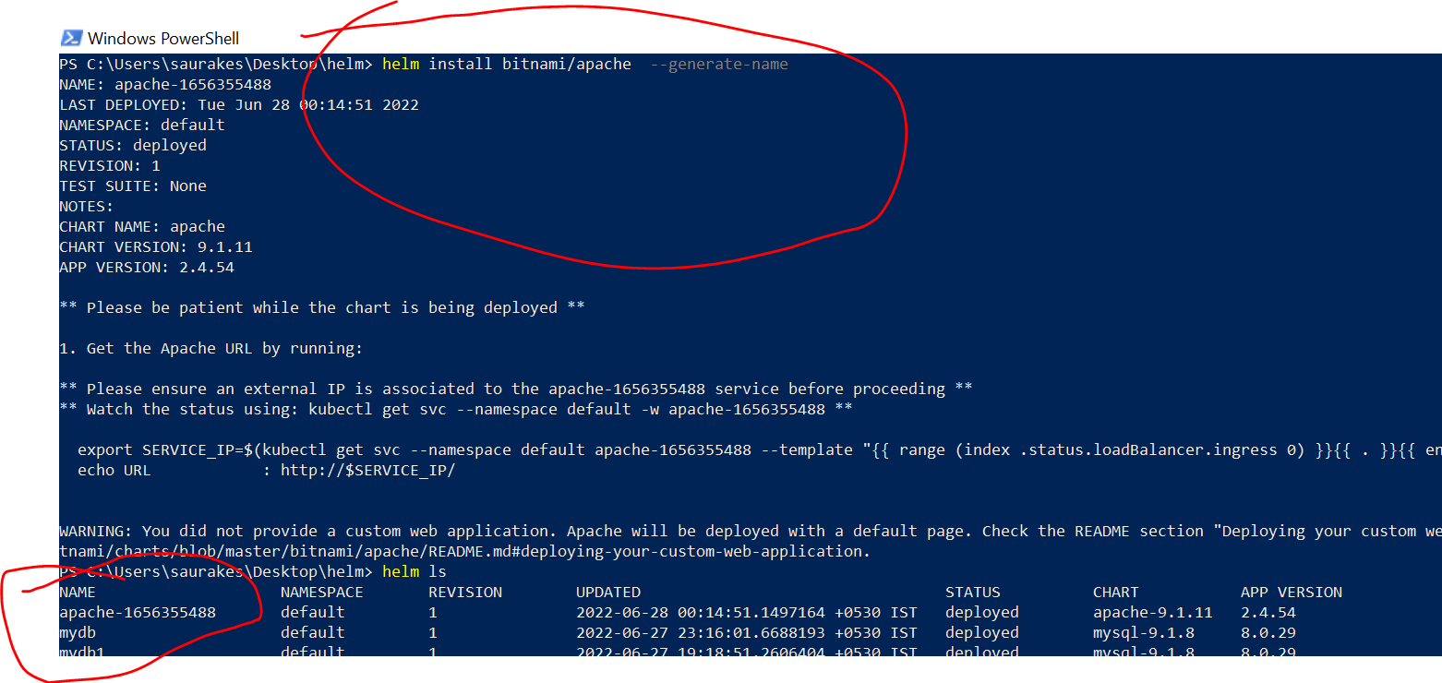

**Helm install bitnami/apache --generate-name --name-template "mywebserver-{{randAlpha 7| lower}}"**

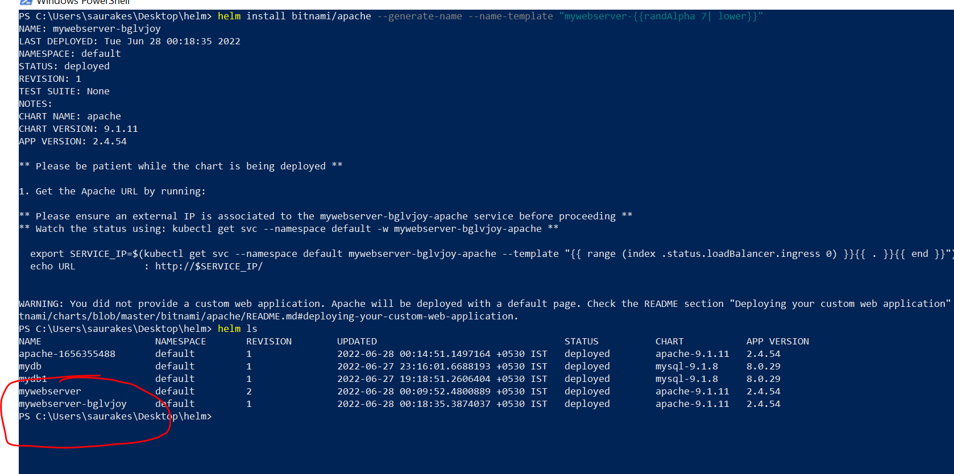

**Note**

**The secret name which is derived from release name cannot be uppercase**

**Wait timeout**

Helm install need to be successful as soon as manifest(yaml) is received by K8S api server.

It doesn't wait for the pods to be up and running

If we want that to be happen we can use **--wait** option

**helm instal mywebserver bitnami/apache --wait**

Helm will wait for the services and deployment to be created and also the pods to be up and running only then the installation will

Be considered as successful

**By default it will wait for 5 minutes**

If the pod doesn't come up within 5 min the installation will be marked as failure

We can specify time also

**helm instal mywebserver bitnami/apache --wait --timeout 5m10s**

**Atomic install**

If we don’t want wait to be happen (if pod didn’t come up )

and want cluster will go to previous successful release

We can use --atomic ( so if installation within default time period it will go to previous successful release)

**helm instal mywebserver bitnami/apache --atomic (** if we use --atomic automatic --wait will be enabled we don’t need to use it**)**

**Forceful upgrades**

We can use couple of flag with helm upgrade

K8s will restart those pod whose value have changed

But if want to create deployment from scratch with upgrade we can use --force

**helm install mywebserver bitnami/apache --force (**it will delete the deployment and create new one**)**

**Cleaned up on failed updates**

**helm instal mywebserver bitnami/apache --cleanup-on-failure**

If upgrades failed we want to clean up all the resources

=================

The "helm template" command validates the generated objects/yaml by communicating with Kubernetes : false

Section 4- Create Charts

So far we have learn how to use existing chart to do our releases. Now we will learn how to create our own chart

Will learn how to create chart and how to package chart

**Create first chart**

**Helm create name of chart**

**Helm create firstchart (** by default helm create command usese nginx chart to create our chart**)**

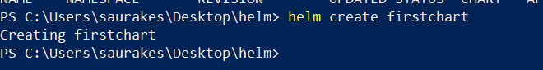

Name of the folder is derived from chart name whatever we given here

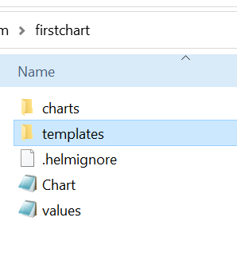

*We saw two files and two folders*

Right now this c**hart folde**r is empty but if this chart depends on any other chart those chart will be pulled and stored in this chart folder

Template folder :--

Values.yaml : contain all the values, default value will go into template.yaml file

**Install the chart**

**helm install firstapp firstchart (chart name -firstchart)**

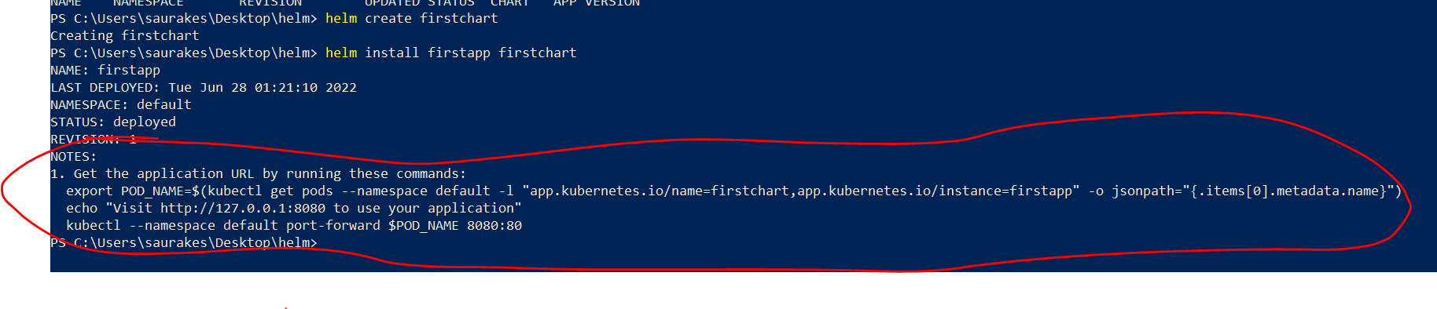

From where these nodes are coming from

**Notes.txt** :- this is the file using which above node render here and there are certain templates in notes.txt which replaced

By values in values.yml and after installation we see the output like machine name , port number

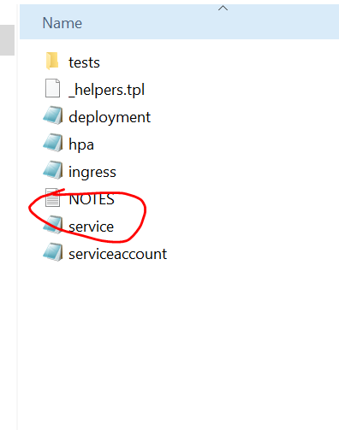

It has three command

. Get the application URL by running these commands:

**First instruction :** getting the pod name which created as part of installation

export POD_NAME=$(kubectl get pods --namespace default -l "app.kubernetes.io/name=firstchart,app.kubernetes.io/instance=firstapp" -o jsonpath="{.items[0].metadata.name}")

**Second instruction**

echo "Visit <http://127.0.0.1:8080> to use your application"

**Third instruction**

kubectl --namespace default port-forward $POD_NAME 8080:80

Note :

**In values.yaml the service is used by default to expose is cluster ip**

**We can change it into NodePort , ingress** as we see in lectures later on

But if want to use outside the cluster we can do port forwarding

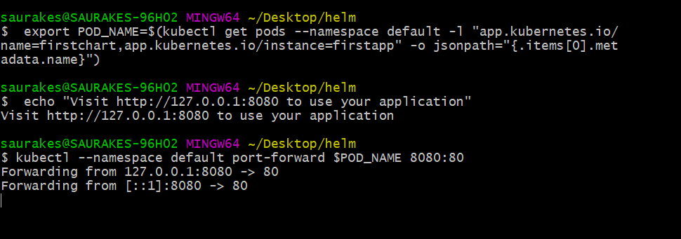

Port 80 on pod

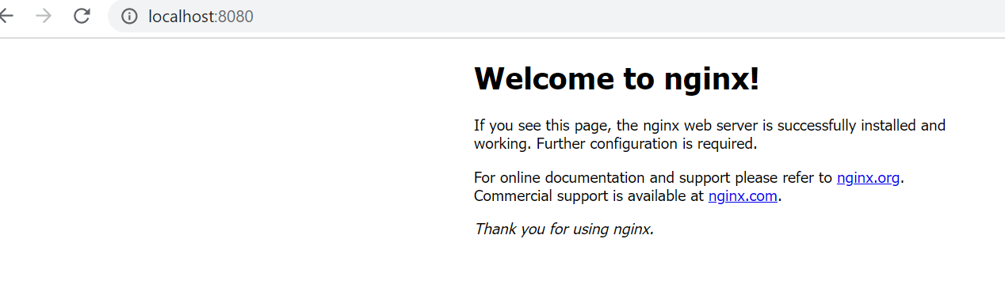

**Chart yaml part -1**

**metadata** is a fancy word. It actually **means** “data that describes other data.

**Chart.yaml**

This is the file that has metadata of our project and tools like artifact hub will use these info and render on the ui.

**There are three mandatory element in chart.yaml**

**apiVersion (** determines the rest of the document that is structure need to be followed , helm 3.0 uses version 2.0**)**

**Name**

**Version**

**appVersion :** application version which will be packaged using this chart

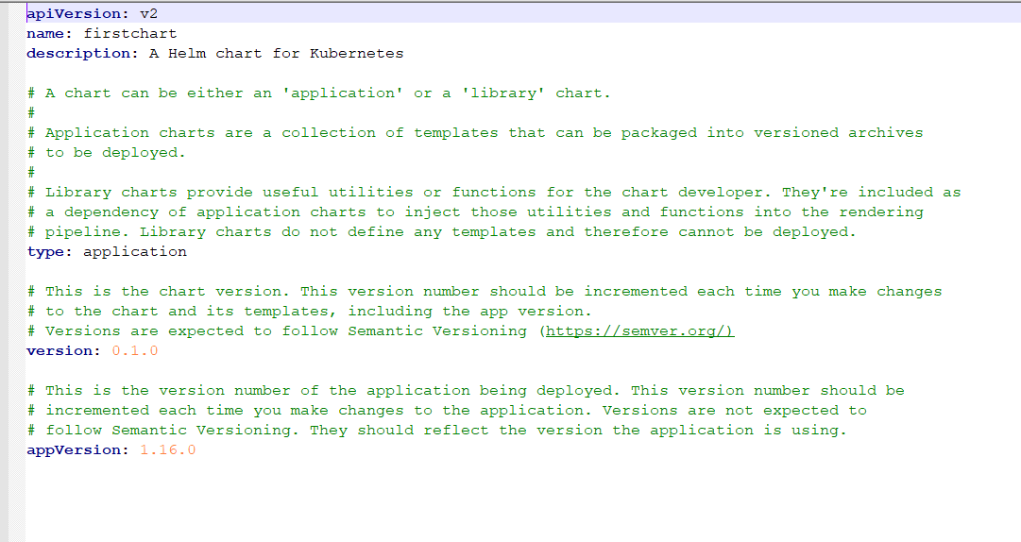

**Chart yaml part -2**

We can include few optional element in chart yaml file

Icon: jpg --------------it will represent project

**1-Templates in brief**

Heart of every helm chart

All these 5 file responsible for final manifest that will send to k8s

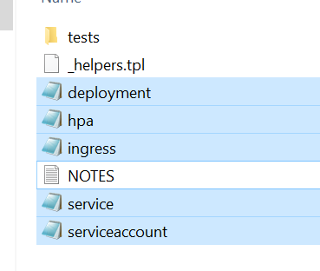

**If we know our project don’t need ingress we can delete it**

A **Kubernetes Manifest files** are the heart of Kubernetes. These **plaintext configuration files describe how a pod's containers should be run and connected to other objects, such as services or replication controllers**. Kubernetes uses a declarative model rather than an imperative model for Pod specification

**Hpa ,ingress :-**check conditional logic

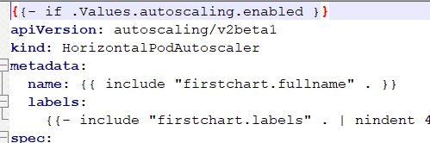

ServiceAccount : all work will be done through service application

**2- Helpers File**

**_helpers.tpl ( tpl stand for template)**

This file will not generate any k8s manifest . It will simply have some method that will use in all other files

This is how function is defined in templating language (**using define**)

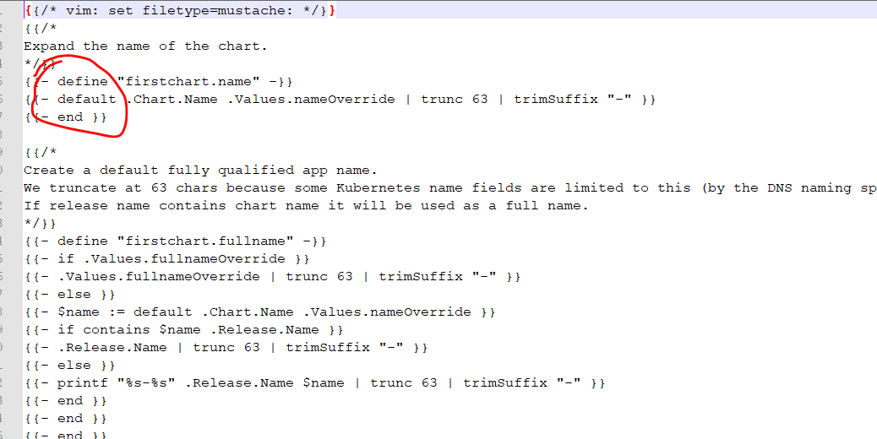

**Firstchart.name ---**method start

**End -----------**method will end here

How we will call this method in other file : firstchart.fullname

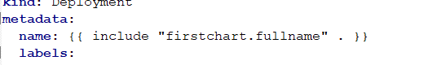

Include is another method in templating syntax

Even we can define our own templating method once we learn the syntax

1. **Values.yaml**

Default value will have that will be use across the templates file under the templates directory

**pullPolicy: IfNotPresent**

If the image not cached in k8s cluster then go and pull the image and if cached it in cluster then use it from there

**pullPolicy: Always**

The image will always pulled for us

**If image need any security credential** those info we can passed in  **imagePullSecret**

**ServiceAccount :**

which is enabled by default. Service account will be created for the chart when we do installation.

That will become part of manifest

**The beauty of values.yaml** : it gives default value which is commented out and if we want to use it we can uncomment

**Service :**

How our pods will expose out by default is uses cluster ip

**Ingress :**

To configure ingress it should be up and running on k8s cluster

Resources

**Autoscaling**

Which is by default disabled, we can provide min replica and max replica

**nodeSelector**

nodeSelector is the simplest recommended form of node selection constraint. You can add the nodeSelector field to your Pod specification and specify the [node labels](https://kubernetes.io/docs/concepts/scheduling-eviction/assign-pod-node/#built-in-node-labels) you want the target node to have. Kubernetes only schedules the Pod onto nodes that have each of the labels you specify.

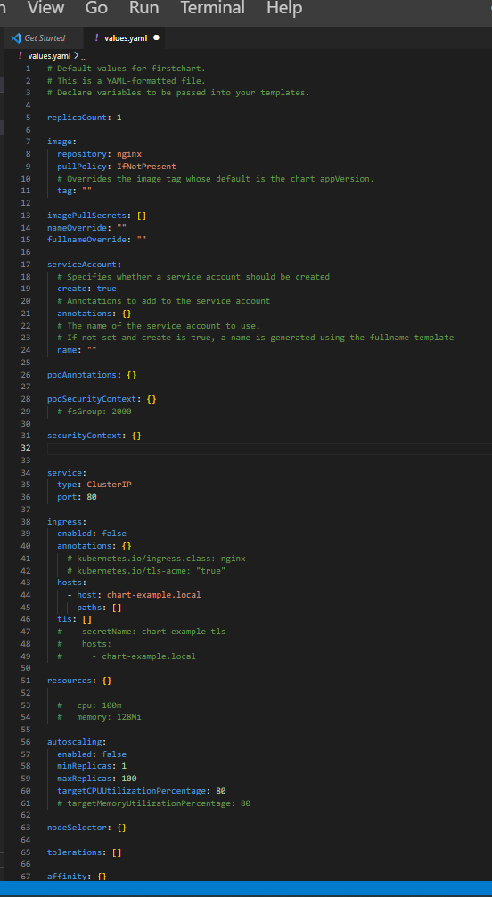

Helm package :

How to package our chart so that it can be distributed or shared though repository.

It can be use to install s/w across env

**Package a chart**

**Helm package firstchart** (chart folder name)

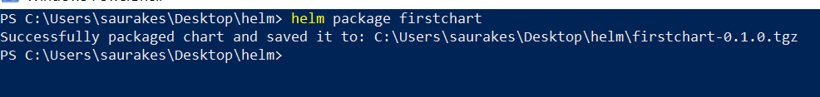

And saved it to current directory

Chartname-version.tgz

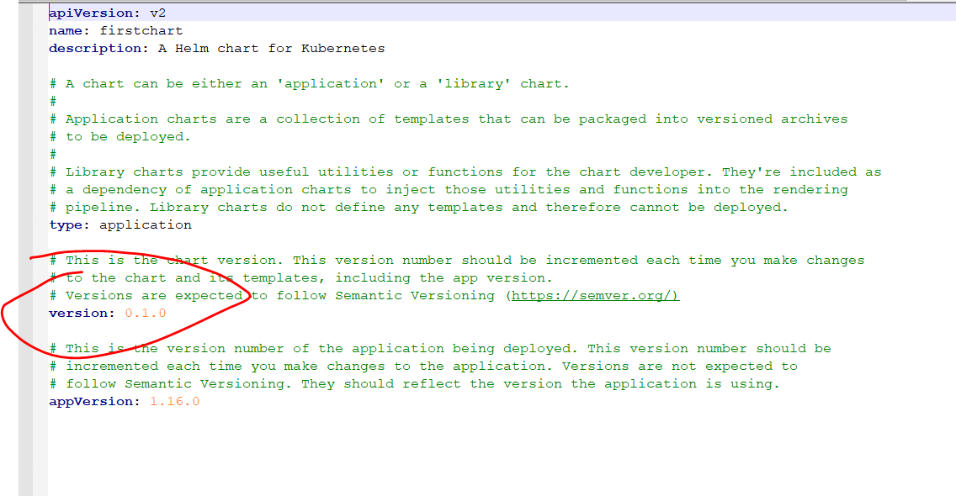

Helm install can work with this tgz and it expect the naming convention that need to be follow.

**Helm package firstchart -u**

It will pull the latest dependency if this chart is depend and put it inside chart folder before the packaging is done.

Those chart will become a part of package and will use during installation.

**Helm package firstchart -d** c://map ( if we want to save tgz file in some other path)

**Helm lint**

Helm lint command will scan through all the templates file and values.yaml file for our chart and it check if there is any issues.

Syntactical or indentation issue

It give three label : **helm link firstchart**

Info

Warning error

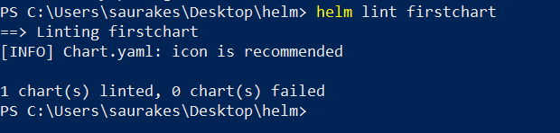

Section 5 Templates Deep Dive

Template are key for every helm chart. The placeholder in the template will be replace with the values in the values.yaml

And the generated yaml will be send to k8s for resource creation.

The template file in the chart will control what resources will be created on k8s cluster and also how they will be created.

Helm uses go templating syntax( wherever we see angular bracket {{ this is nothing but go templating syntax)

Will learn :

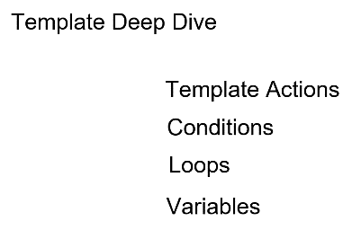

**Template action**

Action start with {{ and also end with }}.

Within these action we can several other element from helm templating syntax such as **defining variable,**

**Using conditional logic if, using loops, invoking function .**

Anything outside this bracket will be render as it is in output but what will see inside action element {{ }} they will be evaluated dynamically.

{{- "helm templating is"}},{{ - "cool"}}

* **Is used to remove any leading or trailing spaces**

**They have hyphen** it will remove unnecessary space which can cause indentation issue

In action element we define dynamic logic. Anything outside this action element will be render as it is and that will be send to k8s

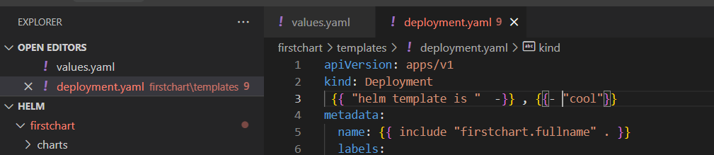

We can test by using command **helm template firstchart**

**Template Information**

When helm renders a template it passes all the information for the template as **single object represented by .(dot)**

If we open deployment.yaml, ingress.yaml **will find .(dot) at the beginning and then Values**

**.(dot)** represent all the information that a template can used and it has sub object like Values**.**

**The sub object Values** contain all the info from **Values.yaml**

**Values** is sub object of **.(dot) object**

1. **.Values ----Values** represent **Values.yaml**

We can create our own **custom tag** also in values .yaml and we can use this across any file

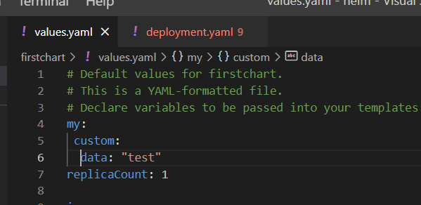

.(dot) represent root element which has all data and Values represent Values.yaml

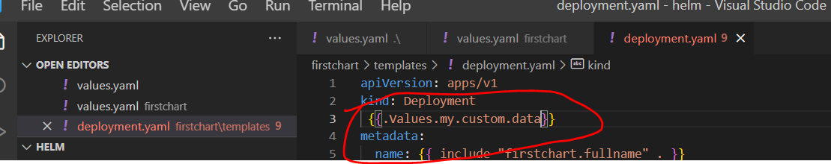

Test it by using **:---- helm template firstchart**

**Note :**

**.Values will be use everywhere across our template files**

**2-We can use .Chart**

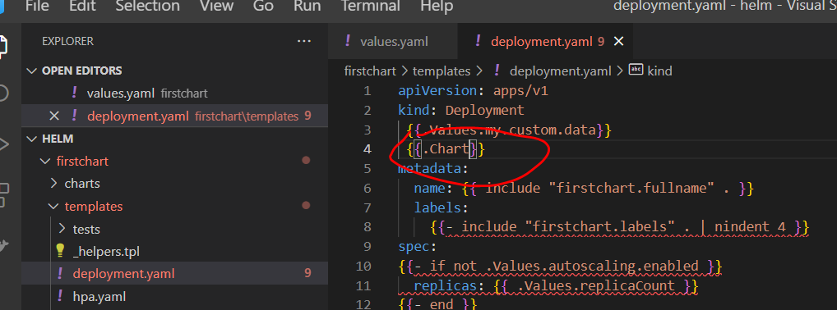

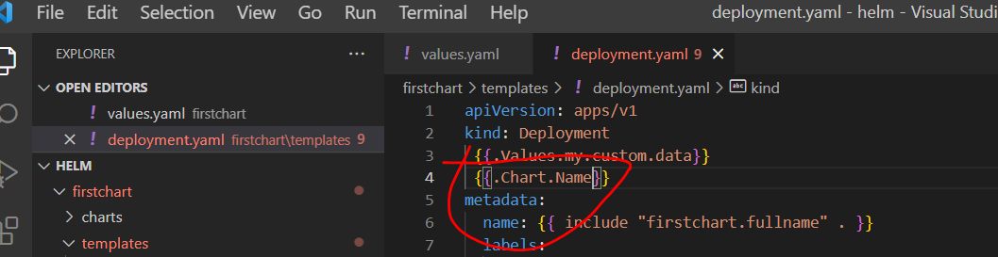

Helm template firstchart

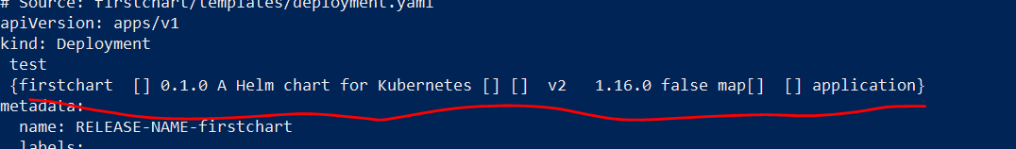

1. **{{.Release}}** ---------- it will give release information whether it is install or upgrade etc

Release.Name :--- whatever name will give during helm upgradation

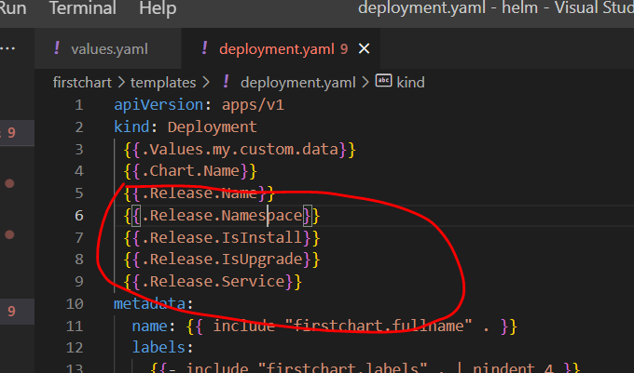

**Helm template firstchart**

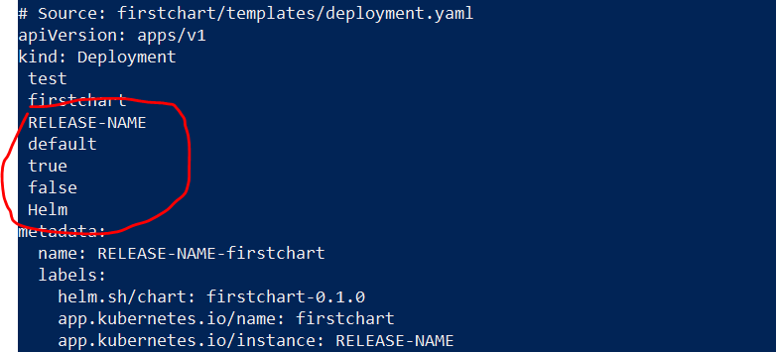

It considered **template as installation : true**

Based on this info we can make dynamic decision for our release and for installation

1. **We can use .Template**

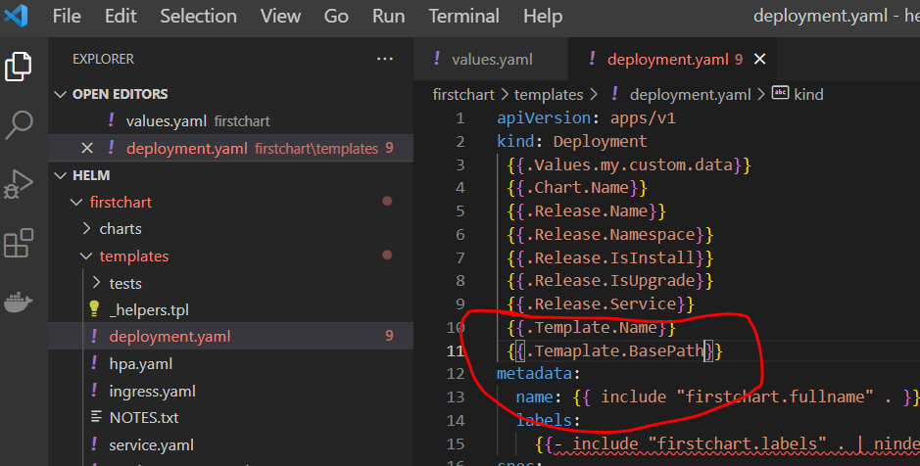

**Helm template firstchart**

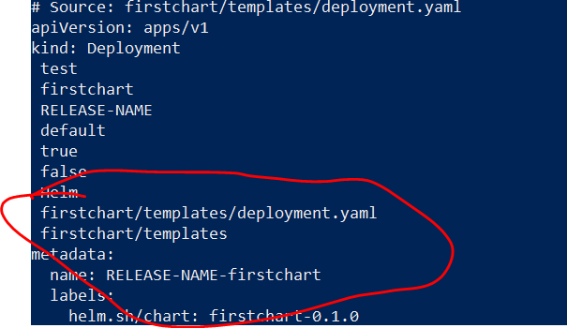

**So we can use :**

**.Values**

**.Chart**

**.Release**

**.template**

**Pipelines**

**|(sysmbol)**  allow us to change multiple expression commands or function called.

The output of function on lhs of this pipe will be pass as input to the function or expression on rhs of pipe.

The output of one command is passed as input to next command

Data value is empty

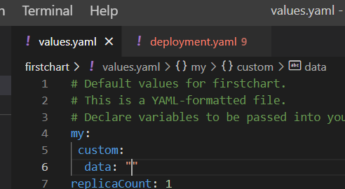

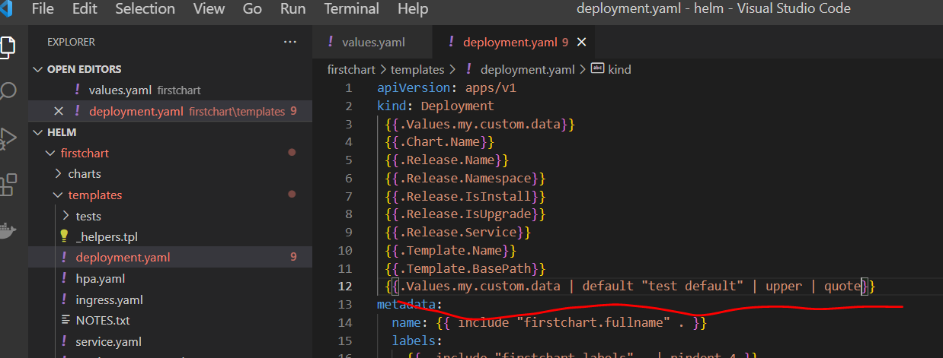

**Helm template firstchart**

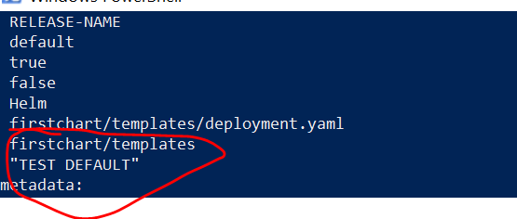

**Quote will give quotation**

**Functions**

Helm give us various template function that is use to transform the data within our template

We have already seen some function default , upper etc

**Nindent** 4:---

new line indent ---add new line and also as many number of spaces we provided.

Here 4 is the argument which we passing to nindent function. So it will add 4 space along with new line

toYaml :-

when we get data from values file chart file we get it as object. This toYaml will convert the current object into yaml.

So that it can be push to output as yaml

**Use Conditional Logic**

On these values we will perform conditional check

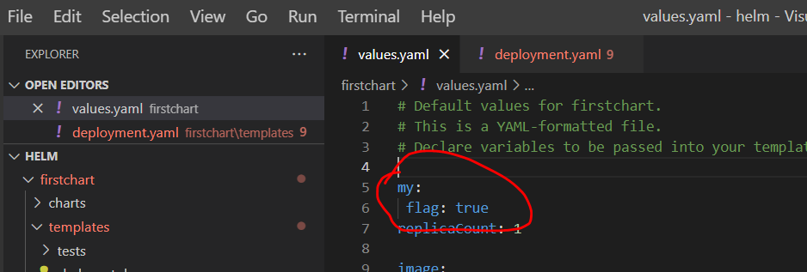

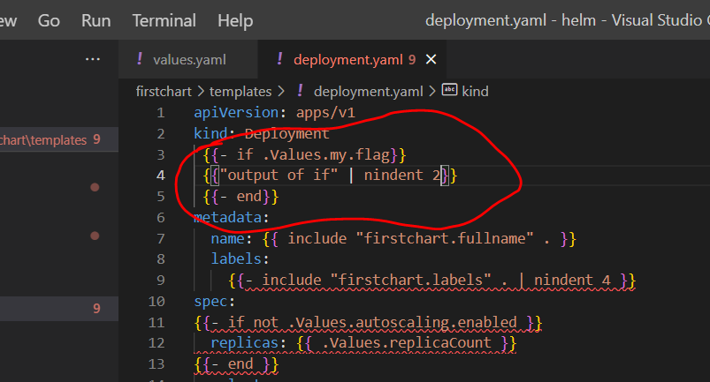

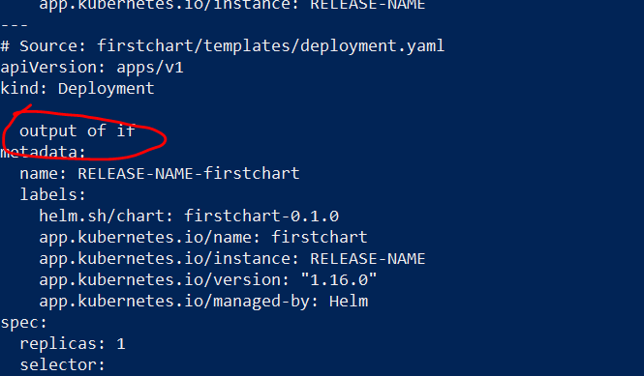

We can also use else

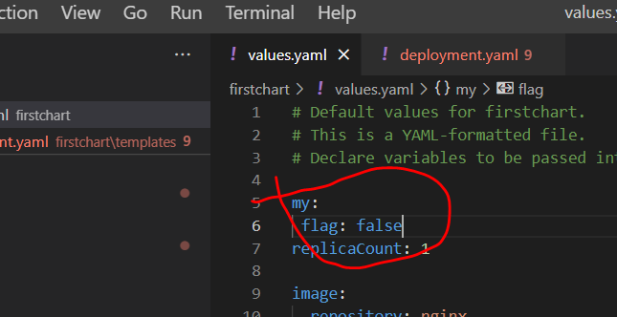

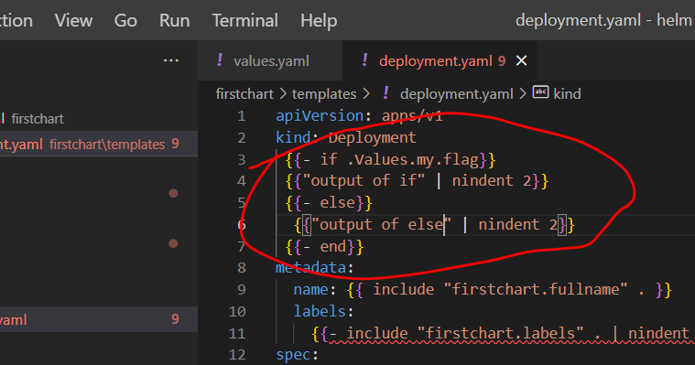

Helm template firstchart

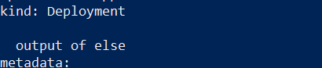

If not ---------same as ! Operator

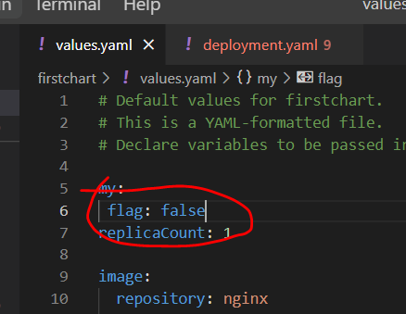

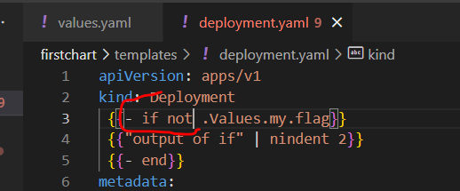

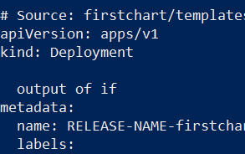

**And and or equivalent to && || in helm chart**

**Use With**

How to use **with** conditional block

With :--- whatever we will be placed within with block will be a part of that only if values is a part of list

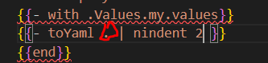

**.(dot) scope here current element which we are checking using with** so .(dot) here point to current element which is values.

We can have our own yaml element within with block

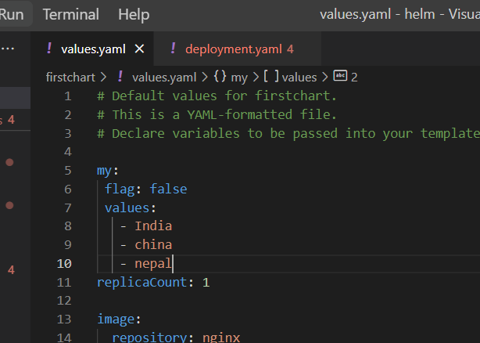

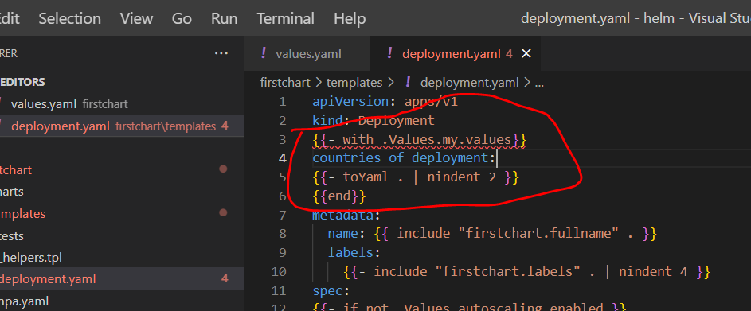

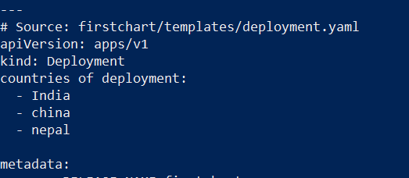

We can also use else using with if element of value is empty it will execute

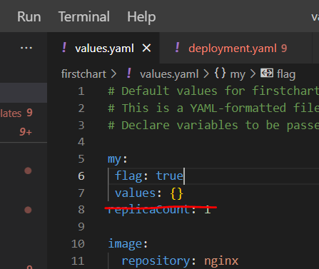

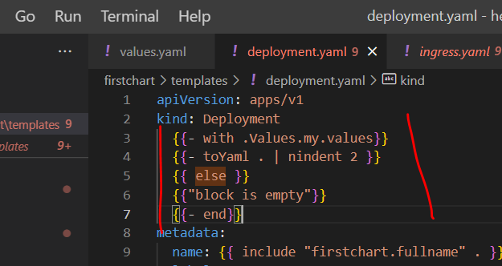

Helm template firstchart

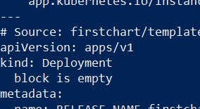

**Define Variables**

How to define variable and use it in template.yaml file

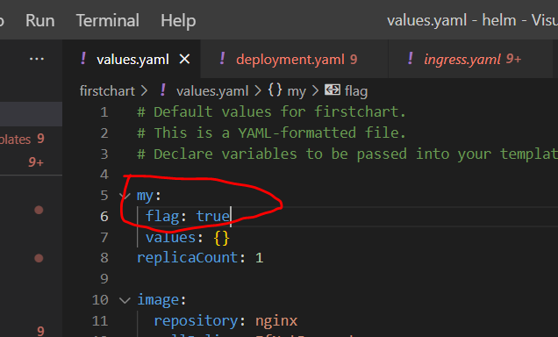

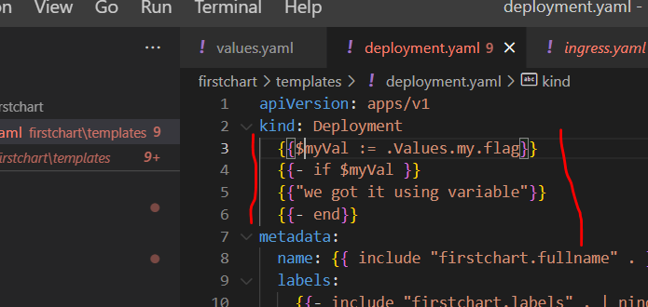

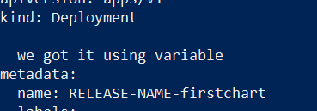

**Use Loops**

**How to use loops in template yaml file**

**We can do it using range ---**

**. ------**represent one value at a time

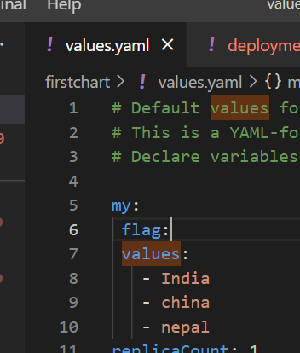

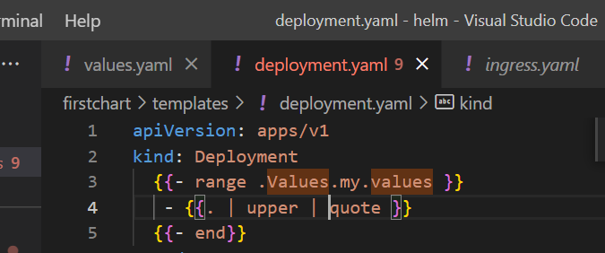

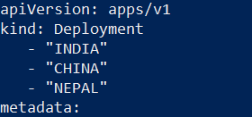

**Loop Dict Types**

**Dictionary :--- key ,value pair**

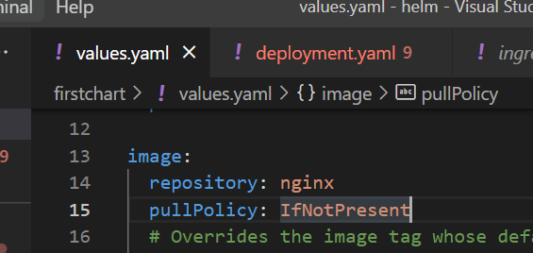

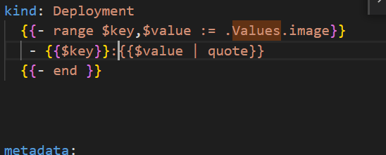

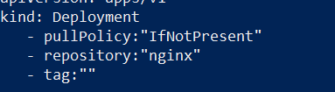

**Debugging the template**

**We already learn how to run dry-run command during installation**

**Objective :**

Now let use to debug our own template

**Dry run command is very helpful to debug template**

Remove one bracket :

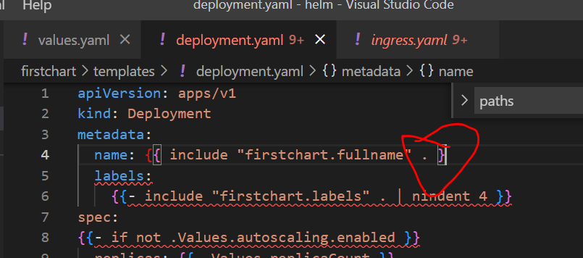

Will get this

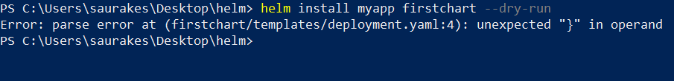

Dry run will also do schema validation

Lets take out kind

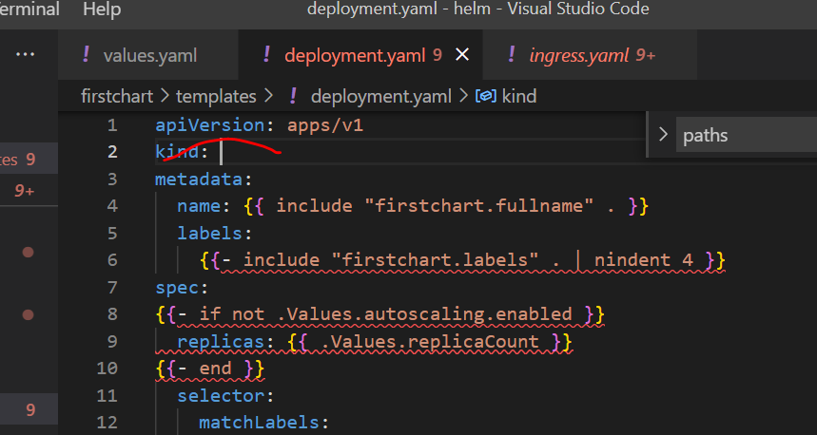

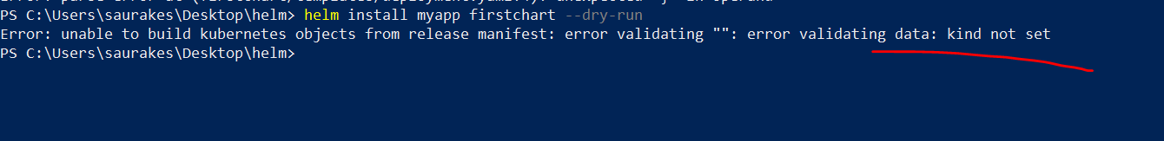

**Helm template firstchart :----** will not do validation but it will check syntactical issue

**Helm get manifest**

When the installation is done ,

**helm get manifest firstapp :** this is manifest file will send to k8s

**_heplers.tpl**

**.tpl stands for template** because this file **host several template fil**e that can be used across the template files

Every template file start with comment and it explains what this template will do.

Template is like function in programming language. We can reuse it and it be reuse within .tpl file as well.

A template begin with define keyword in the action block followed by name of template

Firstchart is unique namespce (like package in java)

**Within define and end block we define entire logic here**

**If we provide**

**Template can be reused across other file**

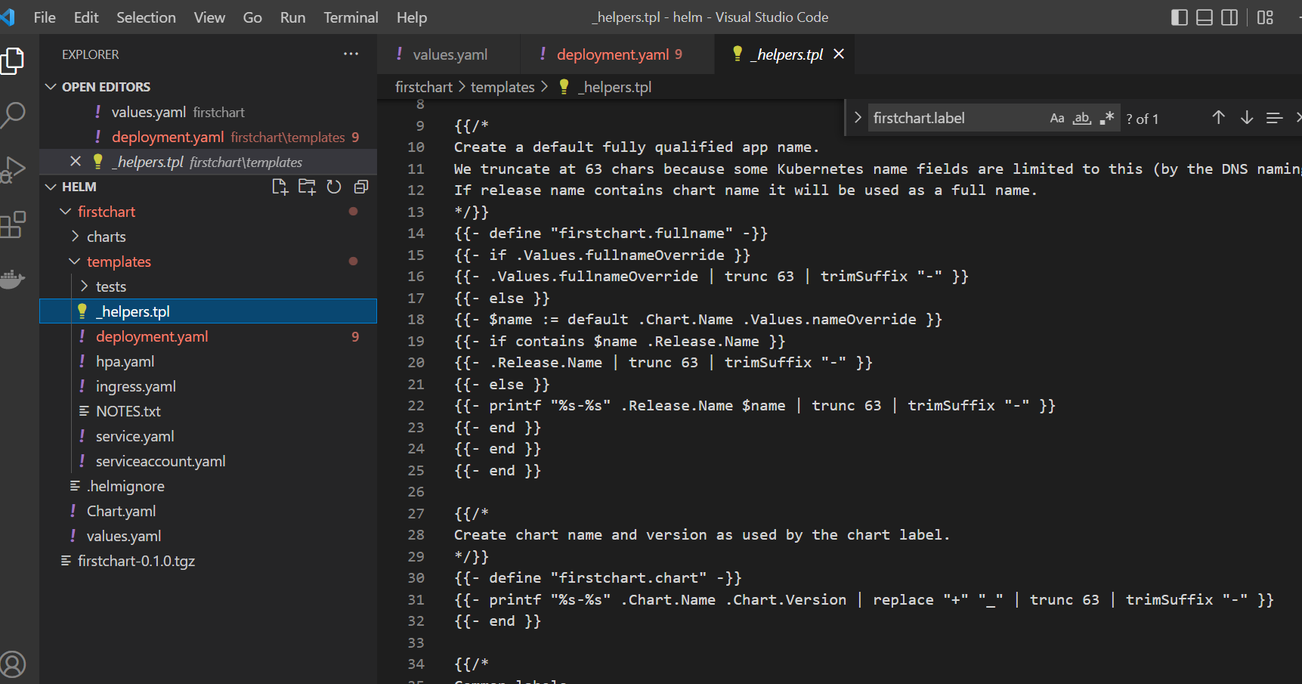

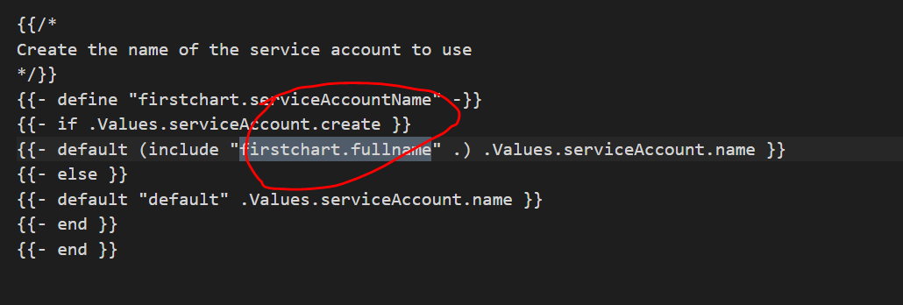

We can use firstchart.fullname using include or template .

The diff is that with template we cant use piping

**Create and use custom template**

How to define our own template and use them

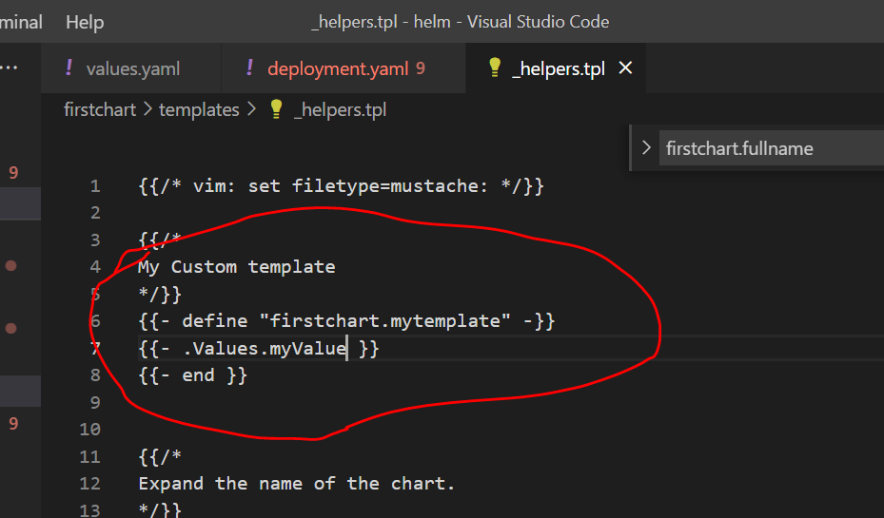

Now we can include this custom template in any other template file and it will return value : test

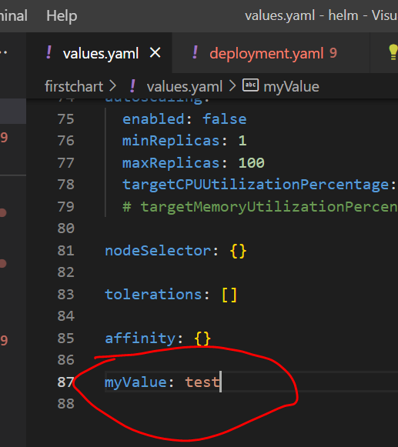

With template we cant use pipeline while with include we can use pipeline.

Note :

We can use both template and include

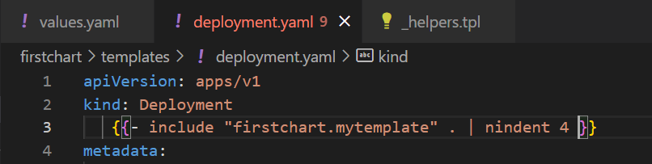

We can pass default also

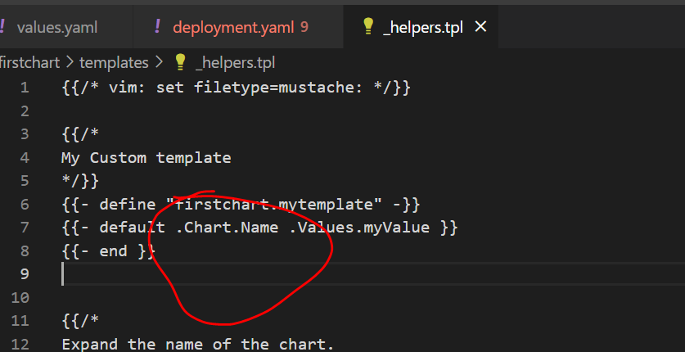

Remove myValue

// output:-

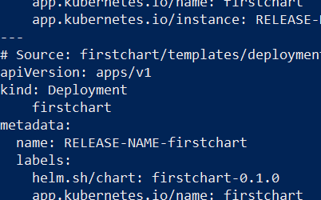

Section 6 Advanced Chart

We can define mysql as dependency inside our application, when we pkg our application mysql chart will also be included in that.

To deploy this pkg chart helm will automatically release mysql as well as our application. Our app will start using mysql which is running

In kube cluster.

Will also learn how to exchange value from main chart to the dependency chart and from dependency chart to main chart.

Will also learn what helm hooks are and will create our own hooks and will learn how to configure and use a hook.

Will also learn how to test our chart and our release are ok.

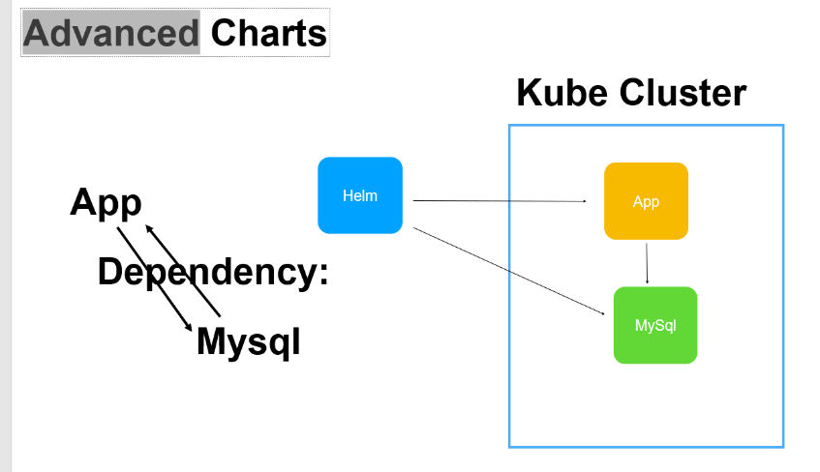

**Add dependencies**

Will learn how to configure and use chart dependencies

Want to add mysql as chart dependencies

We need to add this in chart.yaml

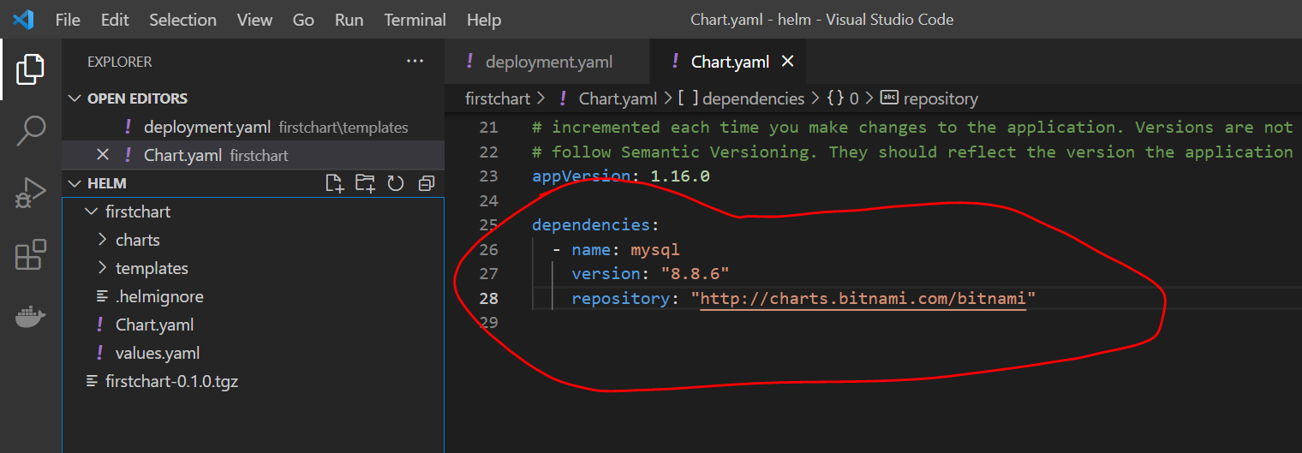

To pull the dependency and start using it

**Helm dependency update firstchart**

When we execute this command it will look dependencies section in chart.yaml and update or pulls the dependencies

After running above command mysql will get downloaded

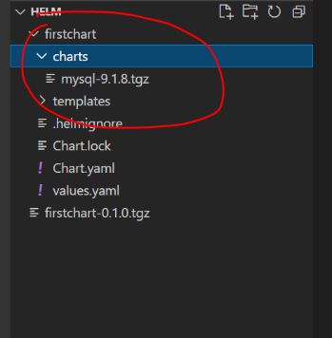

**Helm install myfirstapp firstchart**

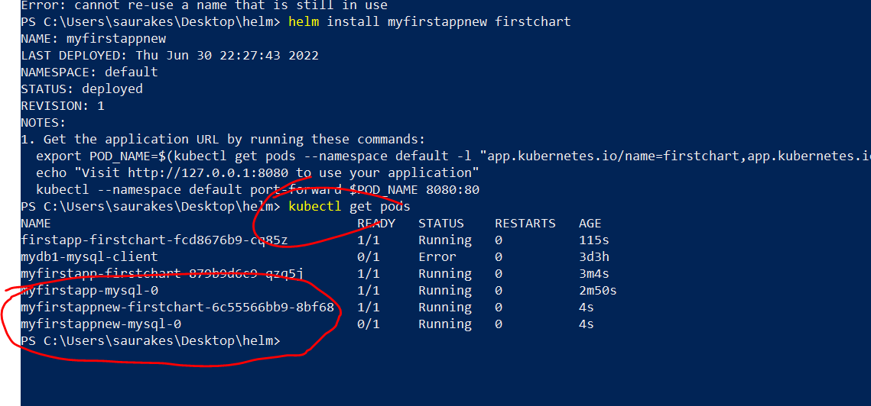

Not only application pod is created but mysql pod is created as well.

Automatically dependent chart(mysql will be use)

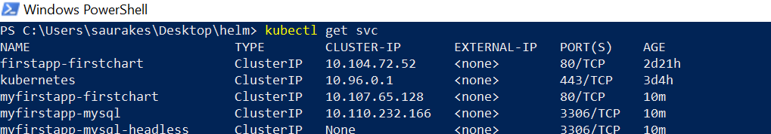

We did not install mysql separately. We simply added chart dependedncy

**Using Version Range**

**Note:**

We can also use range while adding dependencies in chart.yaml

We can define range , helm will automatically pull

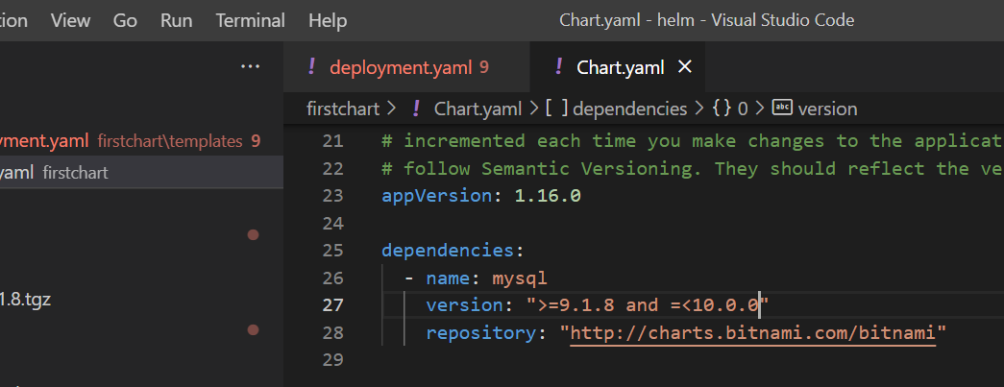

Depending on the latest version available that will be pulled by helm.

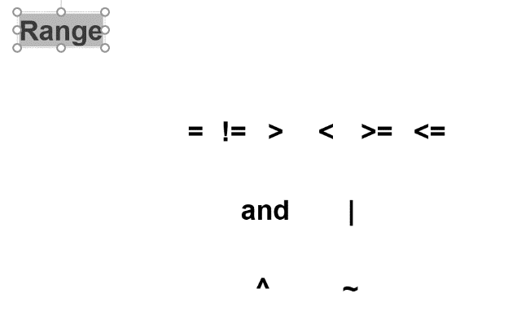

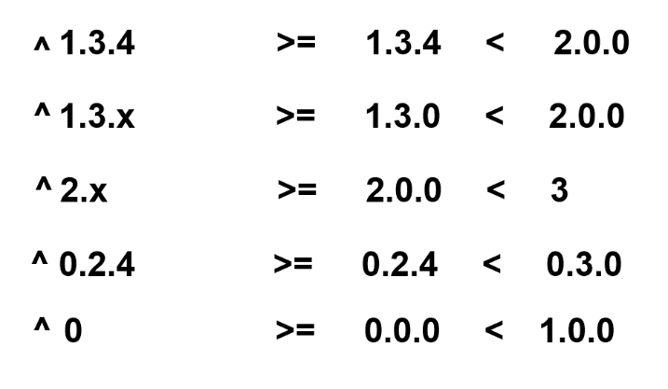

If we use carot symbol it will go to next major version.

**Helm update dependency** will pull version based on the version will provide in chart.yaml

**Note** :

**Chart.lock** will create by helm which will be use across environment . It fixes a particular version when we will do helm update

Dependency.

**Using repo name**

It is recommended to use url in repository

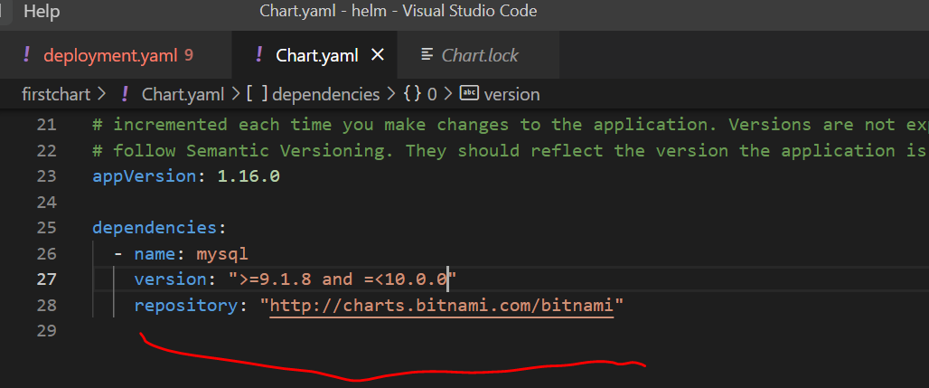

**Use dependencies conditionally**

When we define chart dependency and we have dependent chart under chart folder it will be used when update or install chart occur

And it will also install in k8s cluster

**But if we want this to be happen on conditional which will be passed from values.yaml**

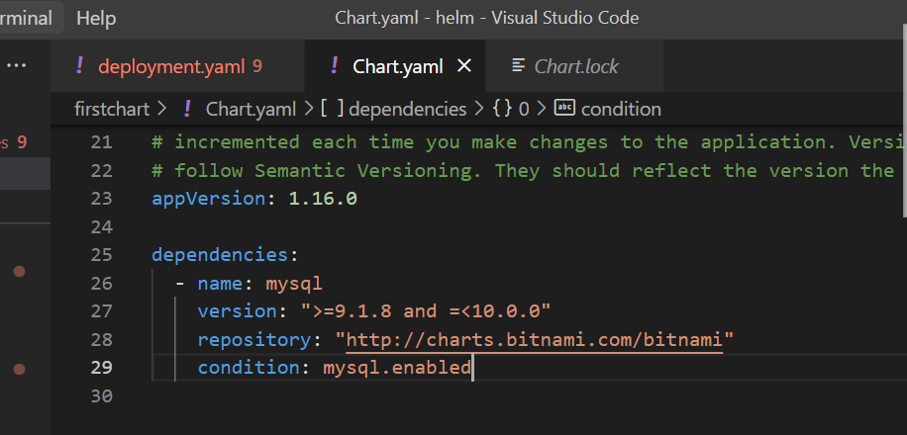

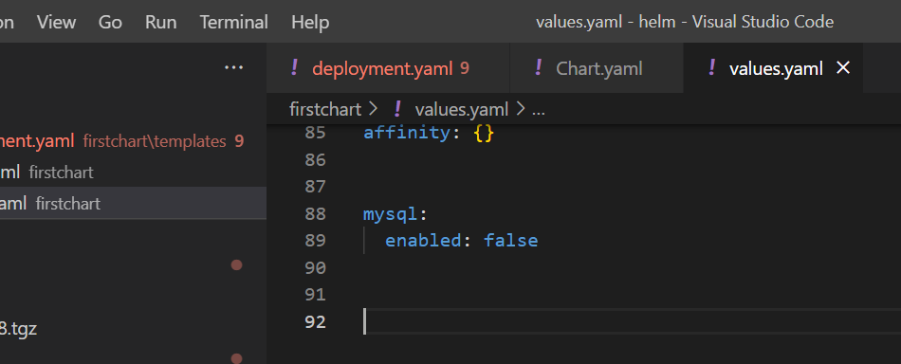

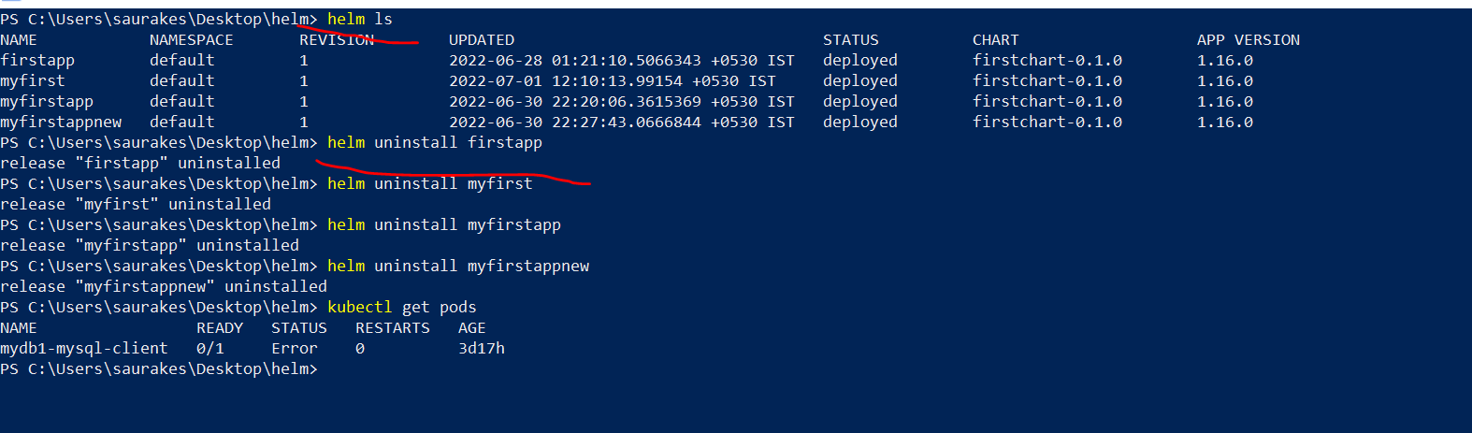

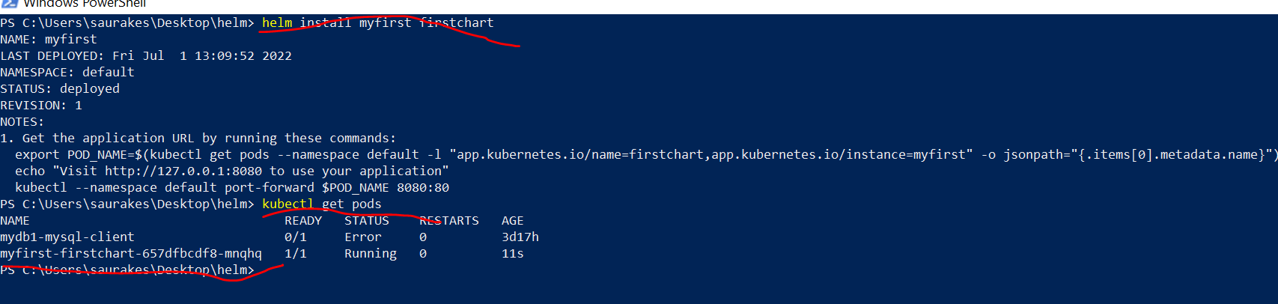

Mysql not installed now

**Note** : that's how we can conditionally controlled dependencies

Now change to true :

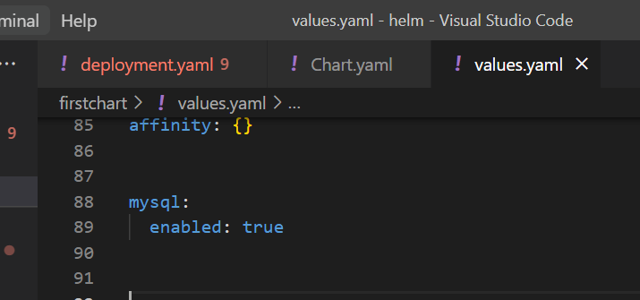

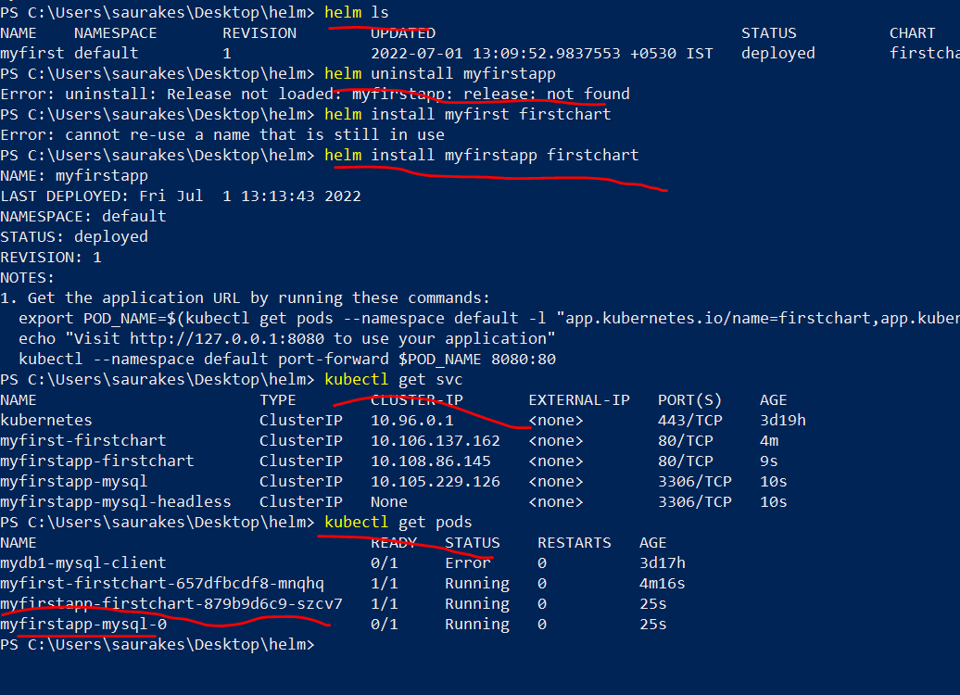

**Use multiple Conditional Dependencies**

We can use **tags** for multiple dependencies

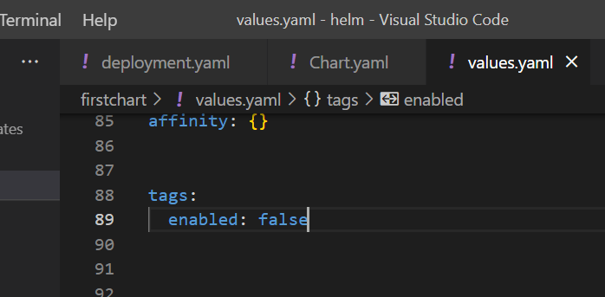

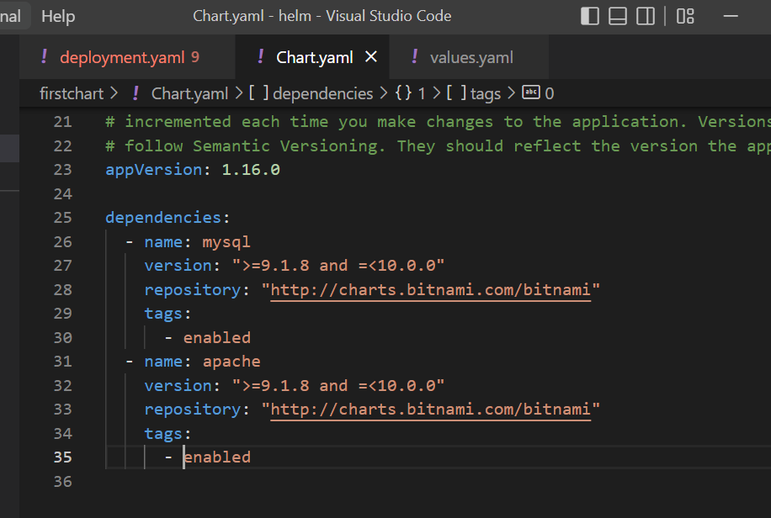

Let test this one

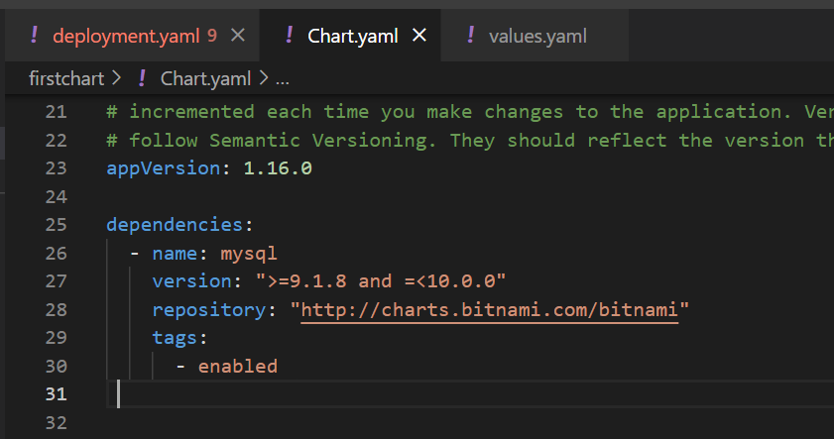

No mysql

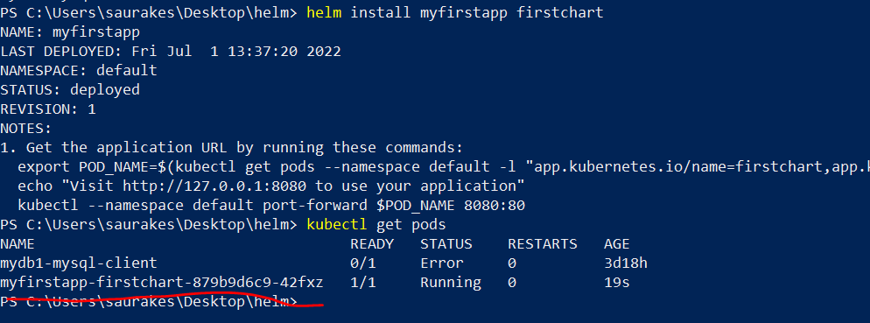

**Change enabled to true**

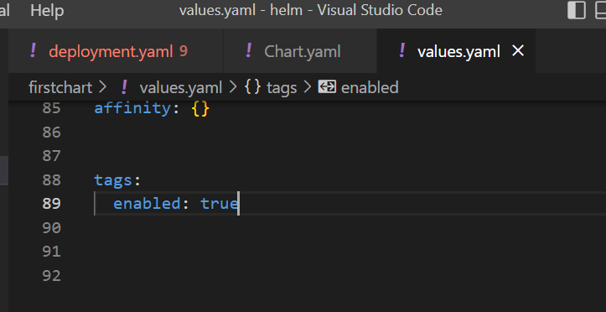

Will get both application and mysql chart

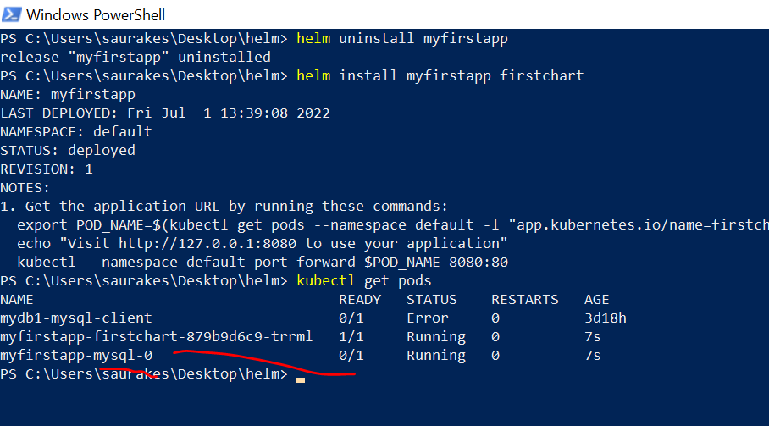

**Pass value to dependencies**

**Note :**

We can pass value to dependent chart from main chart

**By default it is cluster ip**

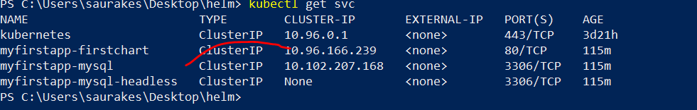

**We can override dependent chart value mysql from main chart**

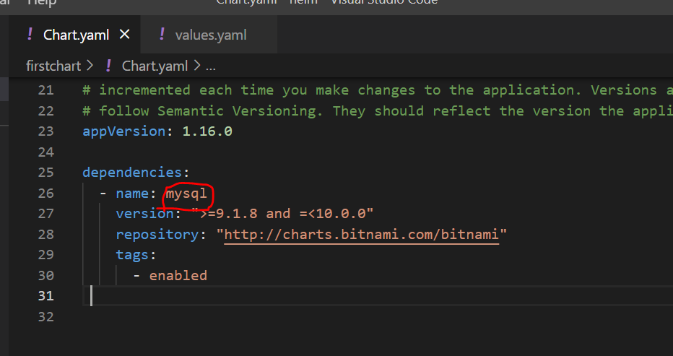

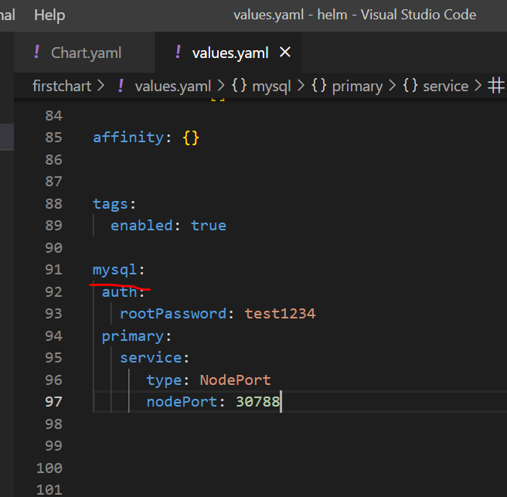

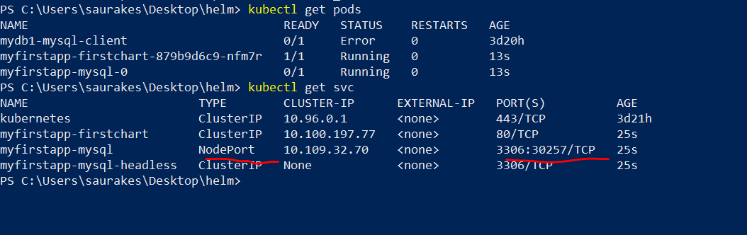

**Read Values from child chart**

**Objective :**

How to import value from child chart to parent chart

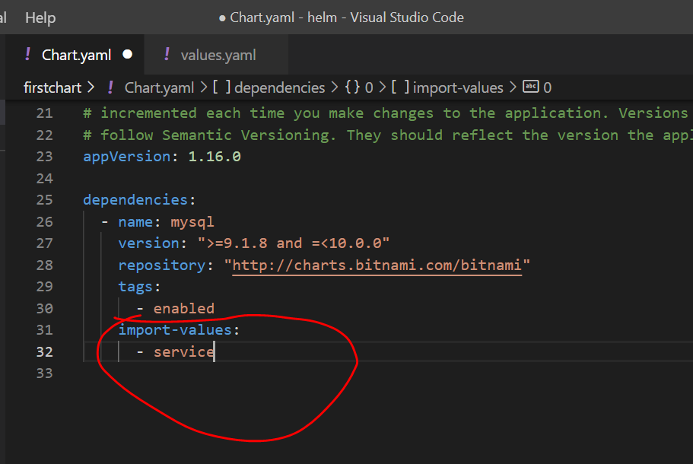

**We can use it in two ways**

By using import-values it will be available in values.yaml and we can use it in any other file like deployment.yaml

.Values.service like this we can use it.

**Use value not exported**

How to use value from child chart even if doesn't explicit any values

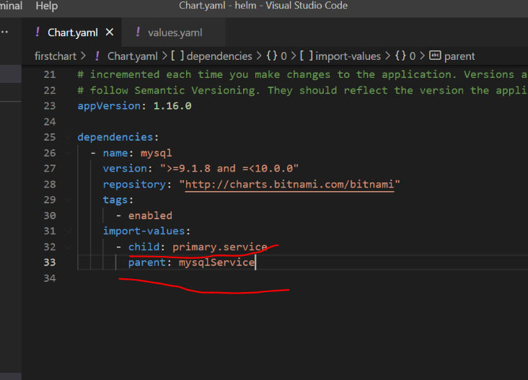

Now child element will be present as mysqlService . This will be present in values.yaml

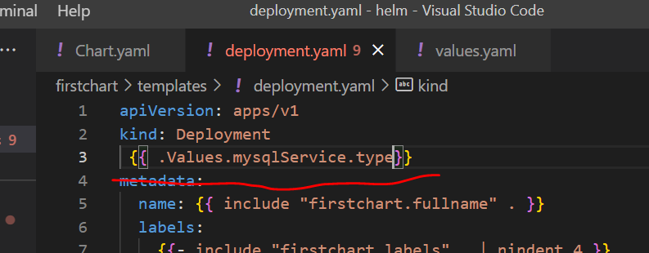

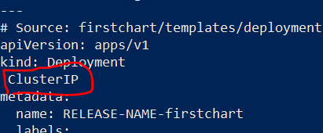

In template we can directly use

**Hooks**

**Objective :**

What helm hooks are and use them

If we want to take some special action during helm release process then create a hook.

Example :

We can store some data to d/b

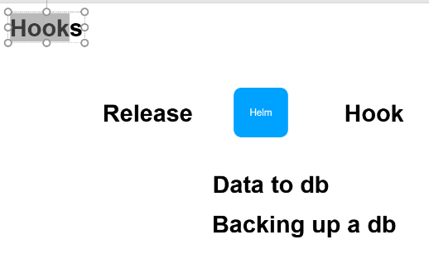

A hook is just like any other template file under the chart templates folder.

Hook will be marked with annotation .as soon as helm see in metadata (hook) it will treat them as hook.

They will not be used when installation happens but we can configure when these hooks should be created

**Pre-install** :-- before all the process happen this hook should be run

We can create different type of resources not only pod, service ,deployment etc.

We can configure hook for different lifecycle phase.

Pre-install

Post-install

Pre-delete --------before uninstallation happen

Post-delete------after uninstallation happen

Pre-upgrade

Post-upgrade

Pre-rollback

Post-rollback

Test

When this hook should cleaned up : three policy

**Before-hook-creation**

**Hook-succeeded**

**Hook-failed**

**Create and use a hook**

**Objective :**

How to create and use a helm hook

This hook will create as a resource type pod.

The name of container can be anything.

To make this hook add a annotation section

 annotations:

    "helm.sh/hook": pre-install

It tell what type of hook it is

When there are multiple hooks, the hooks is executed in ascending order , hook-weight we provide

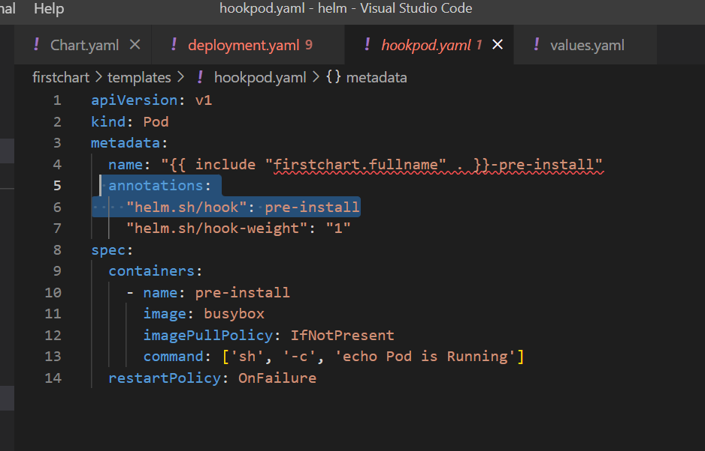

**helm install myfirstapp firstchart**

When we will execute this command it will scan template directory and it will find hook and it knows that this resource should be used as a hook and we provided when this hook should be installed

This time we get three pod is up and running

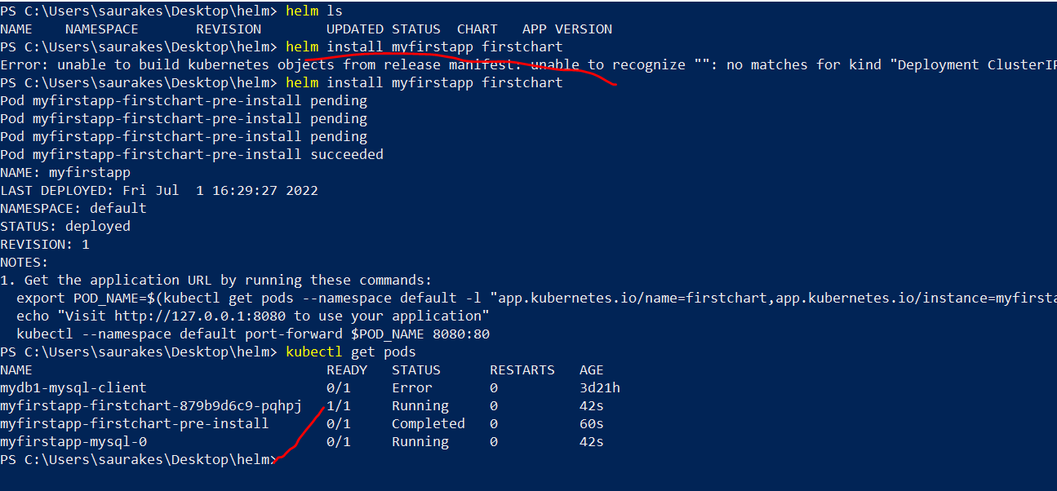

Before-hook-creation that is default value :--- if we don’t provide any hook value

**This time we are running with different hook policy**

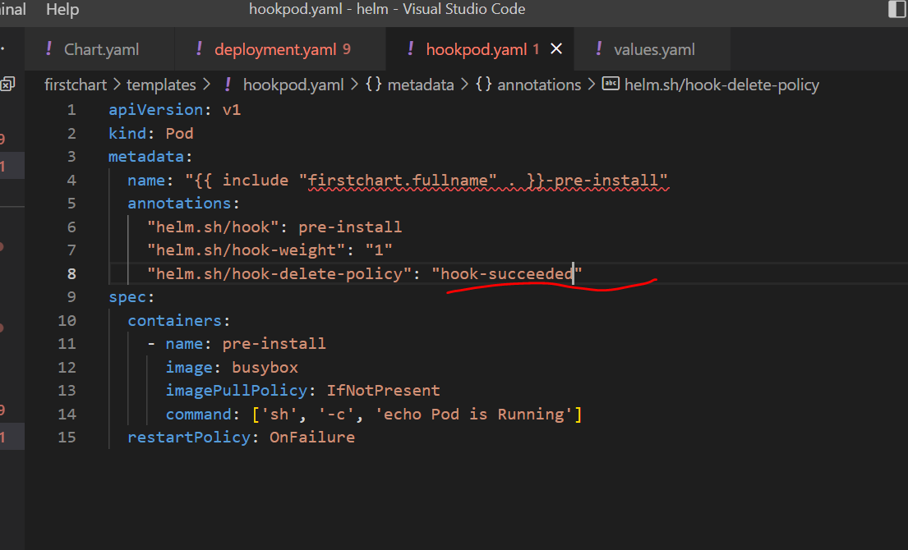

We are not able to see pod since this time it will get deleted

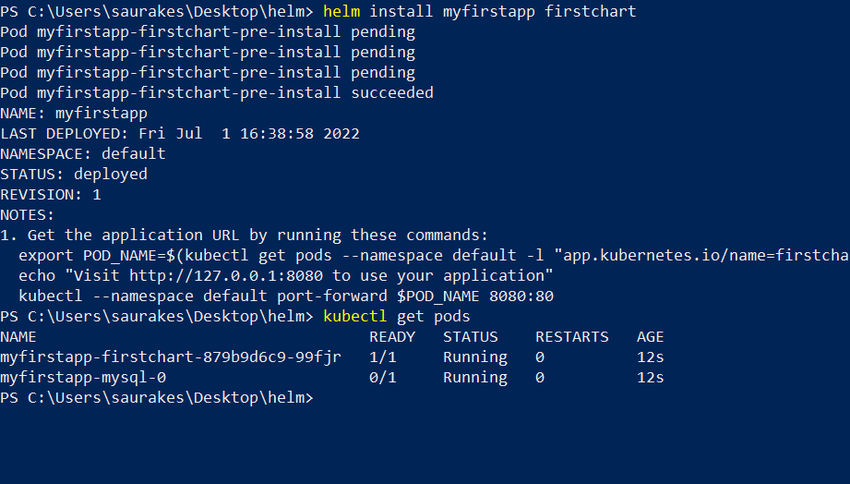

**Kubectl describe pod pod name**

**Testing Introduction**

**Objective :**

How to test chart

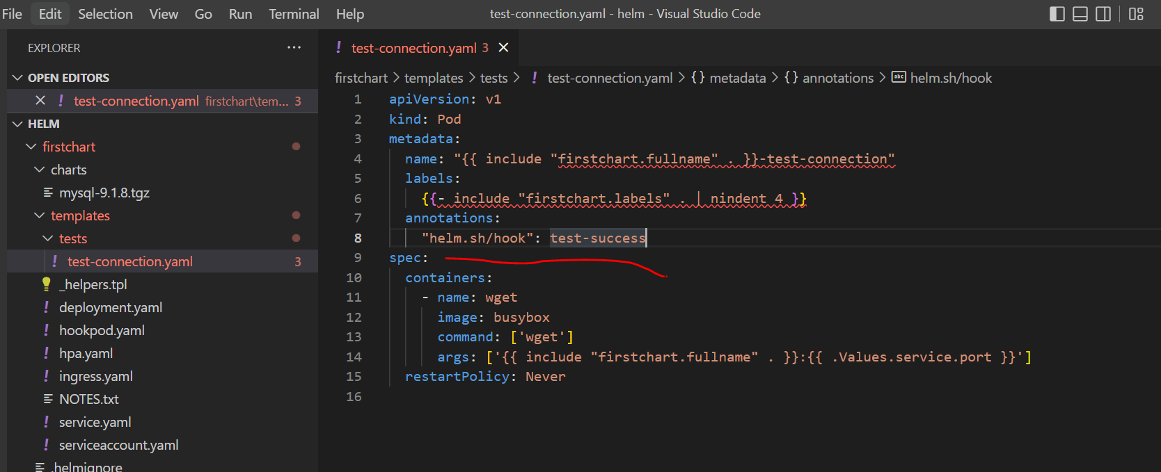

This guy will be enabled and use only when we run **helm test** command

When pod is up a command called wget is used and it will connect to service and port number (**firstchart.fullname is service name**)

**If the connection is successful and wget return 0 value means the release has gone successfully**

**If wget return a non zero it means the test is fail or unsuccessful**

**Test your chart**

**Note :**

Helm is always against the release not the chart

**helm install myfirstapp firstchart**

Now run test

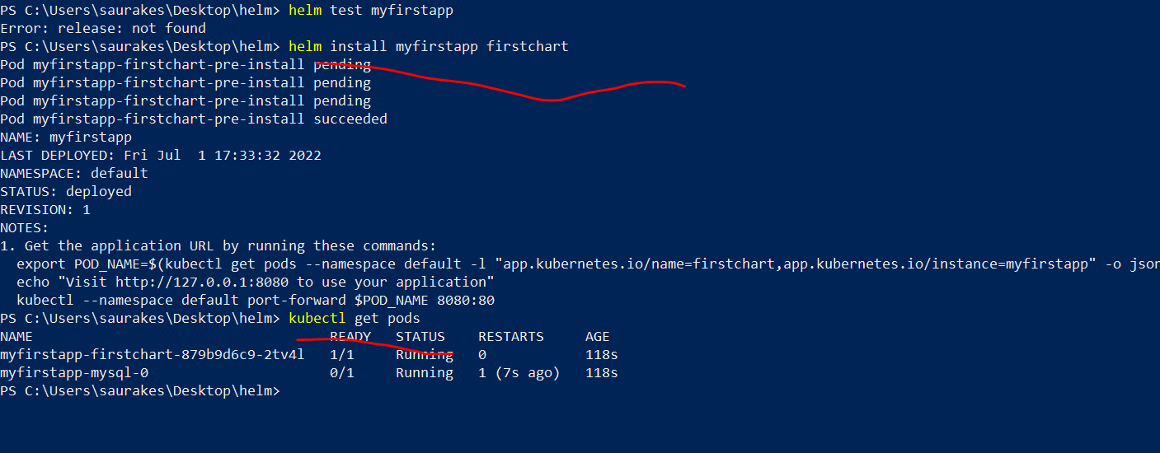

There is no test since hooks Is not enabled

**Helm test release name or installation name**

Now the helm test will be enabled and logic which is defined in test will be executed.

This logic is for nginx because by default the chart is for nginx and we are trying to connect to nginx service port

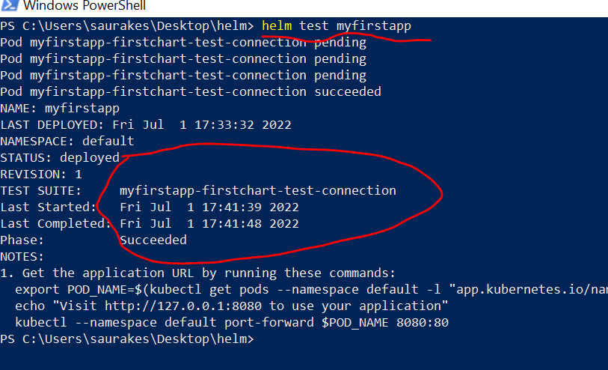

Now there is additional pod that got created when we run our test

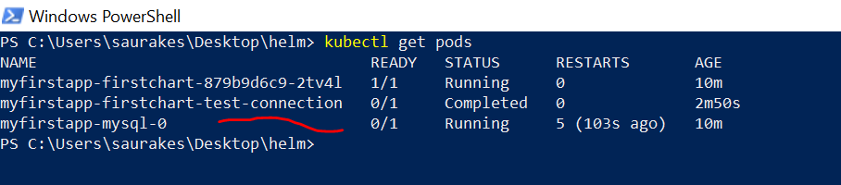

If test fails we want test pod is still there

For testing release name should be there

Kubectl describe pod podname

Section 7 : Repositories

First create repository

Then run in python server

Then create our own repository

**Introduction**

Repository is having index.html while will have all the info abt all the charts in the repository.

Will learn how to generate index file using helm command

Will host a chart repository locally using python webserver

Will also learn how to host public chart repository free using github pages

We can also store helm chart in repository like oci repository and images in oci (open container initiative)

So will launch oci container locally and use as oci repository

**Set up a local repository**

**Objective :**

How to create and use a local chart repository.

The repository should have index.yaml file . We can create manually or go to command line

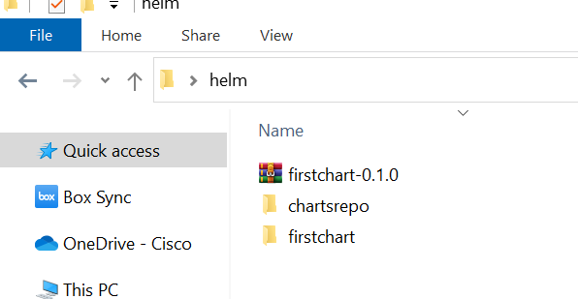

**'**

**Step 1 :** create index.yaml file

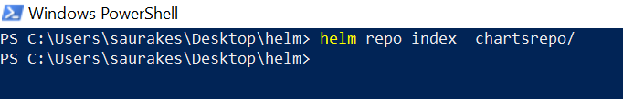

Now let add our first app to this repository

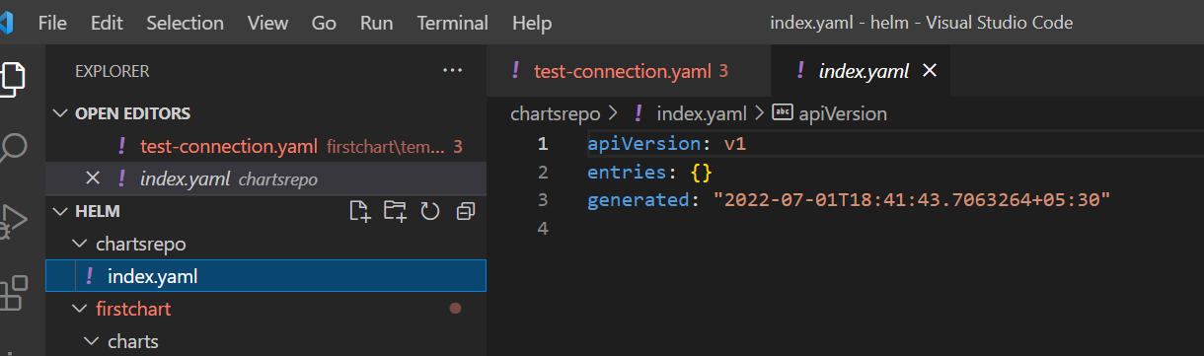

**Step 2:--- first package the chart**

**helm package firstchart -d chartsrepo**

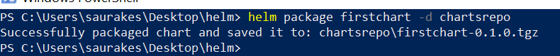

Now it is under charts repo along with index.yaml

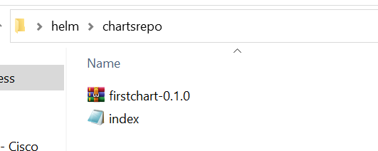

Now we have to update the index.yaml, this index.yaml still does not have the details of the chart we have push under the repository.

To update index.yaml

**Step 3:**

**We need to run :---helm repo index chartsrepo**

This time it will look firstchart and update the index.yaml with firstchart info

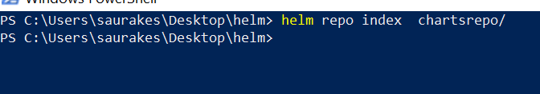

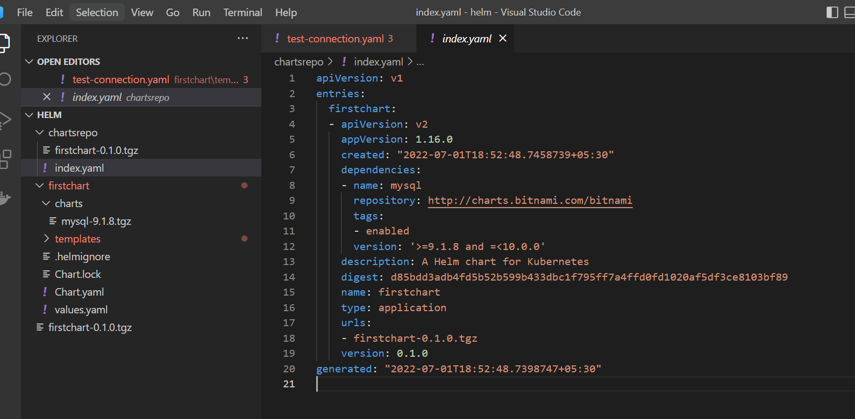

Now it has entire chart info so anybody can look this index.yaml file and can know about the chart info

**Install Python**

When we install python it come with inbuilt server

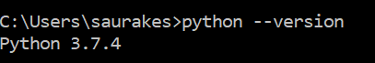

[Manage App Execution Aliases](https://www.tenforums.com/tutorials/102096-manage-app-execution-aliases-windows-10-a.html)

Search it in windows and turn it off app installer

**Host the repository on a web server**

**Objective :**

How to host our helm chart repository so that it can be access through http url

We can use webserver like nginx or apache or s3 but for this demo will use python

Note :

Python comes with inbuilt http server



This http.server will start on local machine and it will start serving the content

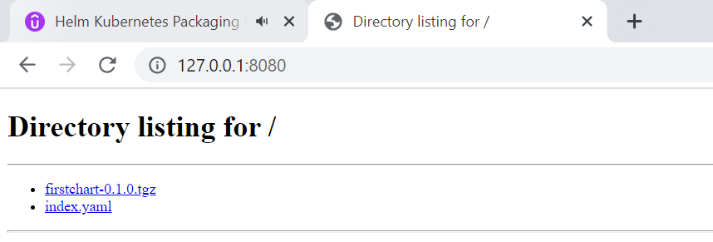

But we rarely uses like this will use command line to pull the chart and use them for releases and installation

**Use the repository**

How to use helm repository that we set up locally on machine

To add our own repository :

**Helm repo add localrepo** [**http://localhost:8080**](http://localhost:8080) where our webserver host and repository is running

**Now this is the url to our repo**

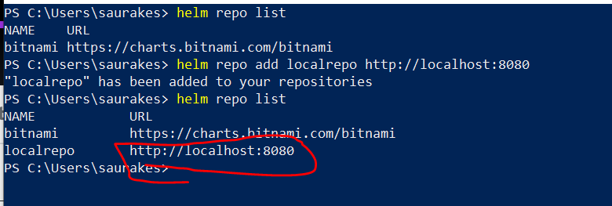

**helm install firstapp localrepo/firstchart --------localrepo ----**repository name **and firstchart---**chart name

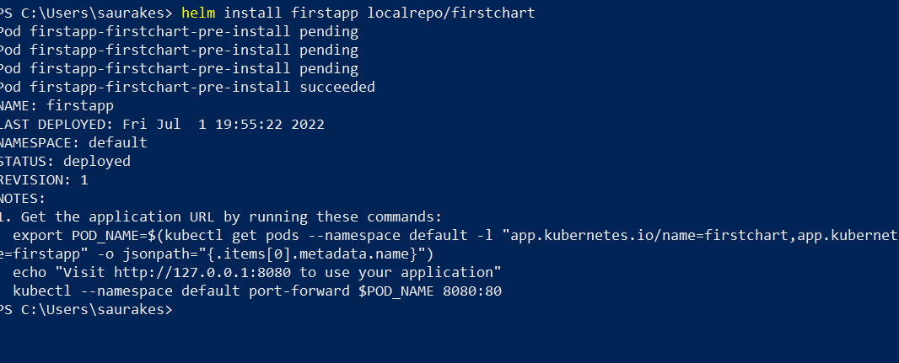

We can see index.yaml is pulled and first chart is pulled

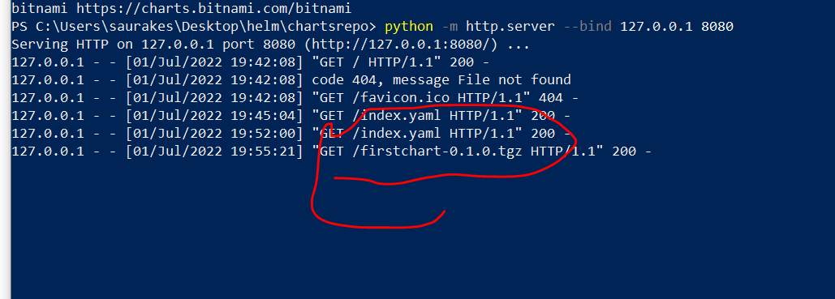

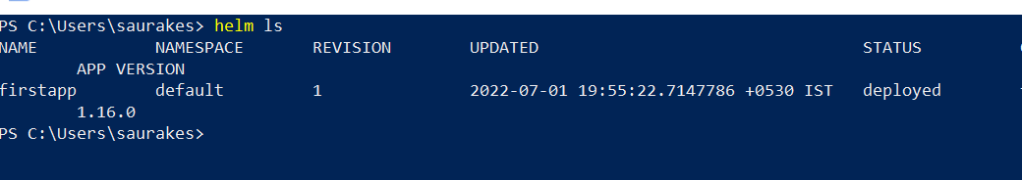

**Install using helm pull**

Will learn another way to pull the chart from the repo

**helm pull localrepo/firstchart**



After running the pull command firstchart will come

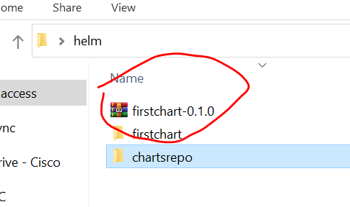

This was pulled from our local repo

Now we can use this chart to install.

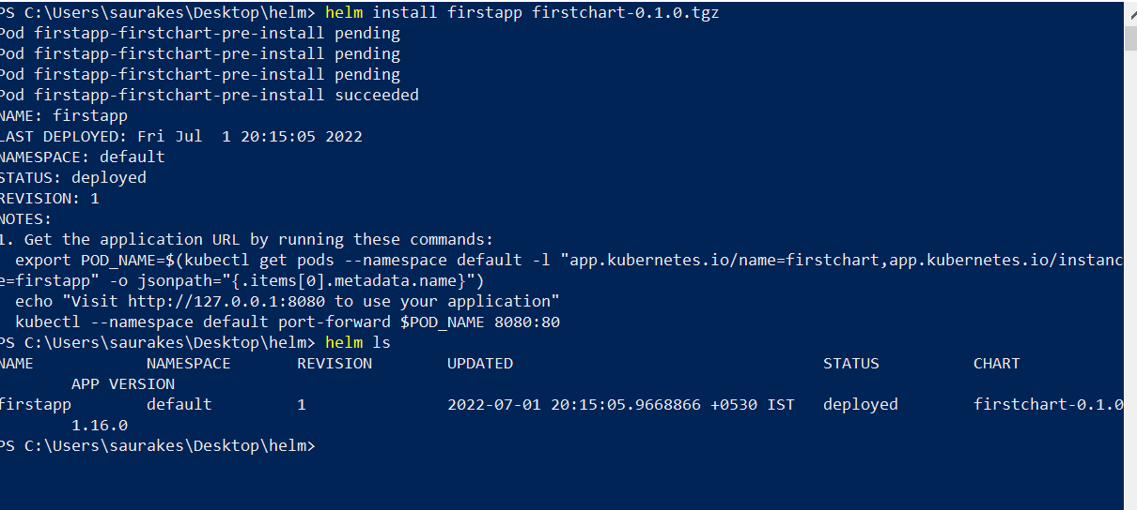

**Update repositories**

**Helm repo update :--** it will update all the repo we configured

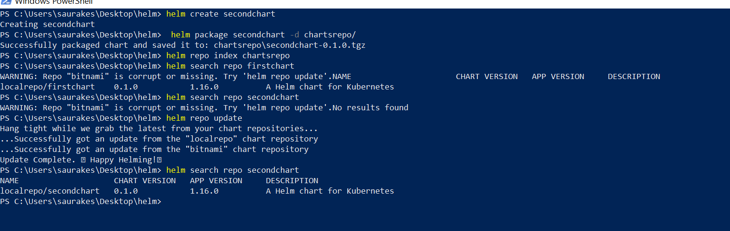

It will clear local caches and pull the latest repo

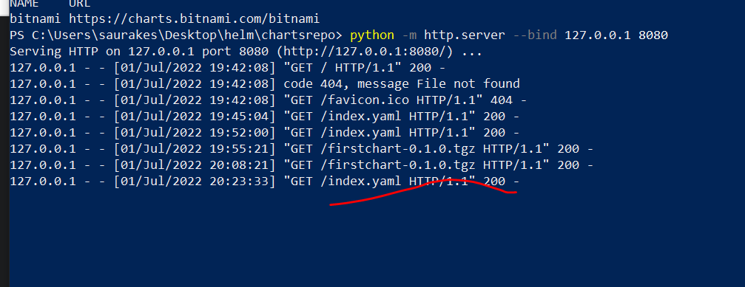

It pull the latest index.yaml one more time

**Use Github Pages**

**Objective :**

Want to host chart publicly use github

Create repo gitchartrepo

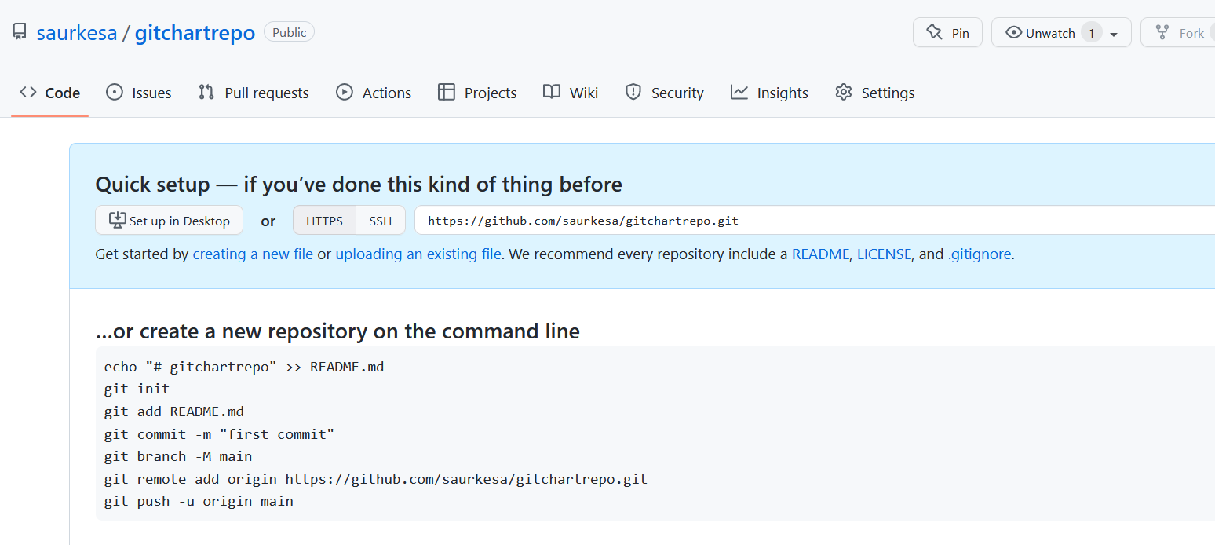

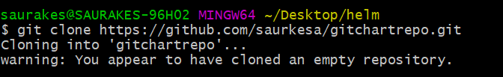

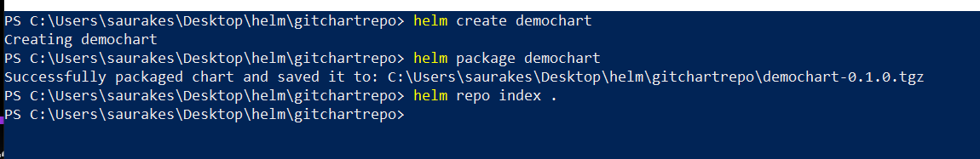

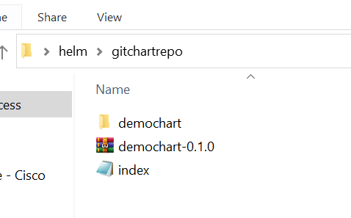

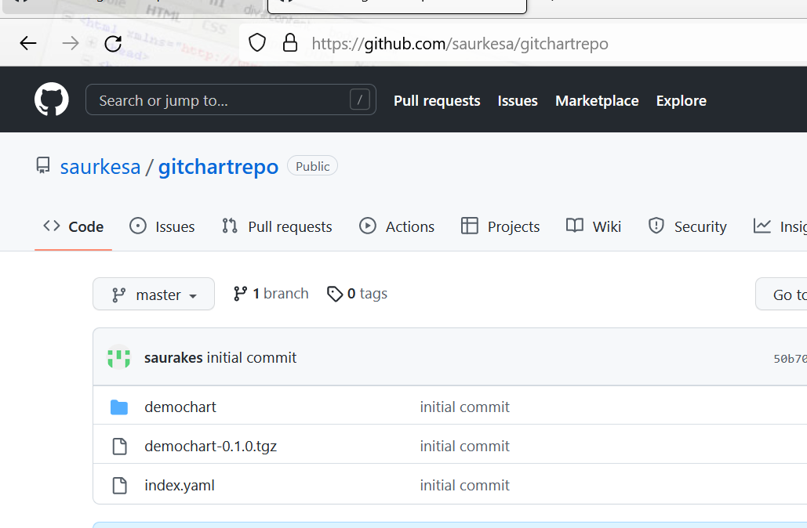

We use gitchartrepo as a repository :

**We have to do one additional step**

**Github/setting/pages/**

**Everytime commit will happen this guy will work as webserver**

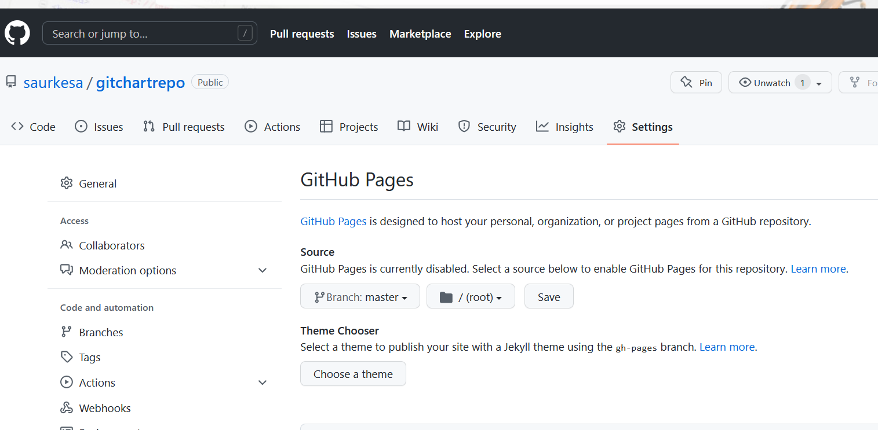

Now we are hosting a repository using github pages.

Everytime is commit the latest will be pulled by user

Save it

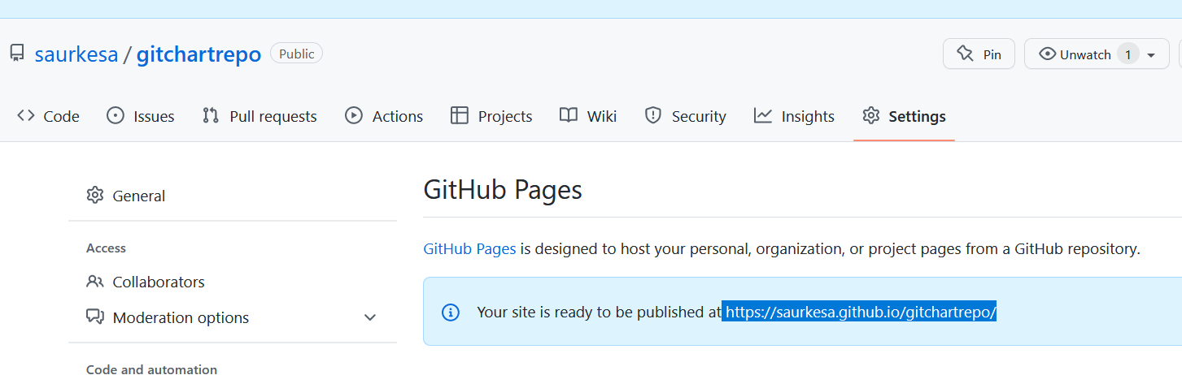

We are adding a new repo but this time on github



**It will pull the index.yaml file and it will added locally in gitrepo**

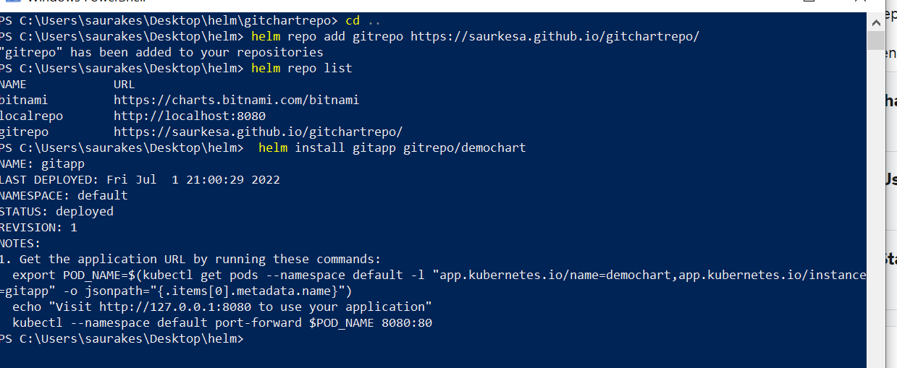

**OCI Repositories**

There is no concept of namespace or isolating these chart with namespace in index.yaml.

Once the user have access in repository he can access all the chart in the repo.

To resolve above issue helm start supporting oci registry starting 3.0 which have addressed all these limitation

By default this features is not turned on.

Once we turned we are able to launch registry locally

**export HELM_EXPERIMENTAL_OCI=1**

Will launch a docker container which we will oci registry and will use these registry as our repository

**Use OCI Repo**

**Objective :**

How to use OCI repo to host our chart

This will pull registry image. Local registry run in port 5000

docker run -d --name oci-registry -p 5000:5000 registry

helm package firstchart -- **will create a tar**

helm push firstchart-0.1.0.tgz oci://localhost:5000/helm-charts ---**push the chart to oci repository**

helm show all oci://localhost:5000/helm-charts/firstchart --version 0.1.0 ---- **we can push multiple version of chart to oci repository**

helm pull oci://localhost:5000/helm-charts/firstchart --version 0.1.0 ---- **to pull the chart on local**

helm template myrelease oci://localhost:5000/helm-charts/firstchart --version 0.1.0---**we can look into template**

helm install myrelease oci://localhost:5000/helm-charts/firstchart --version 0.1.0

helm upgrade myrelease oci://localhost:5000/helm-charts/firstchart --version 0.2.0

helm registry login -u myuser <oci registry> ---**remote registry like dockerhub**

helm registry logout <oci registry url>

Section 8 : Chart Security

For chart security there are two parties involved

Provider of the chart who is responsible for creating the chart putting it into a repository and the user of the chart who will take chart

Do the installation and upgrade using helm command line.

**Provenance** : as the user of the chart we want to ensure that the chart is really from the provider we are expecting

**Integrity** : once the provider put the chart into the repository it should not be modified

To avoid above two helm uses **PGP (Pretty good privacy).**

As a provider of the chart will create private key and public key and when will use helm pkg command will ask helm pkg command

To use the private key and generate mychart.tgz.prov file both the pkg chart and prov file will push to repository.

This prov file will have signature

When the user start using the chart he will be having public key. Using the public key the user can verify the chart he download.

When user run helm install --verify , this command will use the public key calculate the signature on this chart and both the signature should match what is there in .prov file.

We are simply verifying digital signature here

The intial portion of .prov file will have chart info and second portion will have signature.

If the data changes signature will get change

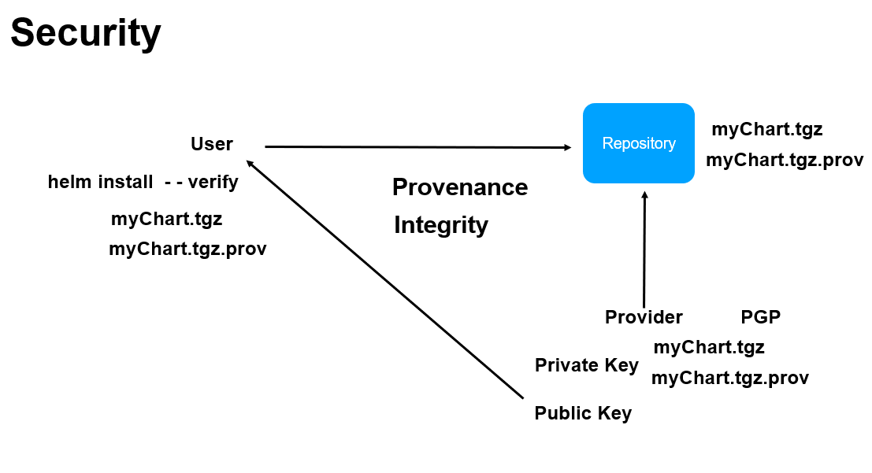

**PGP Key Gen installation**

**To sign and secure out chart we need private key and public key**

**Download gnupg**

Gpg --version

It will store keys under /users/.gnupg

**Generate PGP keys**

**Gpg --full-generate-key**

When we run this command it will ask passphrase :-- give **test123**

Using this command keys will generate and store in /users/.gnupg

The key which is just generated , we have to move in gpg extension instead of .kbx

**Gpg --export-secret-keys > ~./gnupg/secring.gpg**  enter it will ask for passphrase

Now public and private key are part of secring.gpg file

**Sign and verify**

When I am packaging my chart this time will do sign as well

Whatever email we provided while running command (**Gpg --full-generate-key)** that will act as key

While signing it will use private key and when we will verify it , then it will use public key.

**Helm package --sign --key skesarwa@rediffmail.com --keyring ~/.gnupg/secring.gpg firstchart -d chartsrepo**

**Enter it will ask passphrase**

**Note:**

Now along with package chart .prov file will generate . This will have signature and hash

**Now verify whether the pkg chart have right signature or not**

**Helm verify chartsrepo/firstchart-0.1.0.tgz --keyring ~/.gnupg/secring.gpg**

**Enter**

**Chart has verified**

While signing we use private key while verifying signature will use public key

**Verify during install**

How to verify signature while doing helm install or upgrade

Helm verify will look .prov file and it know the alias name

**Helm repo index chartsrepo**

**Now launch webserver inside chartsrepo using python command**



**Helm install --verify ~/.gnupg/secring.gpg temprelease localrepo/firstchart**

**Section 9 : Usecase**

**Objective :**

Deploying m/s application to the k8s cluster using helm

**livenessProbe and readinessProbe :-**

these are required by k8s to know our application is up and running

**Steps**

**Create chart for m/s and configure image**

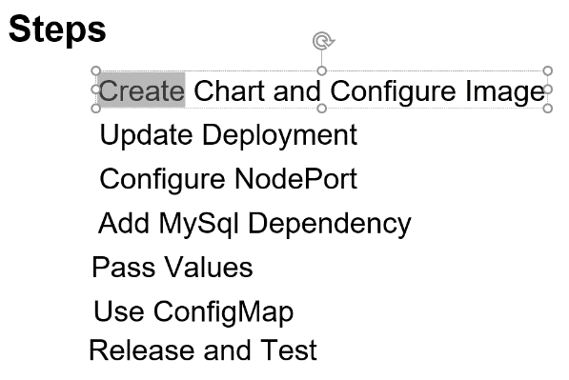

**Create chart**

**Step 1:**

**create chart for m/s and configure image**

**helm create couponservice**

Get rid of these three files

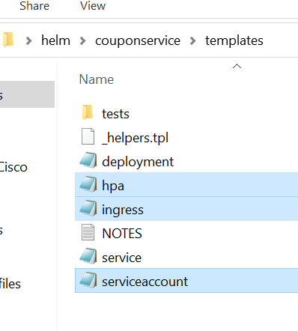

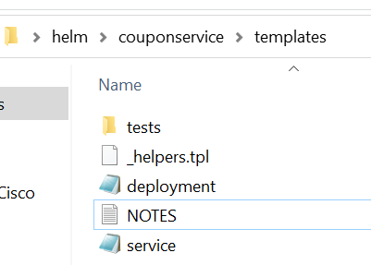

**Get rid of (delete) serviceaccount from helper**

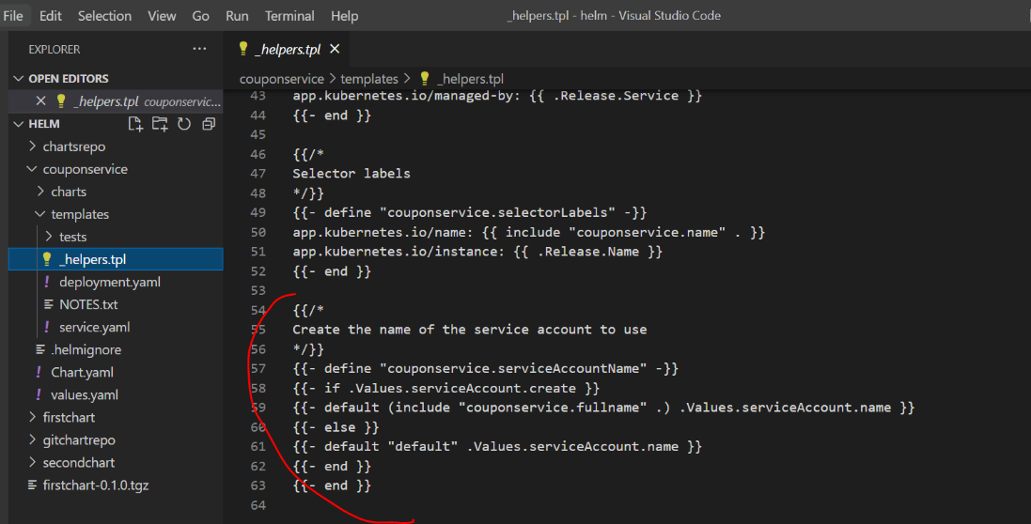

Delete serviceaccoutnt from deployment.yaml

**Changes image in values.yaml by default it is nginx**

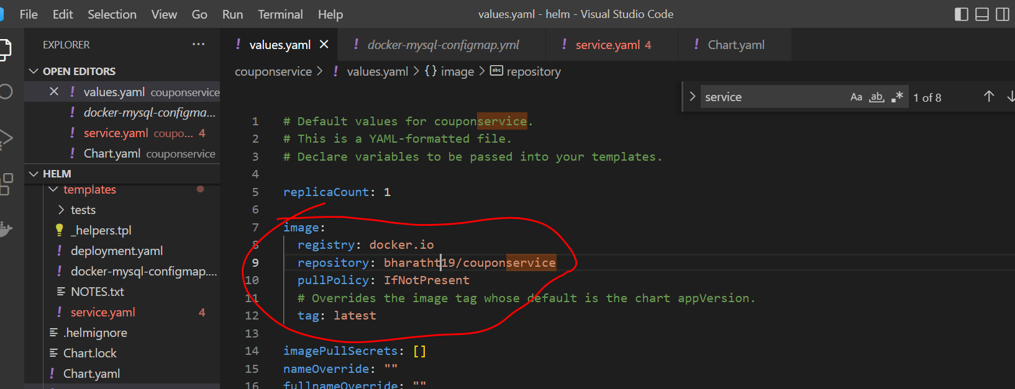

We have created chart and configure image and this image will use to launch container on k8s cluster

**Step 2 : Update Deployment**

K8S is used to check url in liveness and readiness to check our application is up or not in deployment file

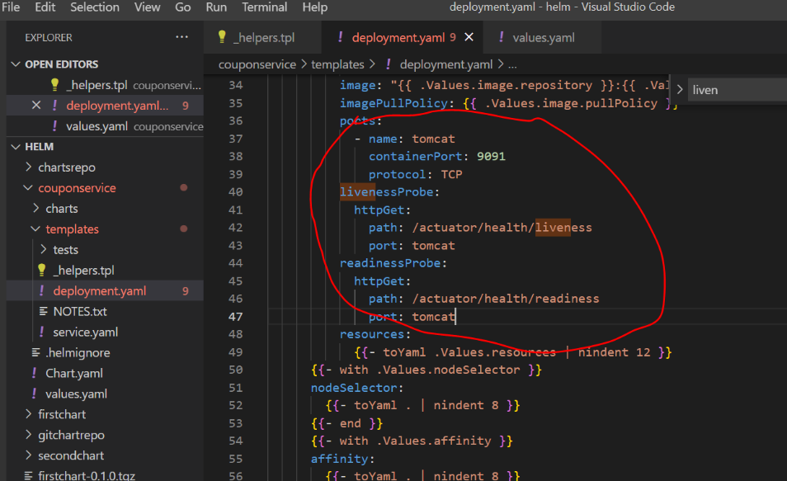

**Step 3- update service**

**Port:** we want to expose it out that application will be publish in this port

**targetPort:** where application is running

**NodePort :** expose outside cluster

Configure service in **values.yaml**

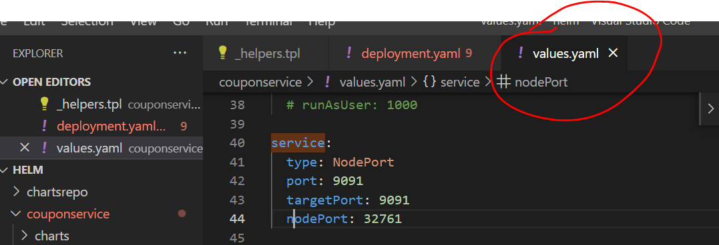

Now go to **service.yaml**

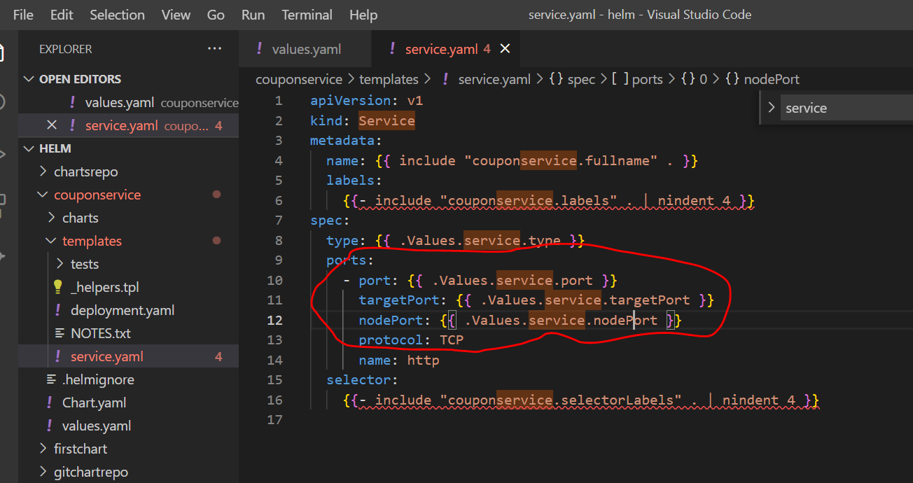

**Add dependency**

**Step 4**

**Add mysql chart dependency**

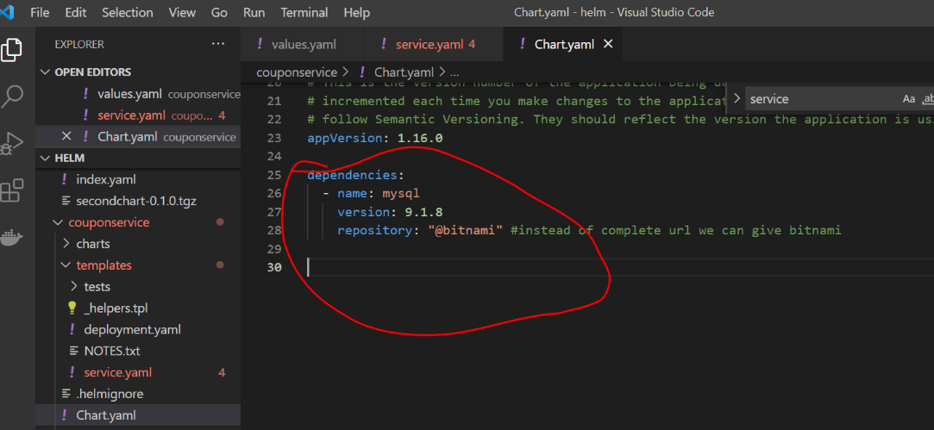

Go to couponservice folder and run **helm dependency update**

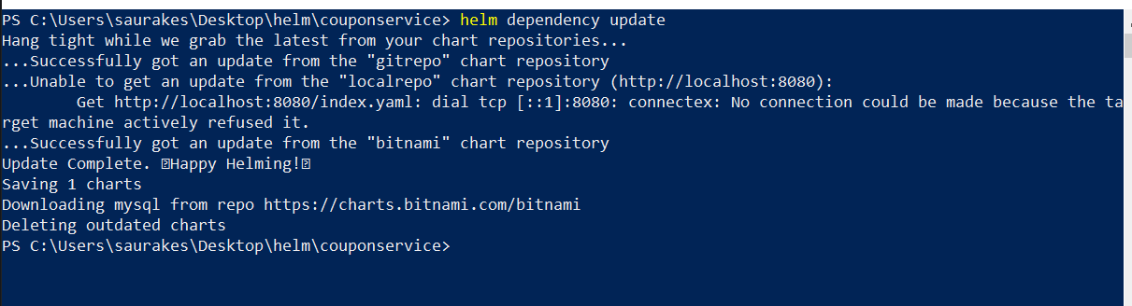

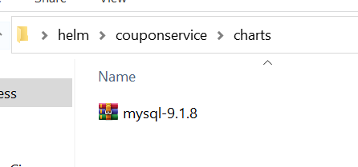

Under chart folder we have mysql dependency that is required

**Configure Values**

**Step 5**

We will pass some values to mysql dependency so that our springboot application will be able to connect to it.

So when container is launch it should use those values.

Go to values.yaml

fullnameOverride: docker-mysql

Means the chart name and release name will not be used, docker-mysql will be use as service name

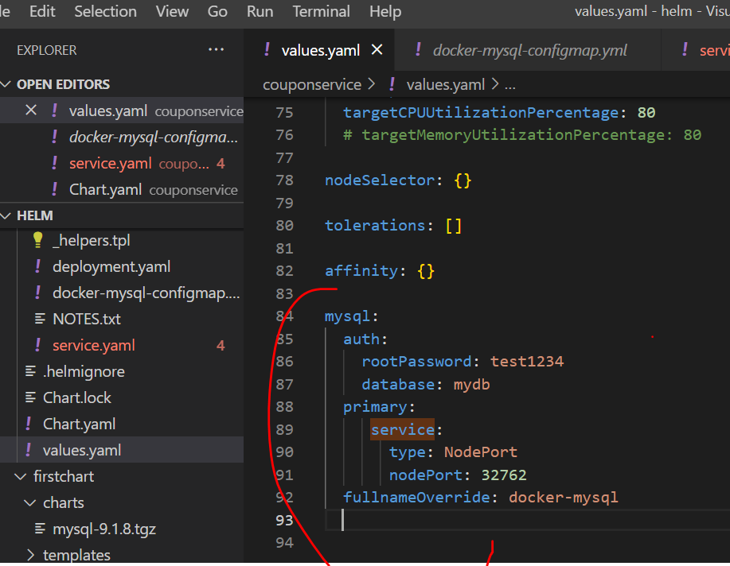

**Add ConfigMap**

**Step 6**

Once mysql server is up and running configMap (sql statement) need to be executed

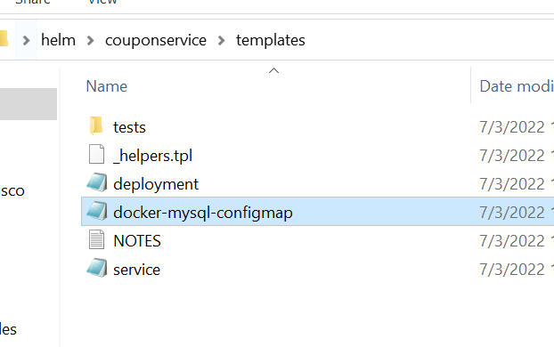

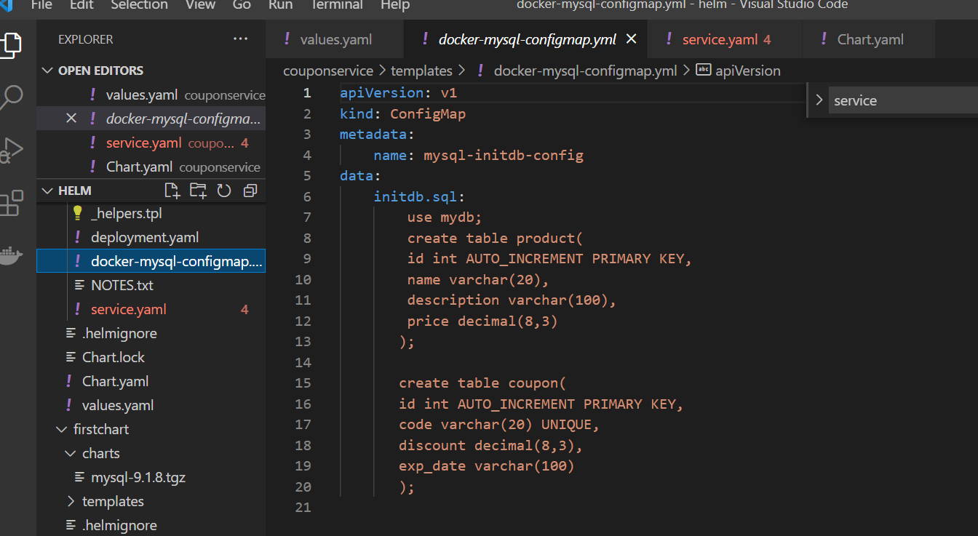

**initdbScriptsConfigMap: mysql-initdb-config (** name is given in configmap**)**

**That will use to initialize data**

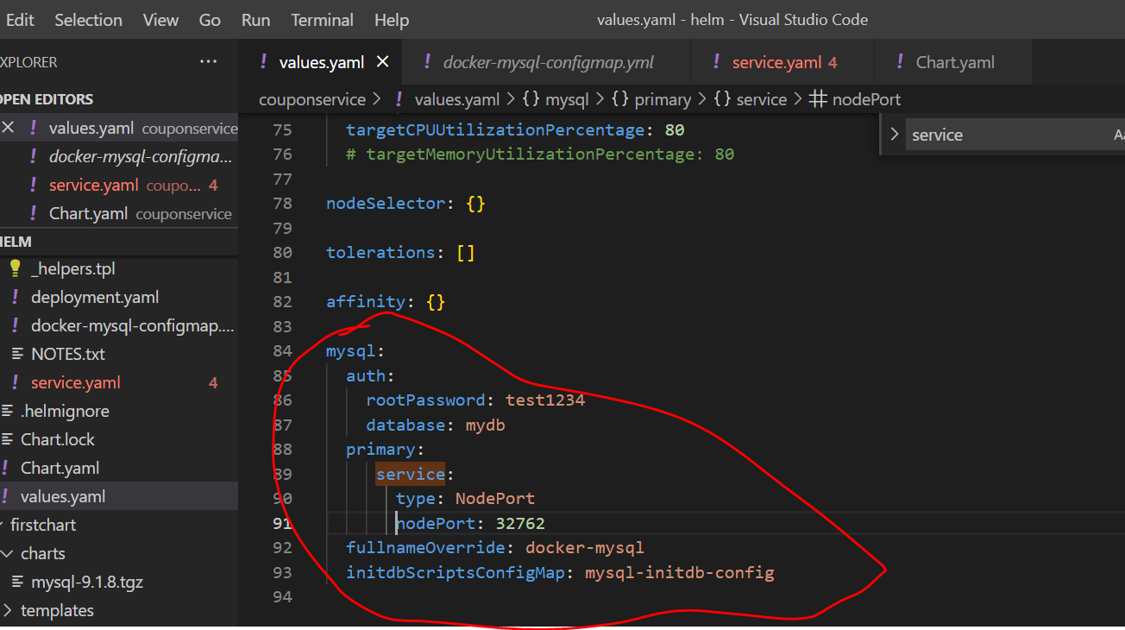

**Release and test**

**Objective :**

To deploy our application in k8s cluster

**helm install couponservice .**

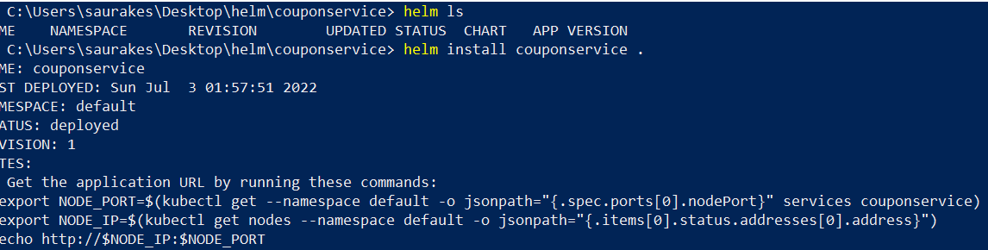

**Kubectl get svc**

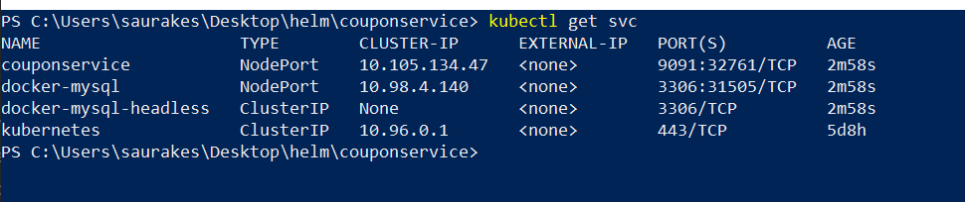

**Kubectl get configmap**

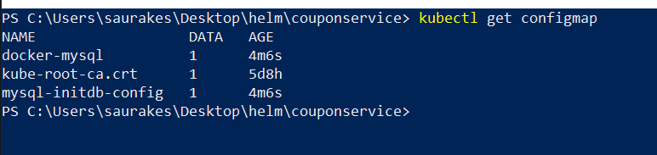

**Kubectl get pods**

**Kubectl logs podname**

The status **ImagePullBackOff** means that a Pod couldn't start, because Kubernetes couldn't pull a container image

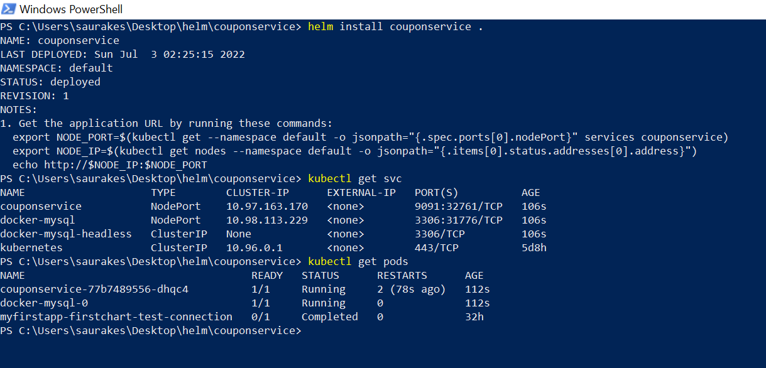

Status should be running in both case

We are connecting to mysql running inside pod or container ( from workbench)

Insert data in coupon using query

Other way to insert data in table :

We can insert in pod of sql

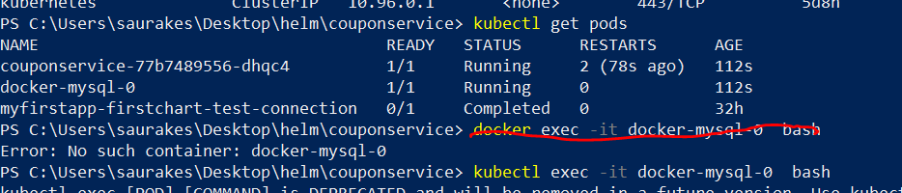

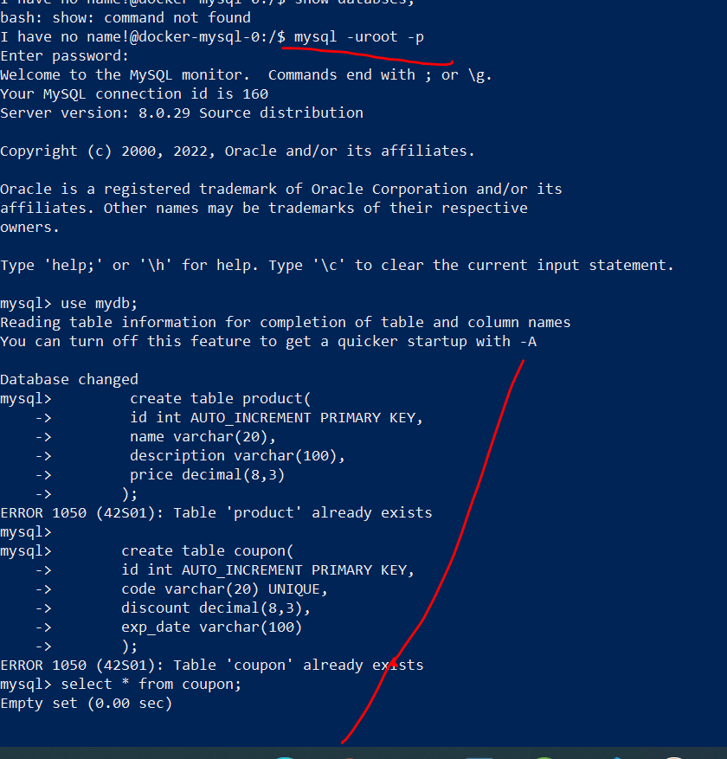

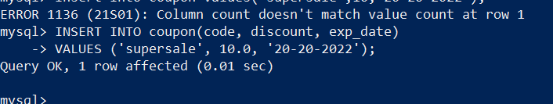

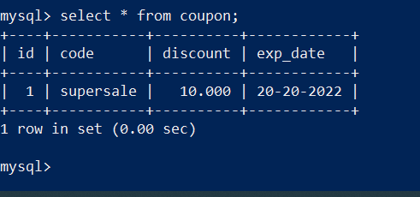

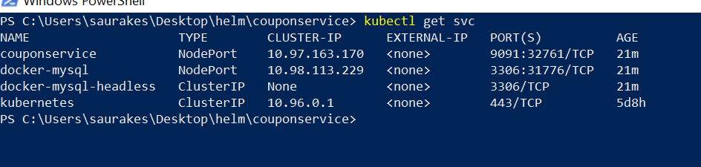

Test it: <http://127.0.0.1:32761/couponsapi/coupon/supersale>

**Section 10 :- starters**

**What helm starters are and how to use them**

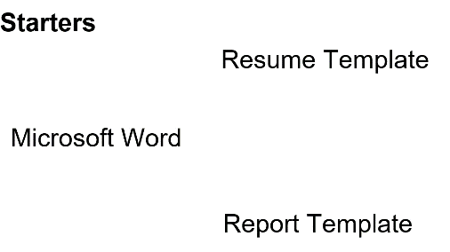

Helm starter allow us to create application specific chart

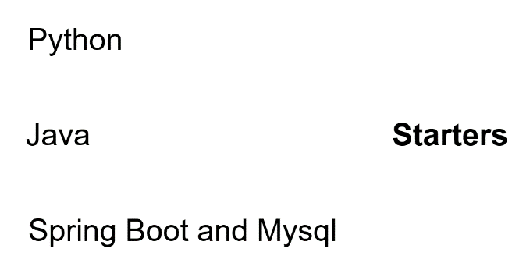

Using starter we can create any number of chart(couponservice)

**Create the starter folder**

C:\Users\saurakes\AppData\Roaming\helm\starters

**Create a starter :-** springwebappmysql

We are replacing couponservice with <CHARTNAME> under template in all files

We replaced in all these

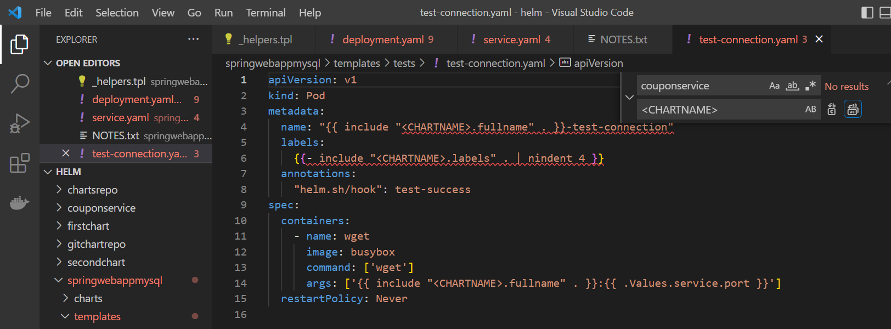

**Create a chart using a starter**

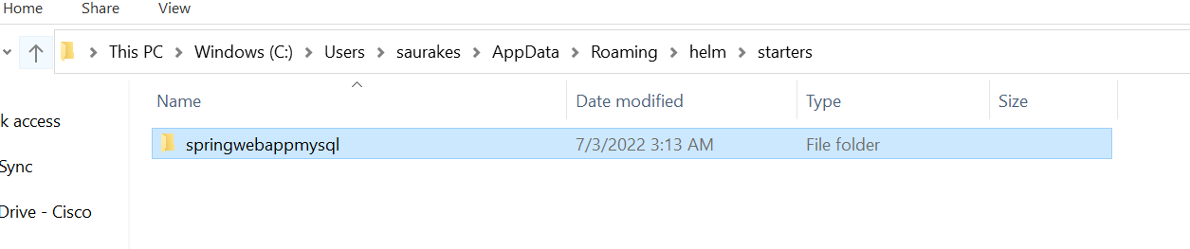

As soon as we will start starter helm will go and look into the starter folder which we created and it used that as a template to create chart

**helm create --starter springwebappmysql demoapp**

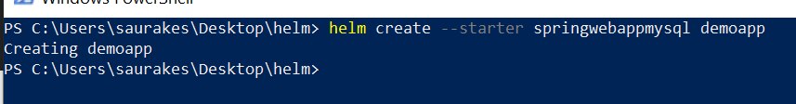

Demoapp will create from starter

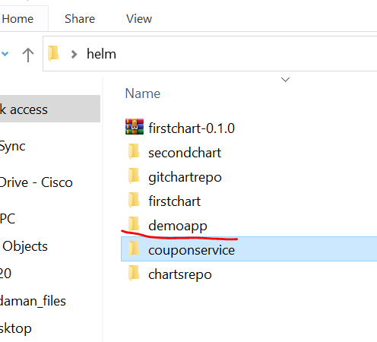

We don’t see now ngnix chart now .

It has now own name demoapp

We can share starter to entire organization who has similar requirement

**Section 11: Plugins**

**Introduction**

We can extend helm functionality by using plugins. We can create our own plugin also and install them and use it.

Every plugin has root directory inside which plugin.yaml. This is configuration file for our plugin and **it is mandatory**.

**Search by helm starter plugin github**

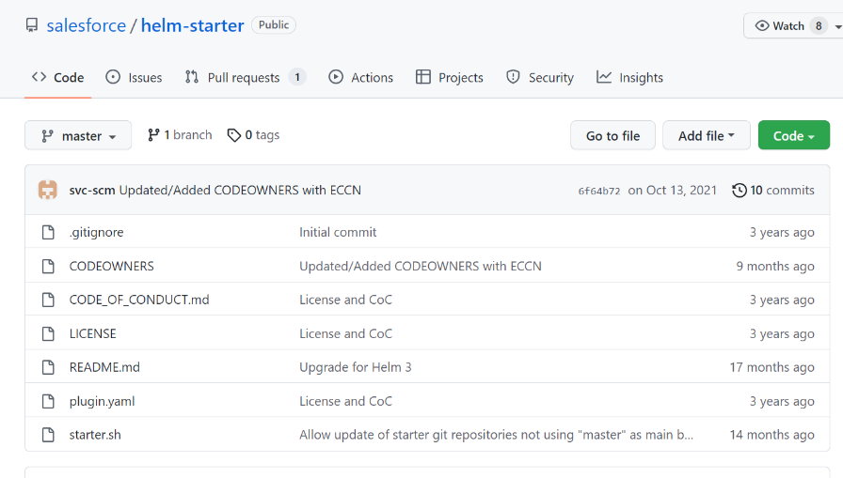

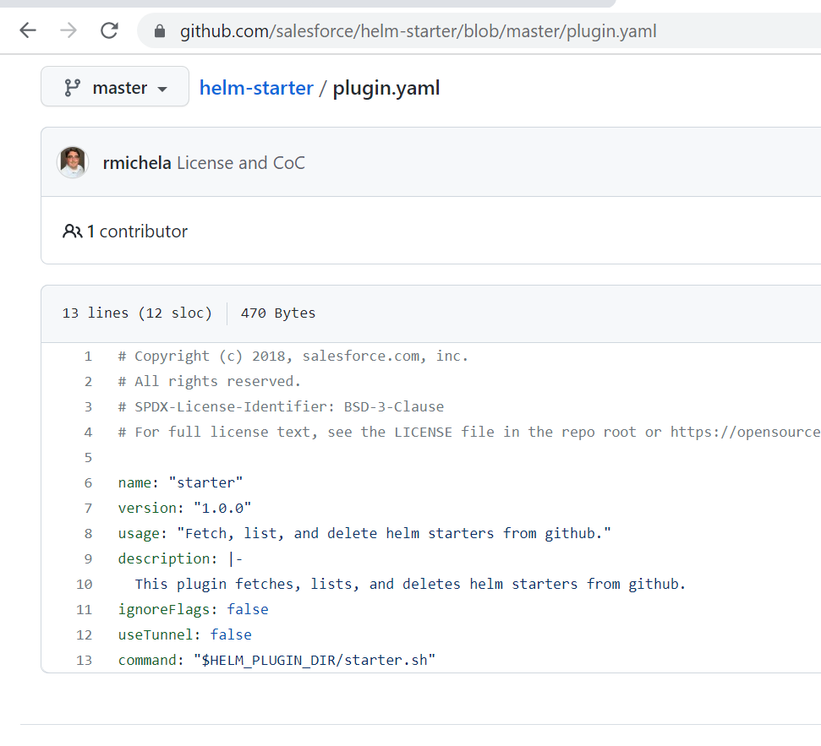

Name of plugin

Version of plugin

Usage

Command : when this plugin is use run starter.sh file. HELM_PLUGIN_DIR is env variable which helm creates.

**Install and use a plugin**

**Helm plugin list**

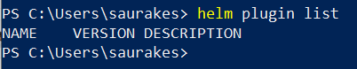

**Install plugin**

**Helm plugin install** [**https://github.com/salesforce/helm-starter.git**](https://github.com/salesforce/helm-starter.git)

**Name of plugin :-** starter

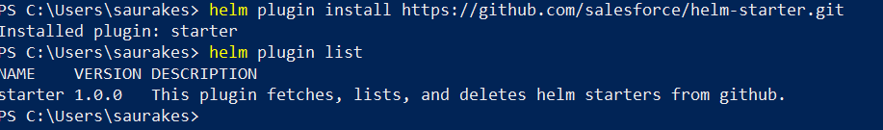

Using this we can use starter that will use to create helm project

**Helm starter --helm**

**Helm starter list**

**Helm plugin update starter**

**Create custom plugin**

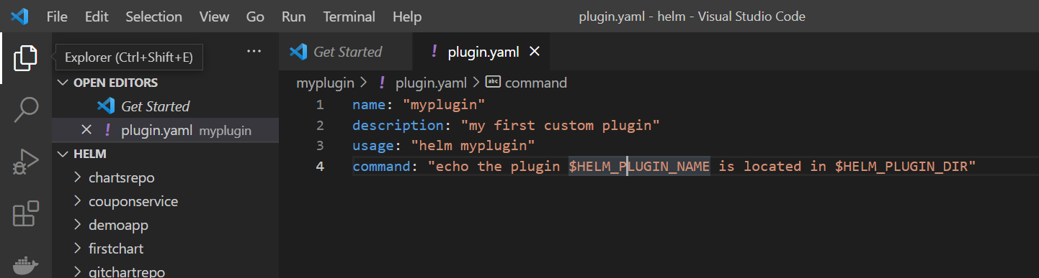

**Helm plugin install .**

**Helm plugin list**

**Helm myplugin**

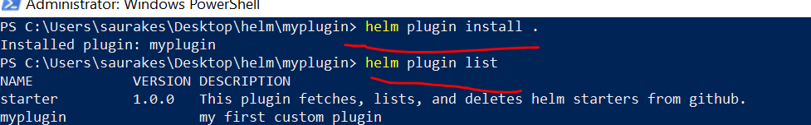

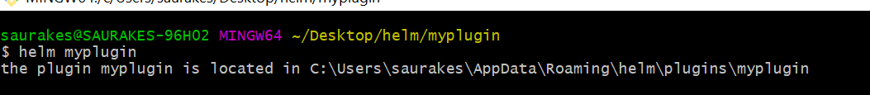

**Section 12 : More helm**

**Introduction**

Starting 3.0 helm allows schema validation for the values.yaml file in our chart

We can make particular element is mandatory within the schema it should be present

We can make sure element value is certain type.

Helm asked us to create a schema file following the json schmea validation format

Where values.yaml file is there same place **values.schema.json** file will be located.

It will automatically validate what will have in values.yaml file

The schema validation come on picture everytime we execute helm lint, helm install and upgrade

**Validate**

How to create default values.schema.json file from values.yaml file

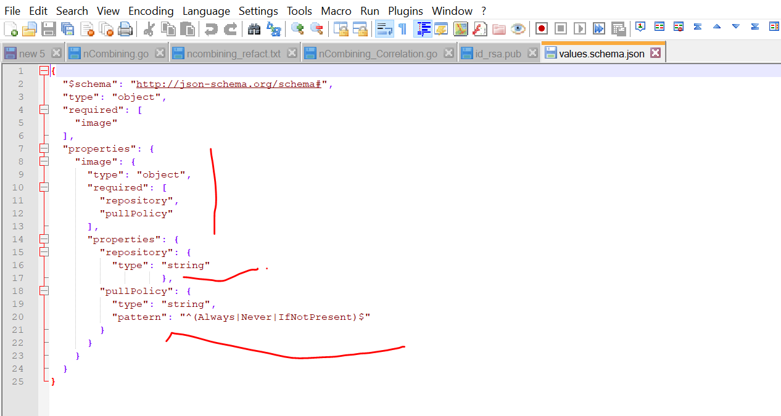

Let see it works

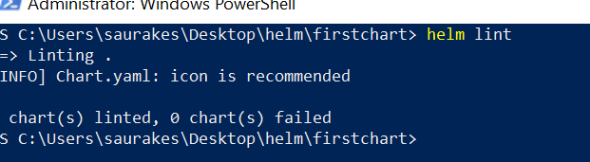

Now go to values.yaml file and change pull policy

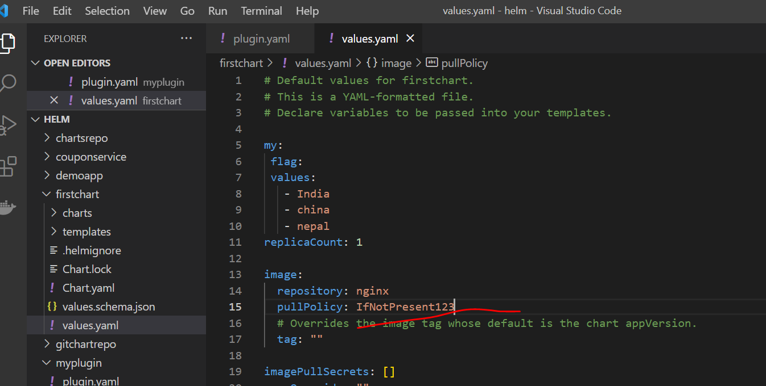

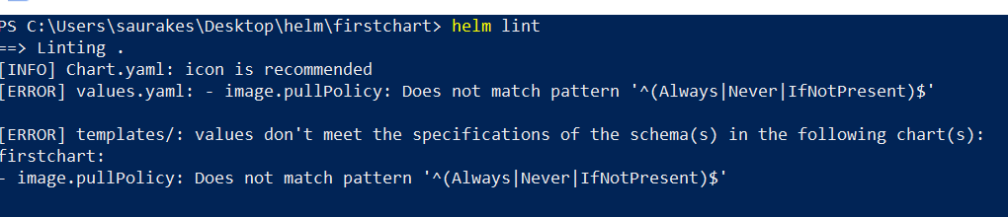

That is how we can use json schema to validate values.yaml file

**Generate Schema**

**Two step process**

First convert values.yaml to json then will use that json to generate a json shema

Copy values.yaml and convert to json then convert json to schema using below site

<https://www.json2yaml.com/>

<https://jsonschema.net/>